1. **In vivo MI**

The Fig 1.E showed representative condensed electrocardiograms the ECG tracing I-III were picked up, expended and shown at the bottom of panel.

**Control**

**Pre-ligation-normal ECG**

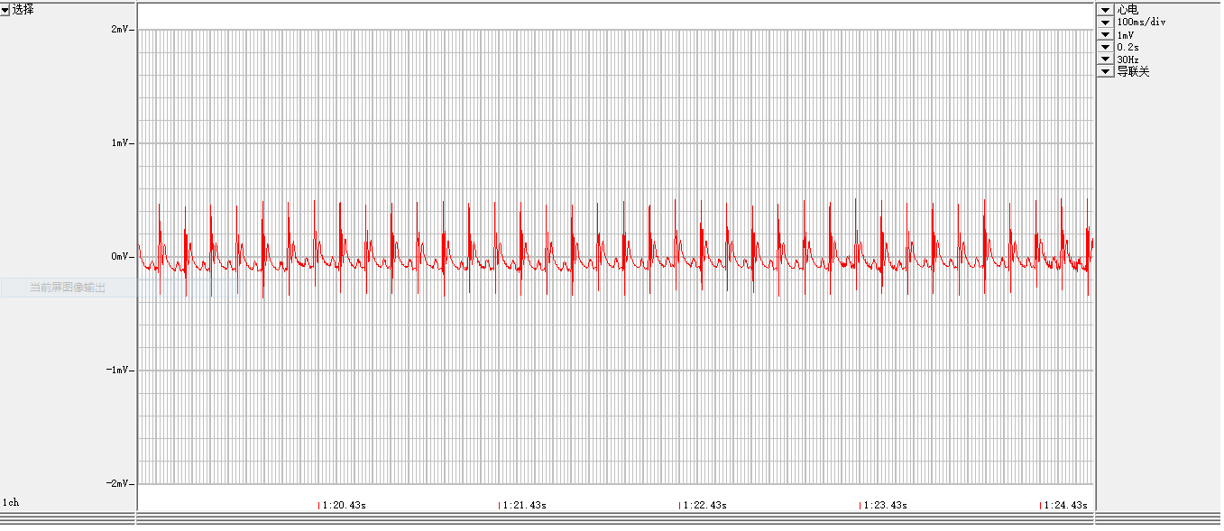

**Ligation-ST elevation**

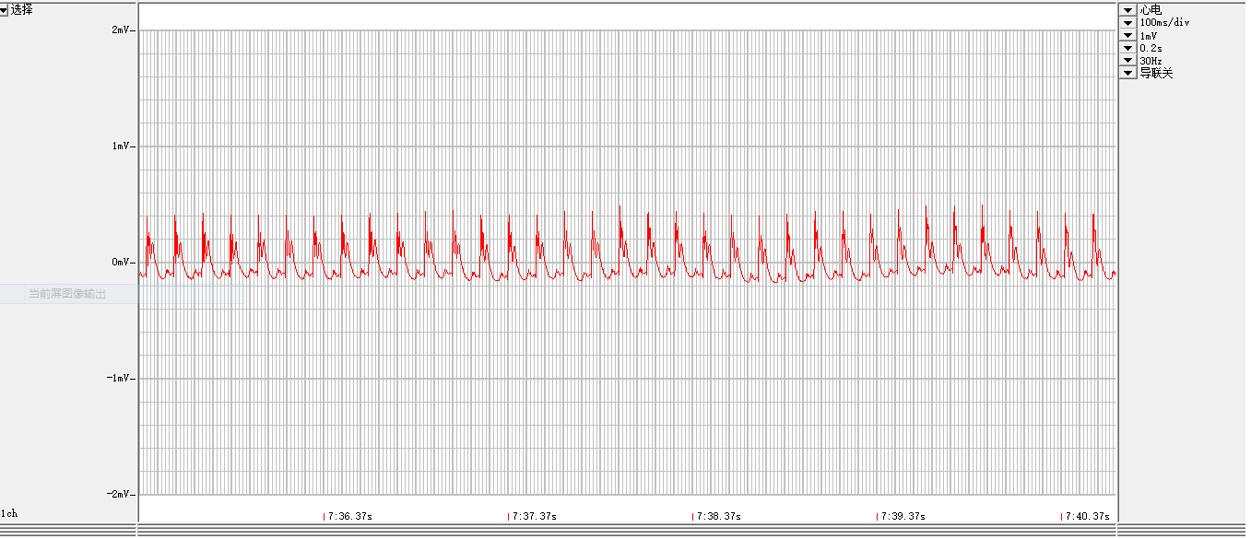

**Onset of arrhythmia, about 5 min post ligation**

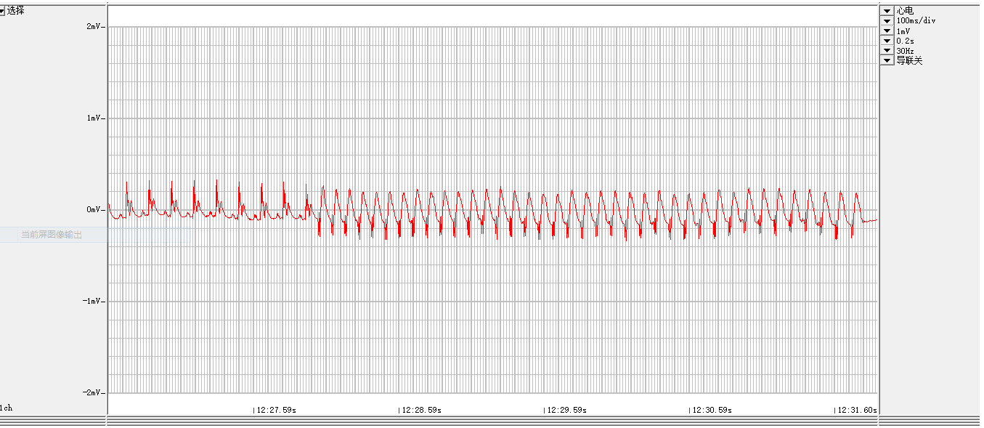

**PVC**

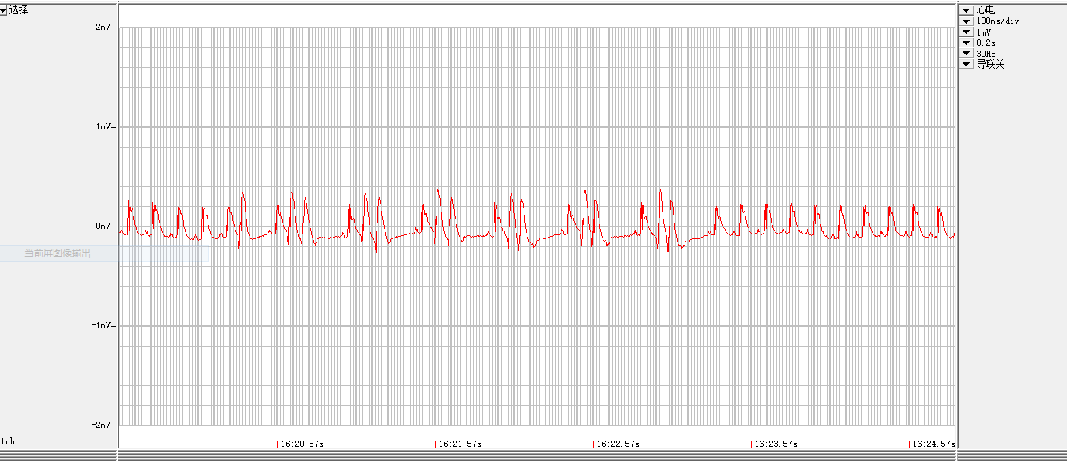

**VF**

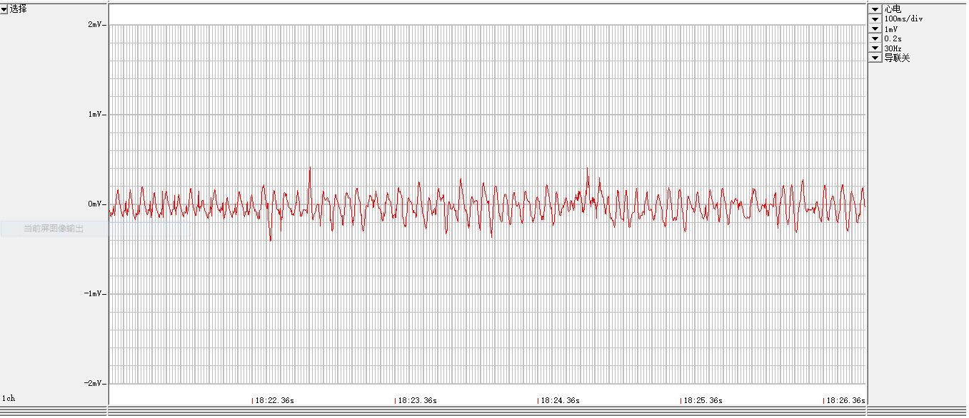

**Zacopride**

**Pre-ligation-normal ECG**

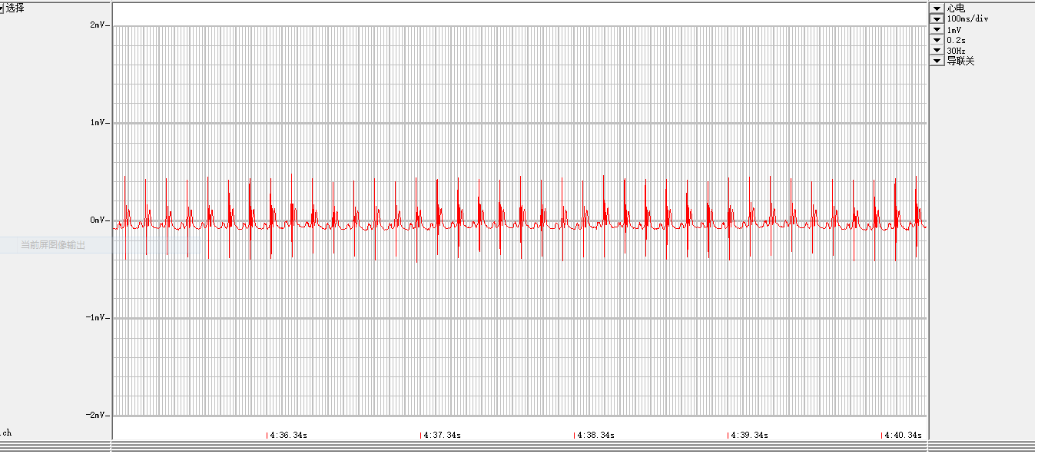

**Pre-ligation-Zacopride**

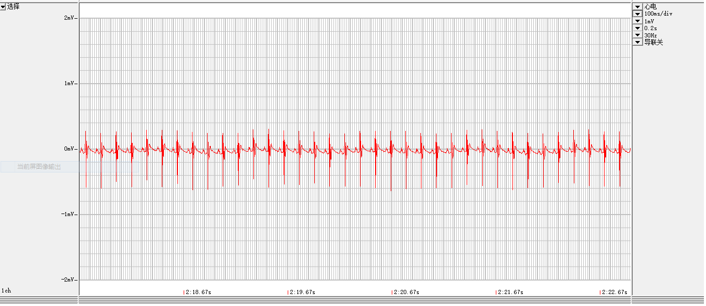

**Ligation-ST elevation**

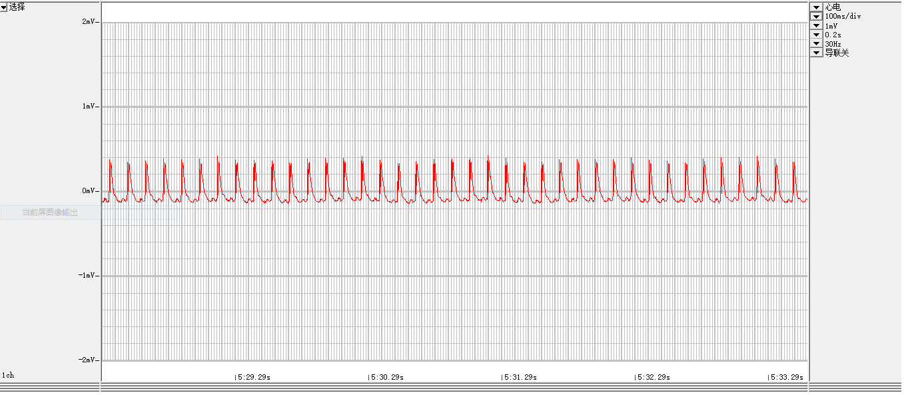

**Onset of arrhythmia, about 9 min post ligation**

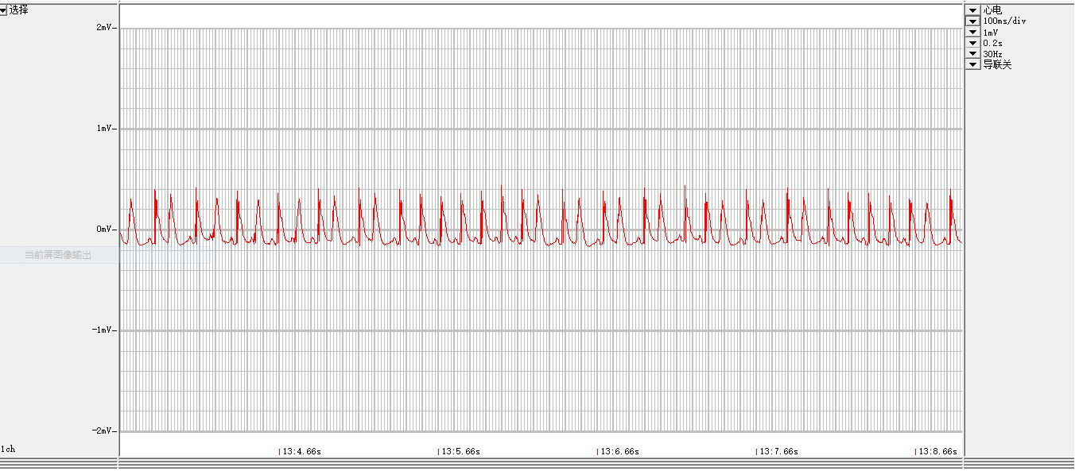

**Ligation-about 15min**

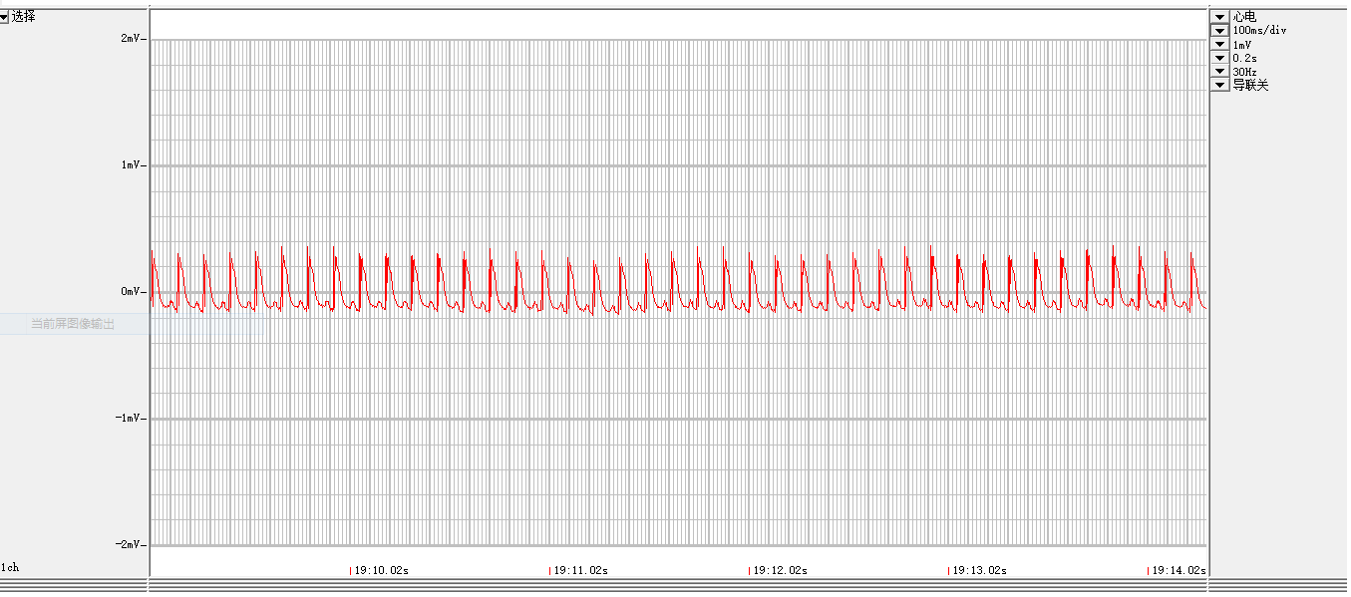

**Lidocaine**

**Pre-ligation-normal ECG**

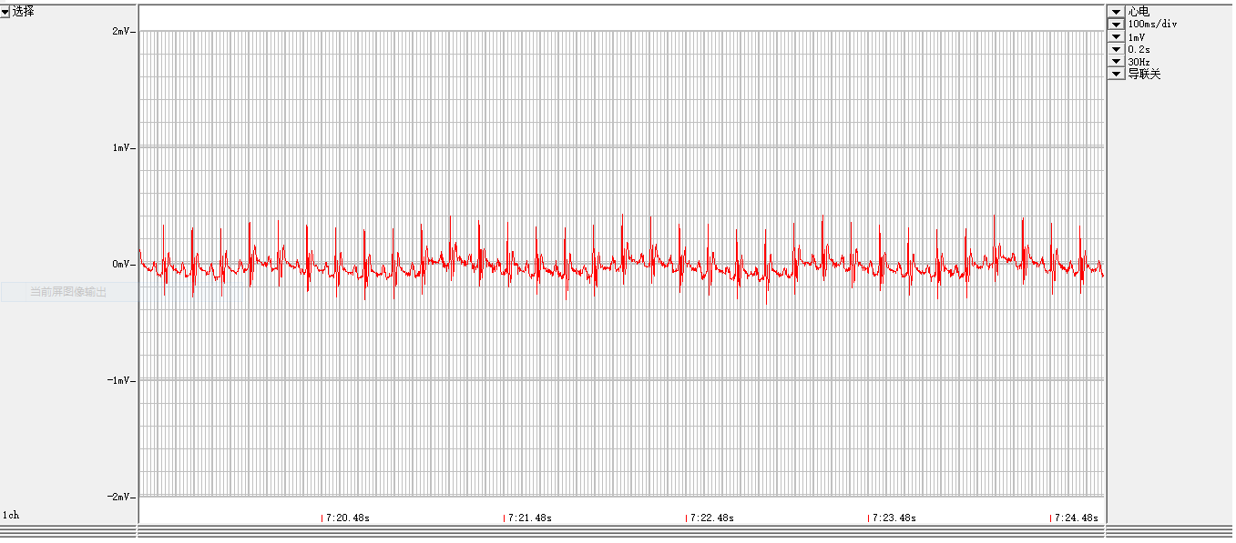

**Pre-ligation-Lidocaine, slightly slows the heart rhythm**

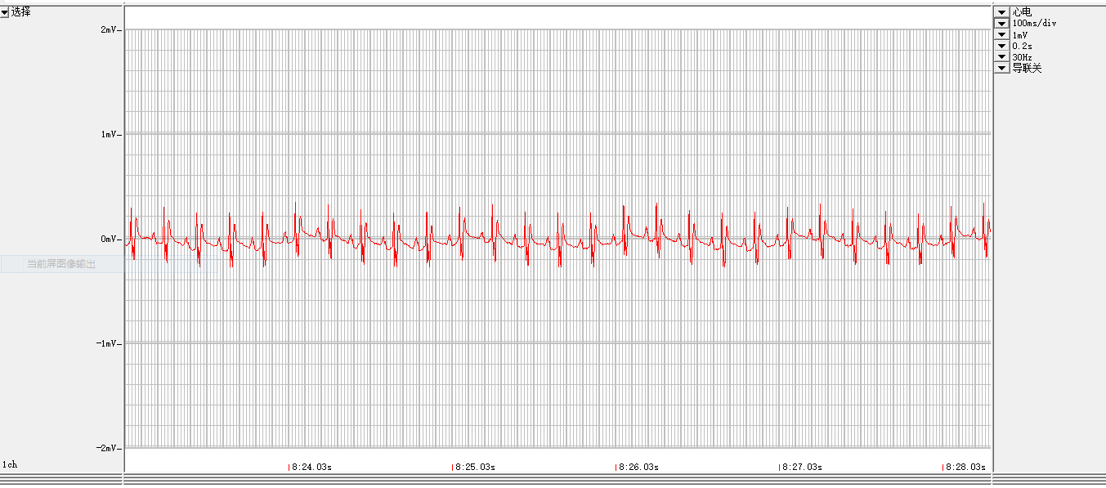

**Ligation-ST elevation**

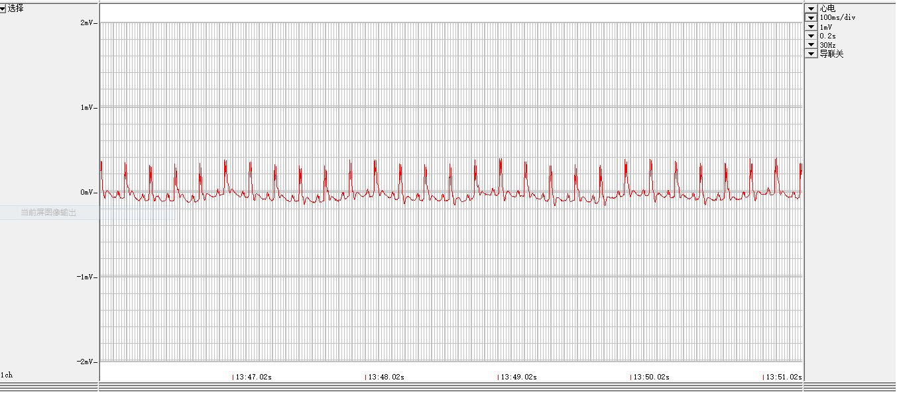

**Onset of arrhythmia, about 10 min post ligation**

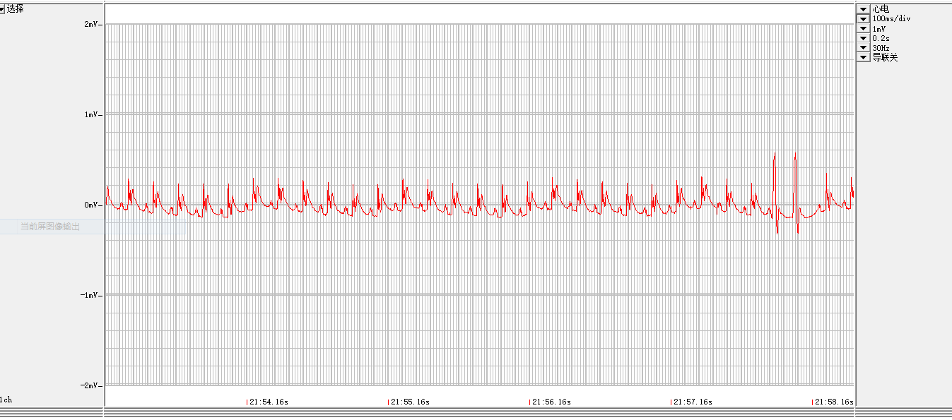

**Ligation-about 13min**

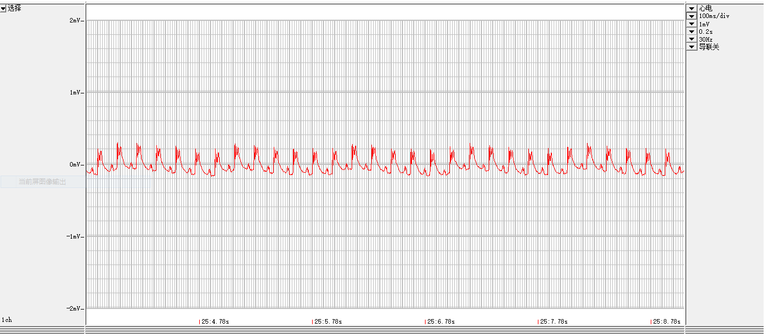

**2. Ex vivo - MI**

**Control**

**Pre-ligation- ECG**

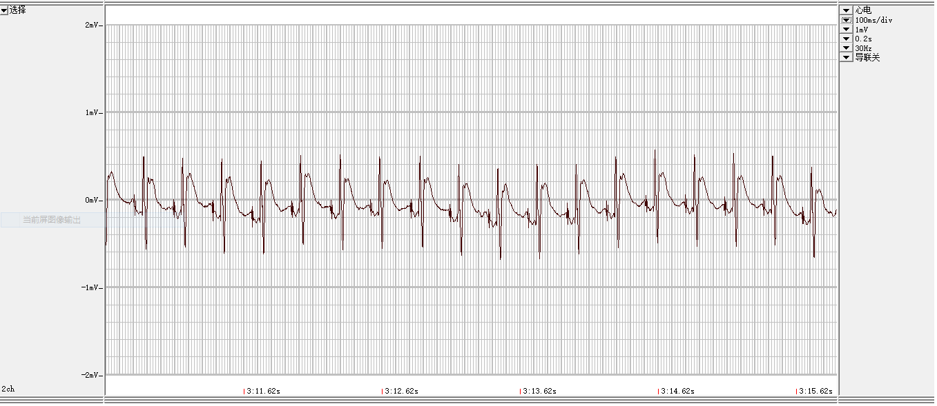

**Ligation-ST elevation**

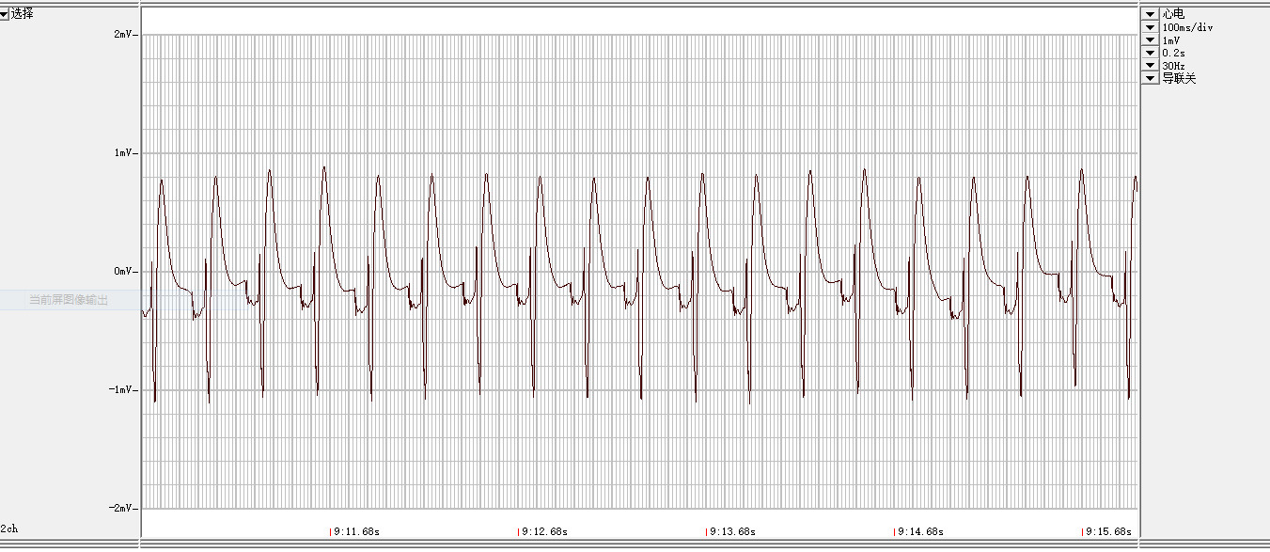

**Ligation**

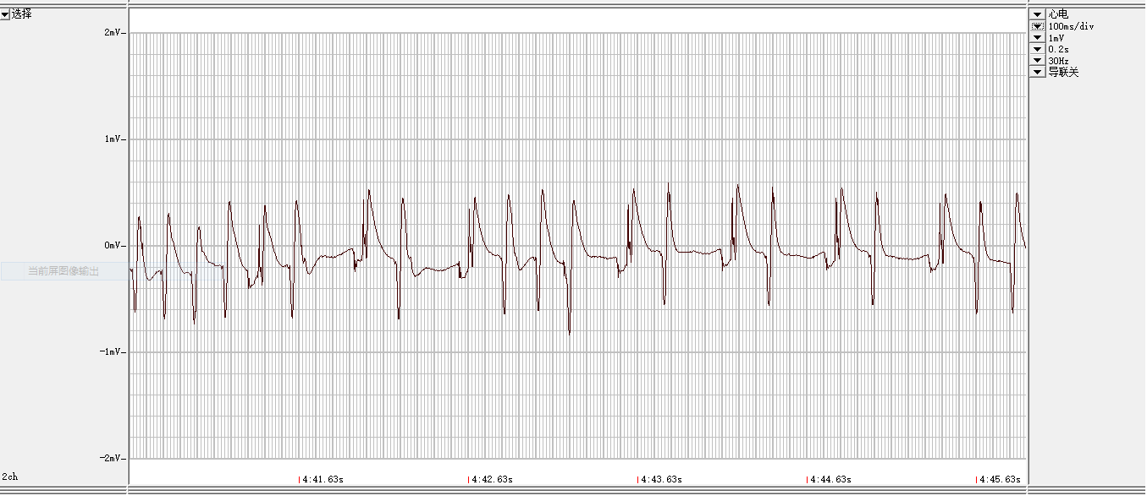

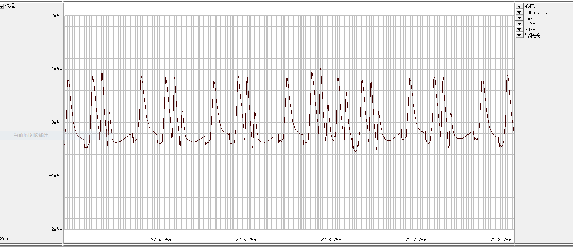

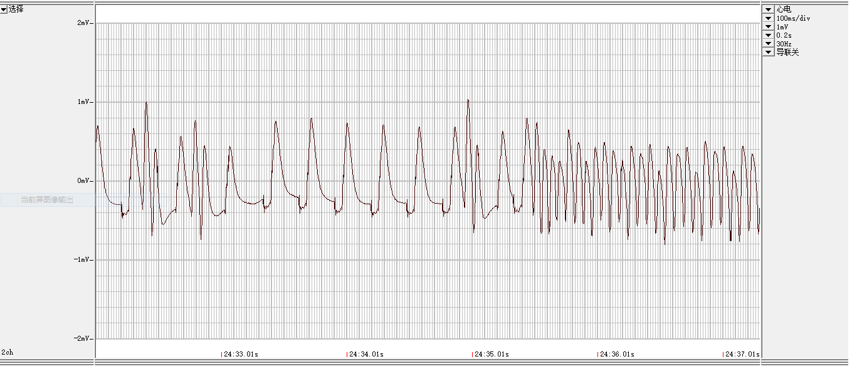

**Zacopride-1**

**Pre-ligation**

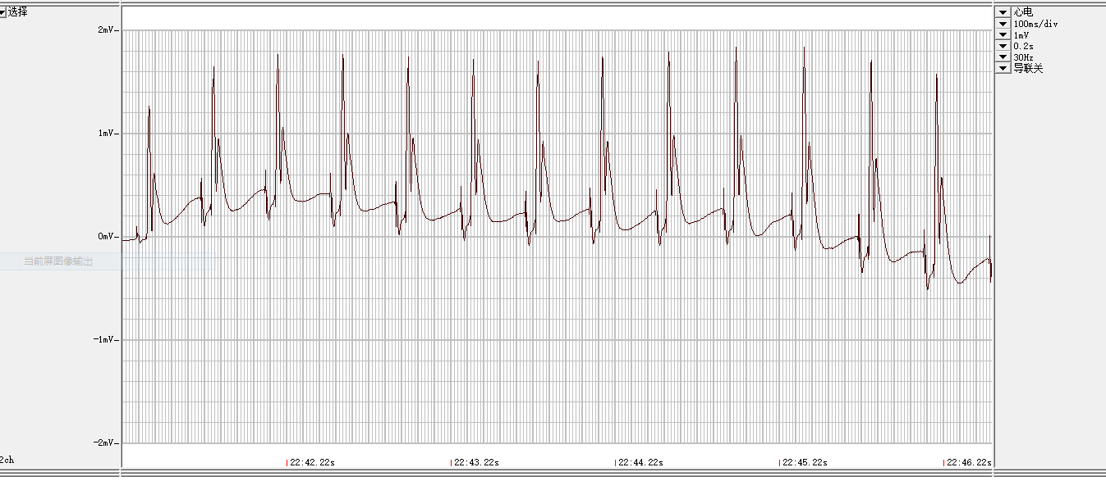

**Ligation-ST elevation**

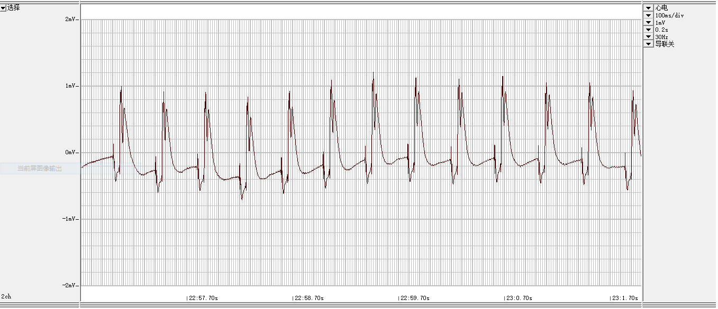

**Ligation**

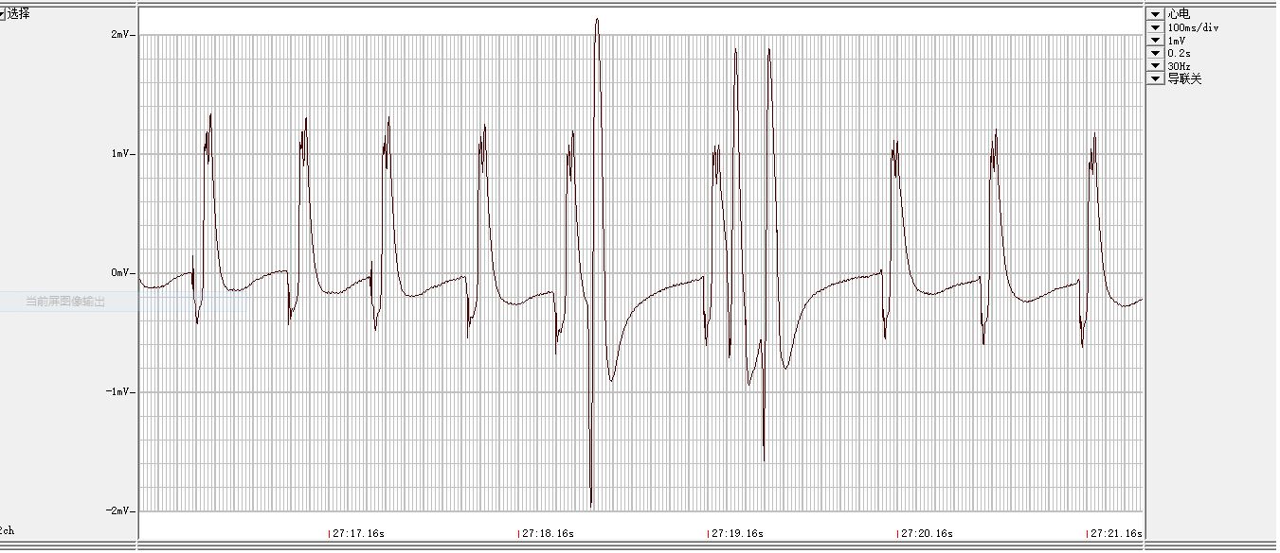

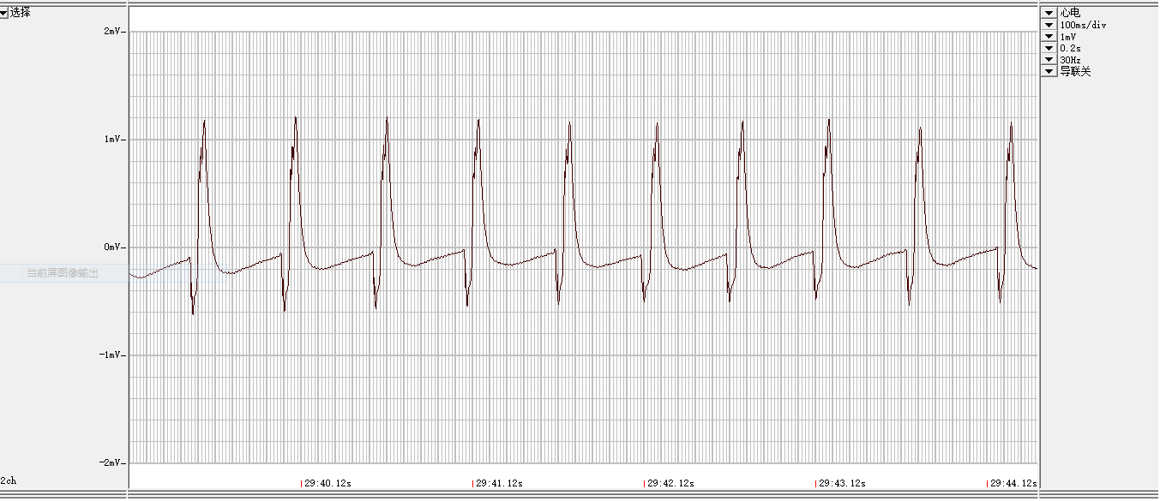

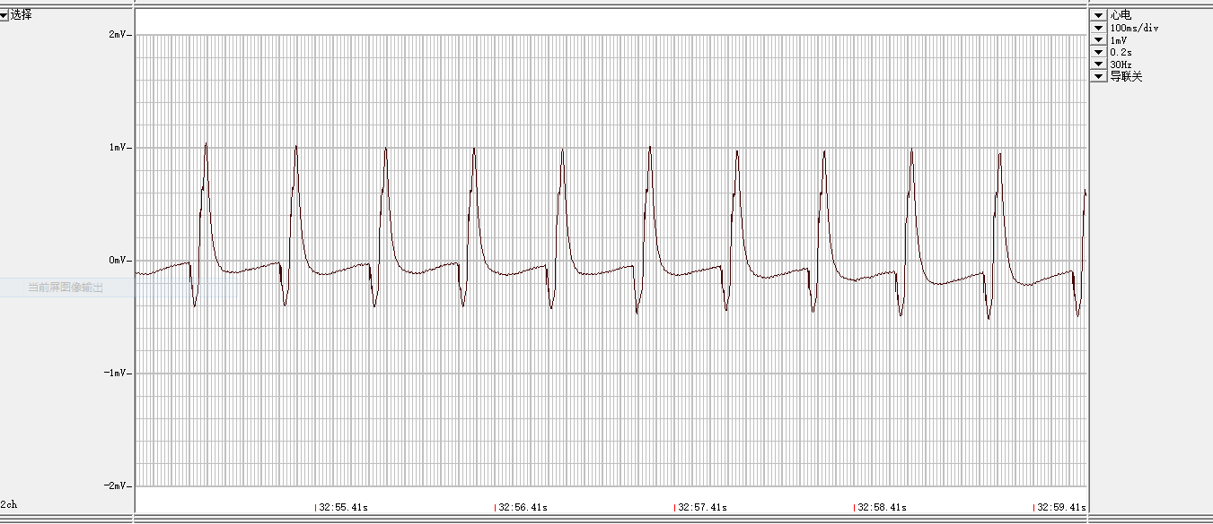

**Zacopride-2**

**Pre-ligation-normal ECG**

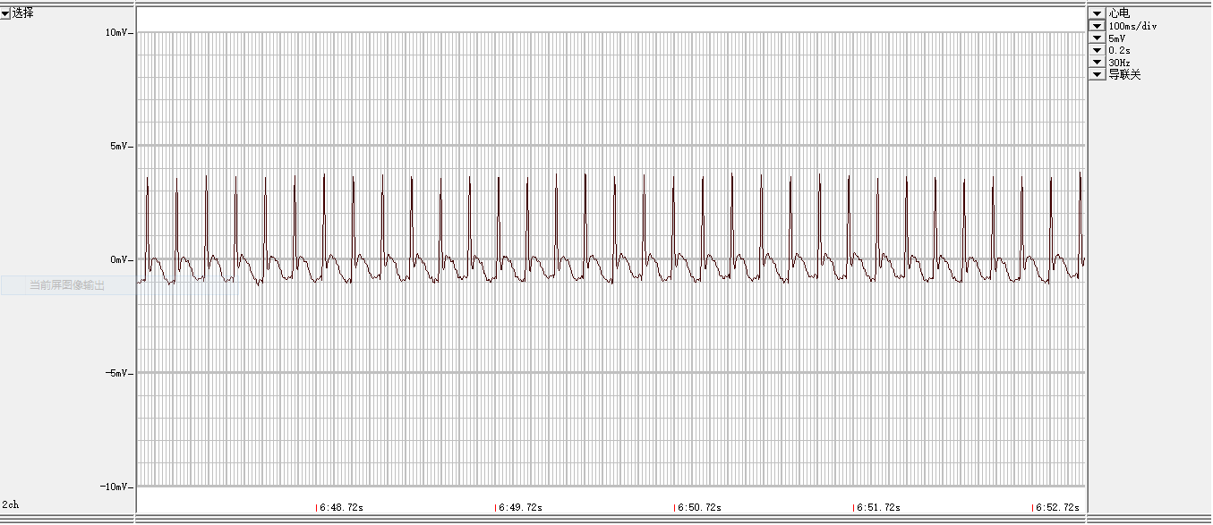

**Ligation-ST elevation**

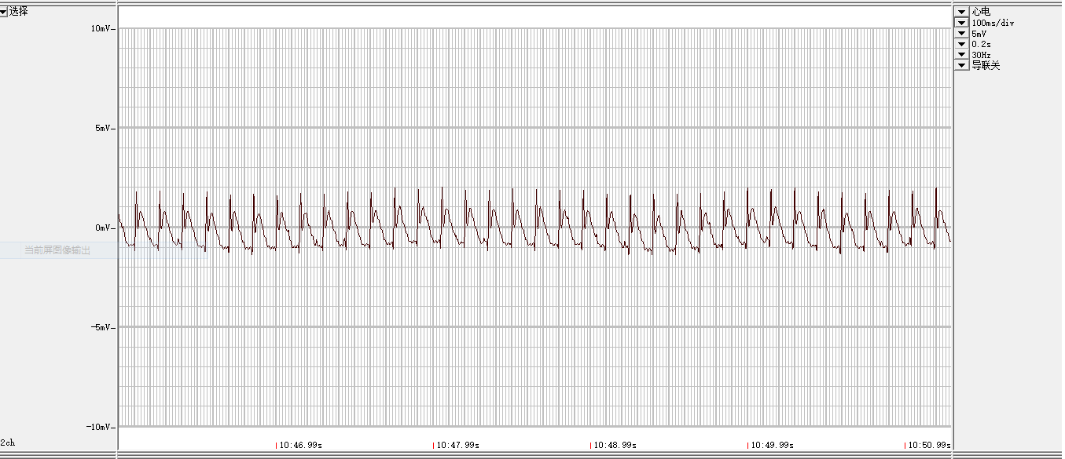

**Ligation** 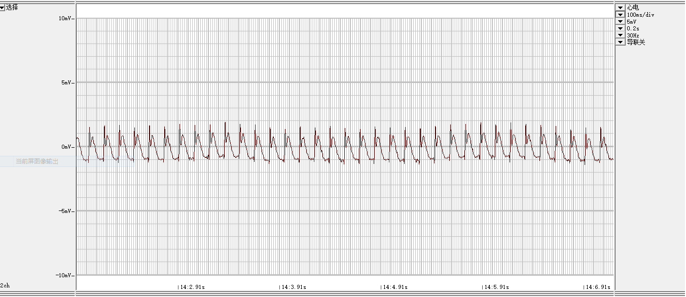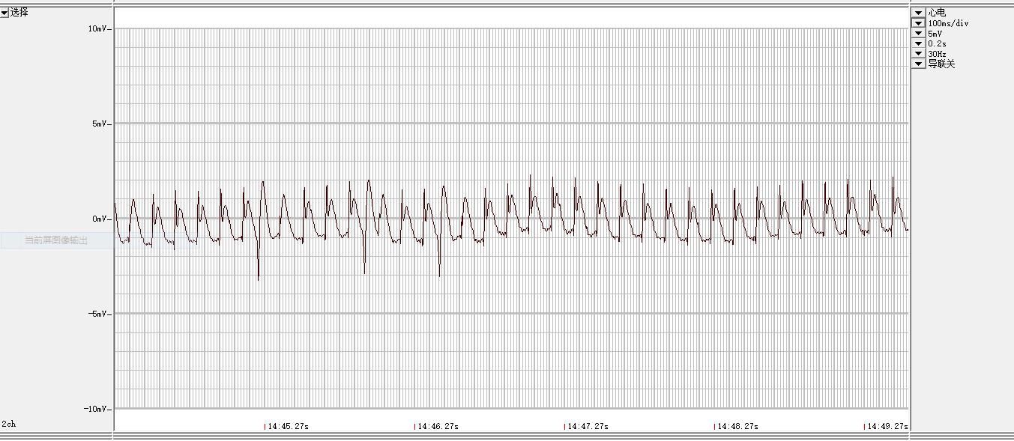

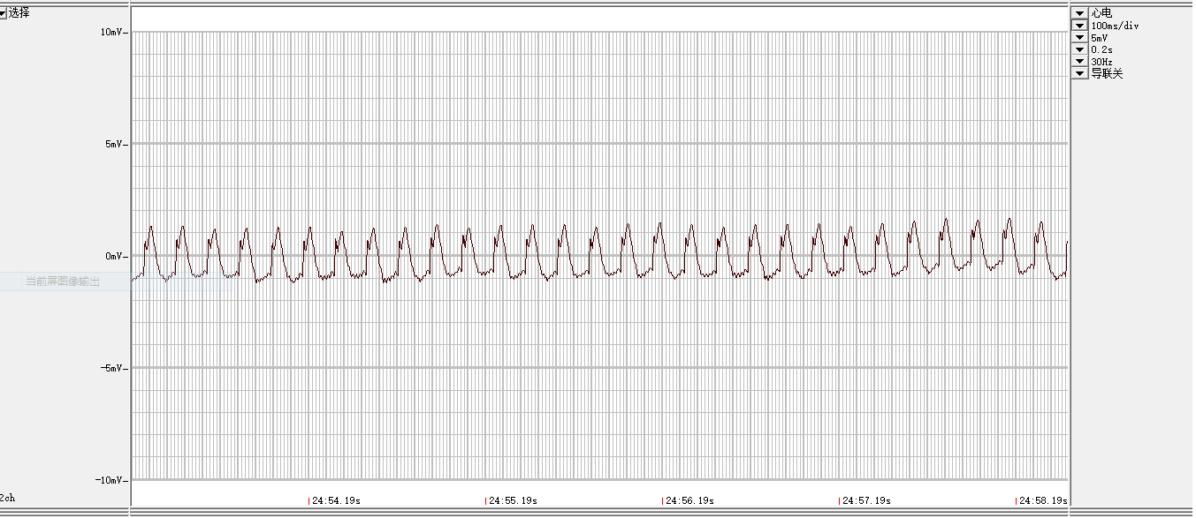

**Zacopride+BaCl2**

**Pre-ligation-normal ECG**

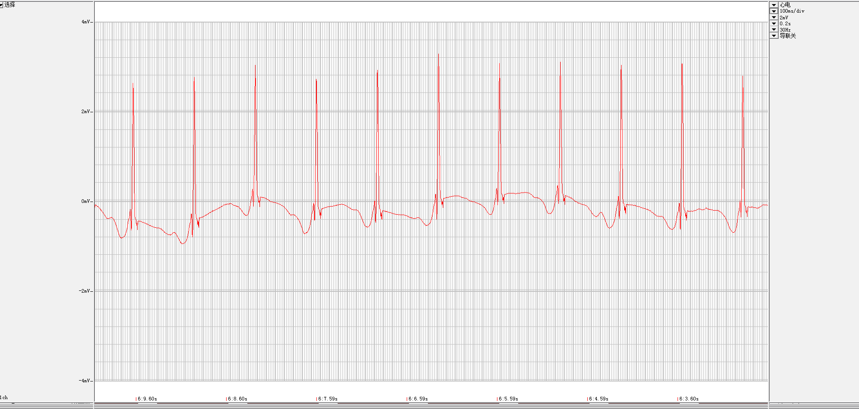

**Pre-ligation- 1 μmol/L BaCl2**

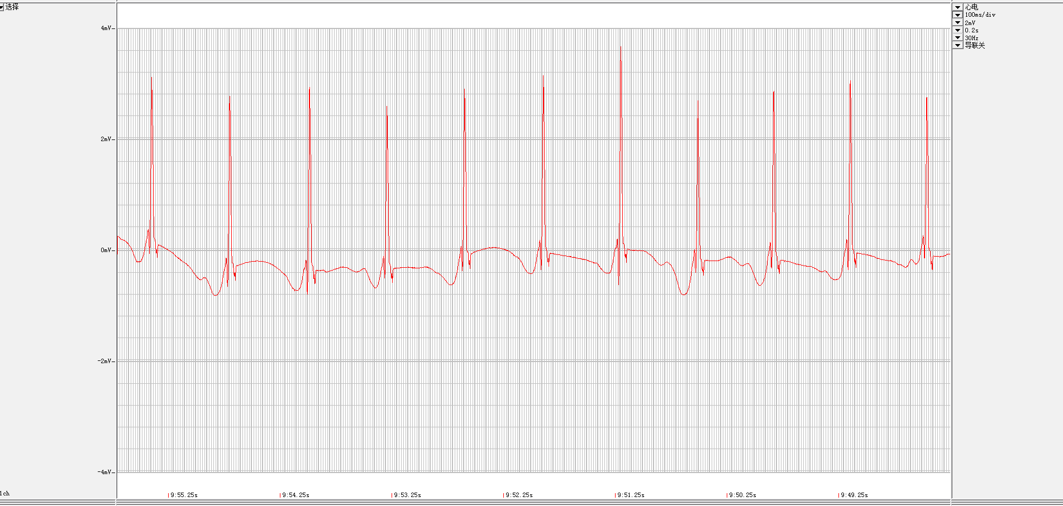

**ligation- 1 μmol/L BaCl2+1 μmol/L zacopride**

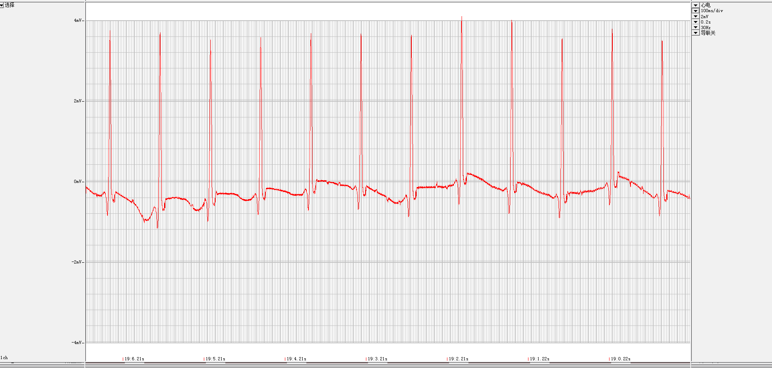

**ligation- 1 μmol/L BaCl2+1 μmol/L zacopride**

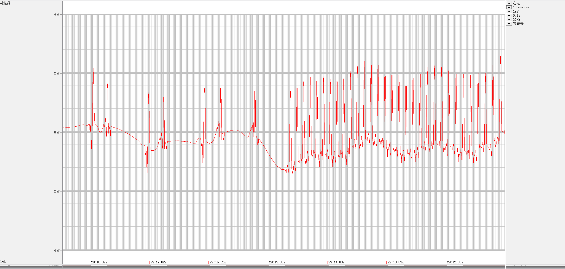

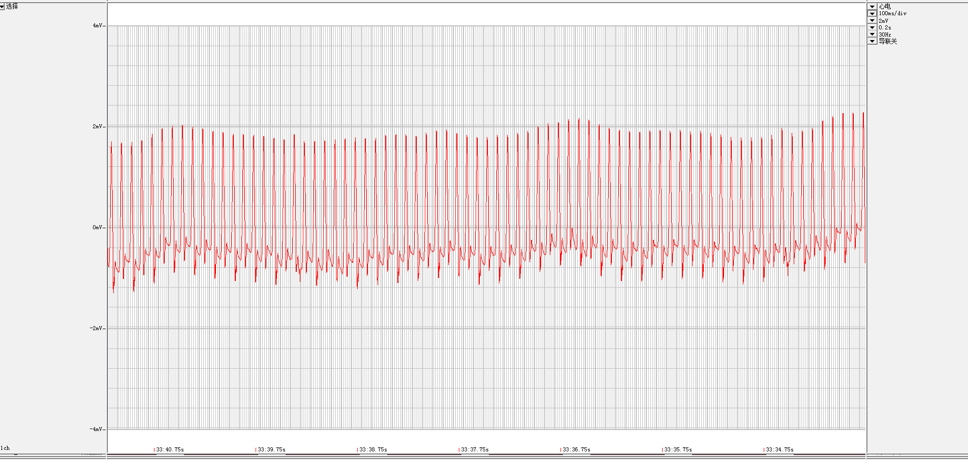

1. Patch clamp recording sweeps for IK1 in a rat ventricular myocyte

Zacopride restores hypoxia-induced *I*K1 decline. The increment of current was reversed by 1.0 µmol/LBaCl2.





1. Patch clamp recording sweeps for Kir 2.1, Kir 2.2 and Kir 2.3 in CHO

Zacopride rescues the hypoxia-induced decline of *I*Kir2.1, but not IKir2.2 and IKir2.3, in CHO cells

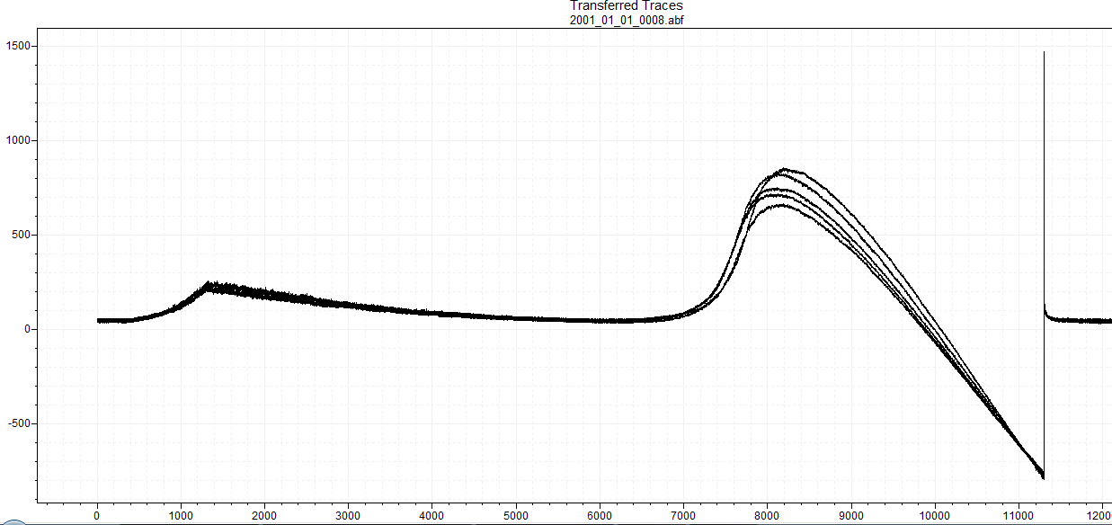

**Kir2.1**

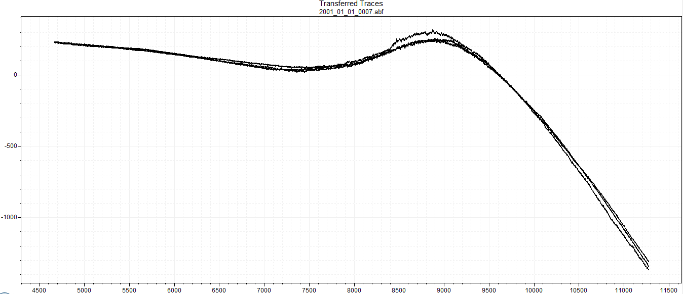

**Kir2.2**

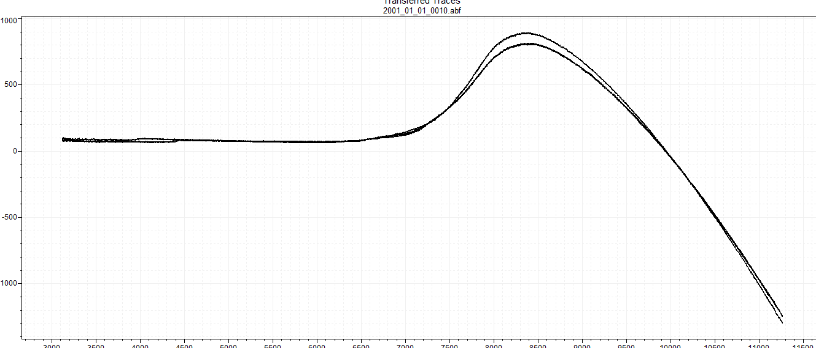

**Kir2.3**

1. **Zacopride restores hypoxia-induced RMP depolarization**

