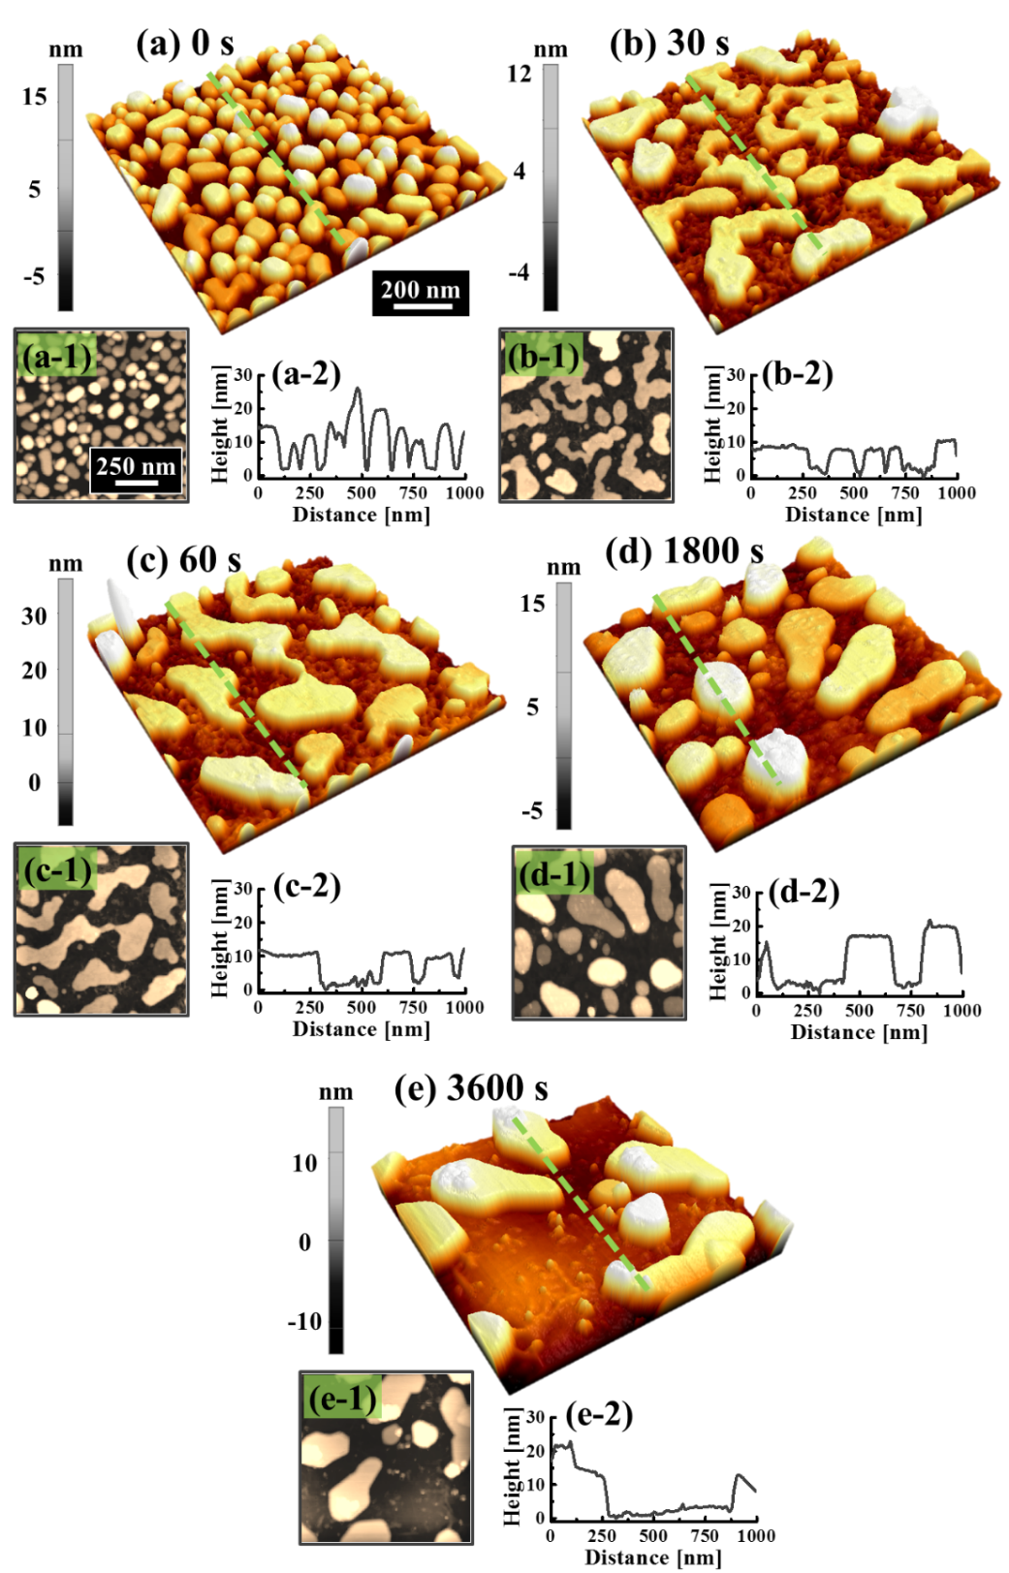
S17 Fig. (a) – (e) AFM side-views (1 × 1 µm²) of the Pt NPs formed by the annealing duration control from 0 to 3600 s at 800 ˚C with 15 nm Pt deposition thickness. (a-1) – (e-1) Corresponding top-views. (a-2) – (e-2) Cross-sectional line-profiles.

