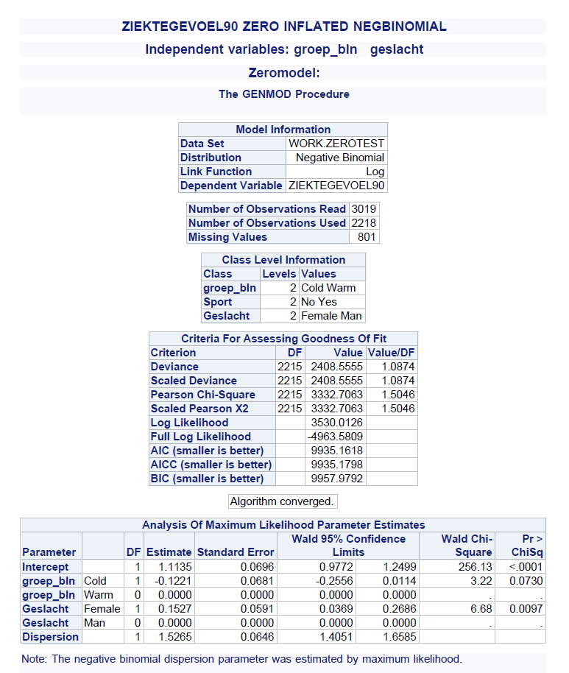
S2 Table. Final model output from SAS PROC GENMOD for illness.

This study investigated the effect of cold showering on health and work: a trial randomizing a (hot-to-) cold shower for 30, 60, 90 seconds or a control group during 30 consecutive days followed by 60 days of showering cold at their own discretion for the intervention groups.

