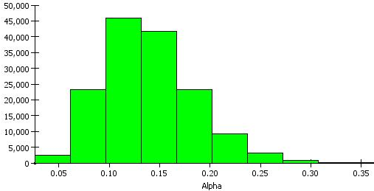
(a)
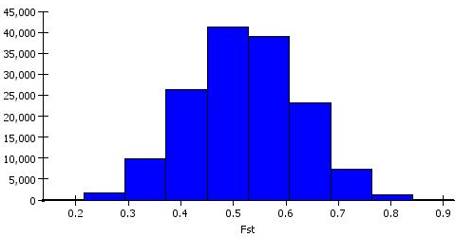
(b)
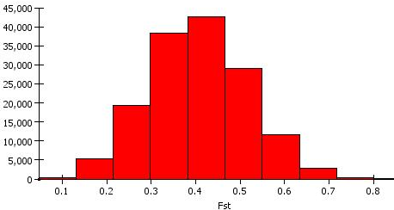
(c)
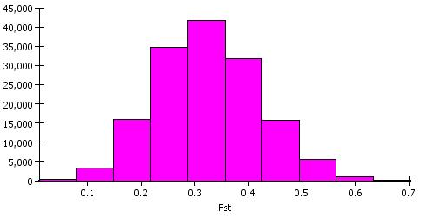
Supplementary fig.1 The distribution pattern of α value in the population and distribution of F_{ST} values in the sub-populations (a)Histogram of distribution of alpha values, (b) Histogram of distribution of Fst1 values, (c) Histogram of distribution of Fst2 values and (d) Histogram of distribution of Fst3 values.

