Fig. S1
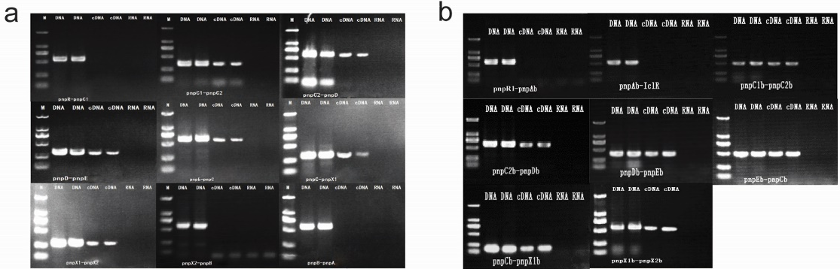
Fig. S1. RT-PCR products for validation of operon predictions (2.0% agarose gel). DNA = genomic DNA template. cDNA = cDNA template. RNA = RNA template. (a) RT-PCR results for 10 genes from the pnp cluster. (b) RT-PCR results for 10 genes from the pnp1 cluster.

