S4 Text. Supplementary Figures A, B.
Figure Legends
Figure A. Trends of radiation exposure-induced cancer incidence risk (REIC)(percent), using excess absolute risk model for a Japanese population, with numbers of stem-cell divisions per year, log₁₀[cumulative number of stem-cell divisions], and extra-risk score (ERS).

Figure B. Trends of mortality rate difference (current vs former smokers) (/10⁵ /year) with numbers of stem-cell divisions per year, log₁₀[cumulative number of stem-cell divisions], and extra-risk score (ERS).

Figure A.
numbers of stem-cell divisions per year
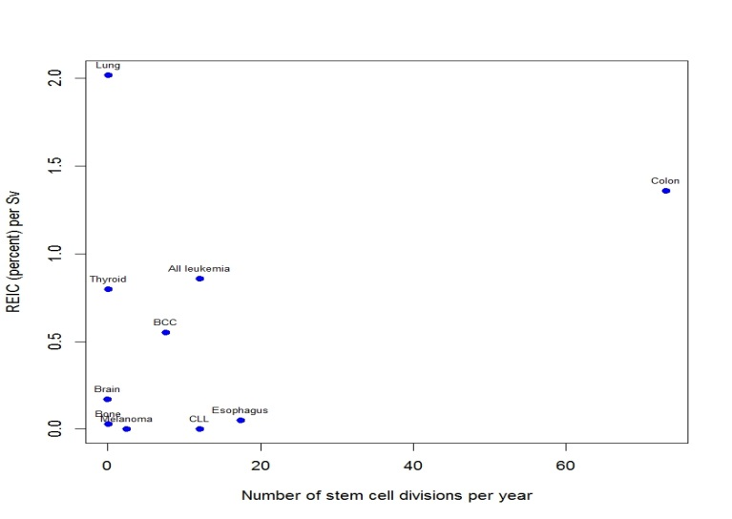
log₁₀[cumulative number of stem-cell divisions]
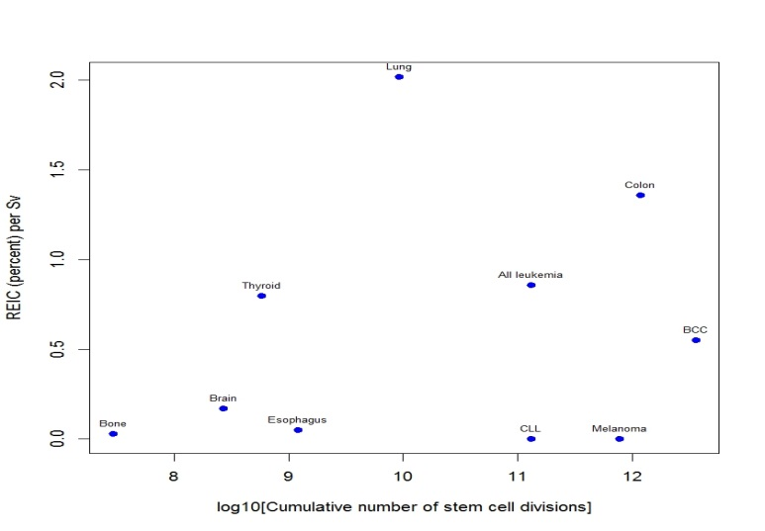
extra risk score
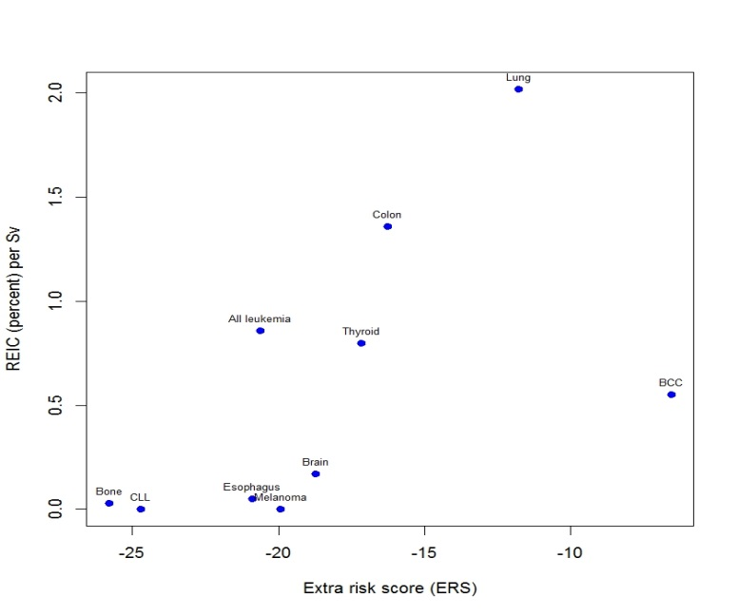

Figure B.
numbers of stem-cell divisions per year
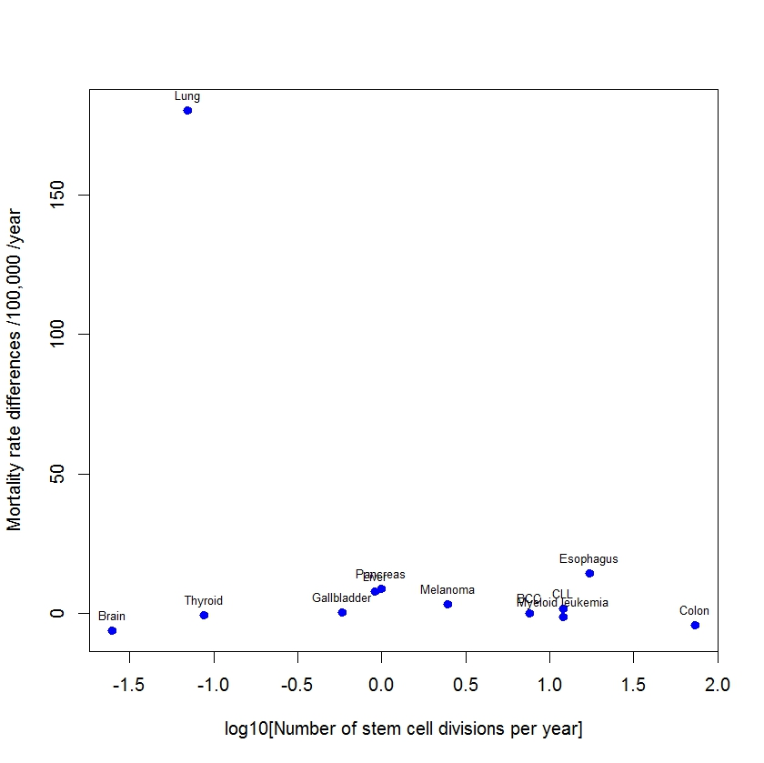
log₁₀[cumulative number of stem-cell divisions]
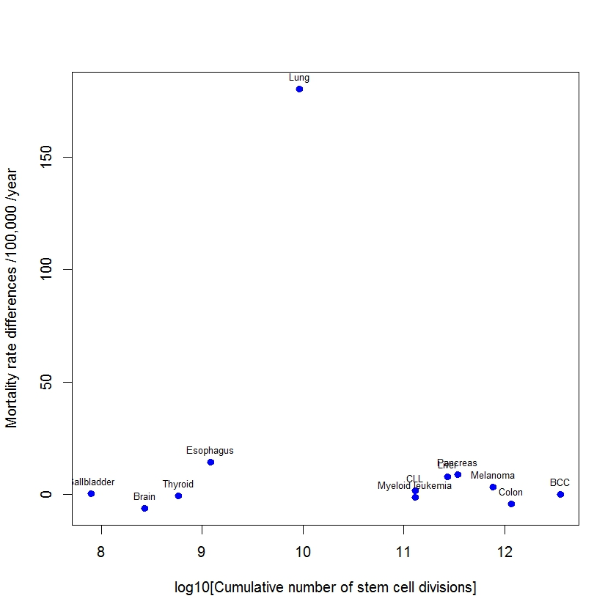
extra risk score
