ELISA data on clinical samples
For SLIT-2, the majority of the benign (48/52), Ta (41/46), T1 (34/36) and T2+ (28/29) samples were positive. Also, theT2+ samples showed a statistical difference compared to Benign and Ta groups (p-value<0.05). For SPARC, very few benign (4/20), Ta (2/21) and T1 (4/20) samples were positive compared to the T2+ positive samples (9/21). Furthermore, the T2+ samples showed a statistical difference compared to the other groups (*p-value<0.05). (Figs A, B)
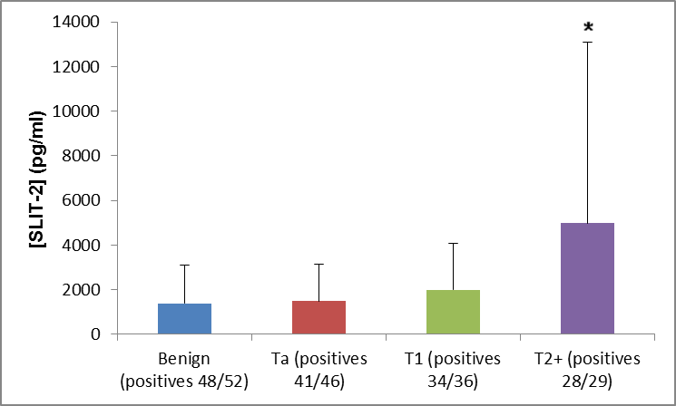
Figure A. ELISA data in urine samples (Benign controls and BC cases Ta, T1, T2+) for SLIT-2. (*p≤0.05)

Figure B. ELISA data in urine samples (Benign controls and BC cases Ta, T1, T2+) for SPARC. (*p≤0.05)

