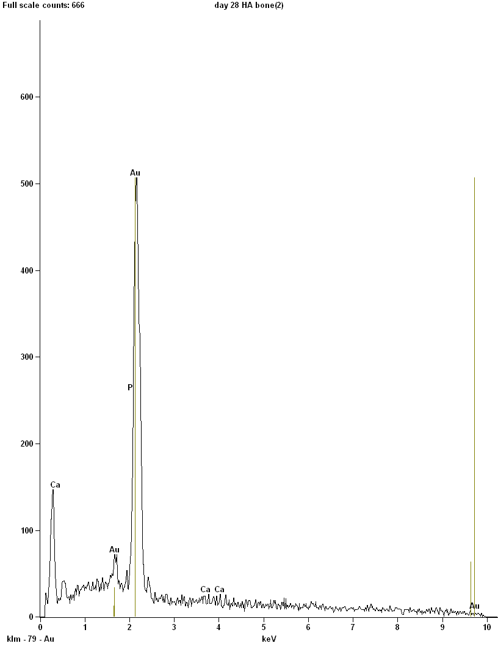

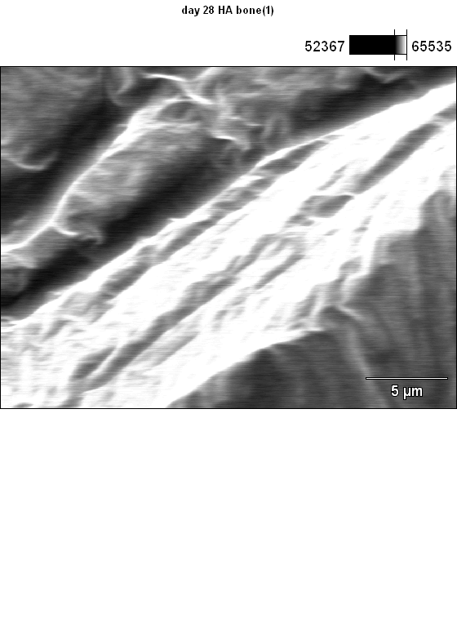

Accelerating Voltage: 10.0 kV Magnification: 4300

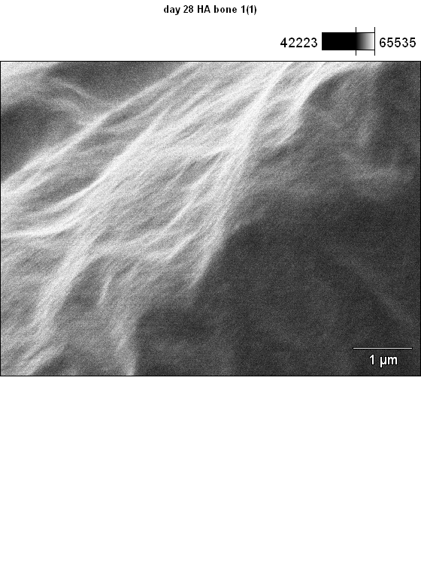

Accelerating Voltage: 10.0 kV Magnification: 17000

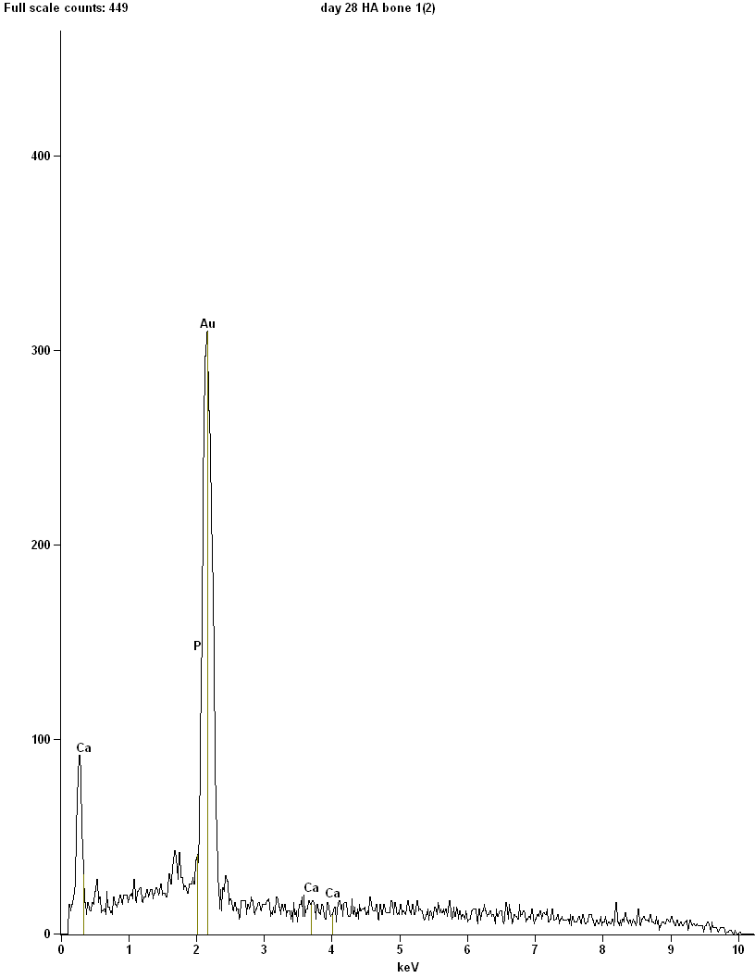

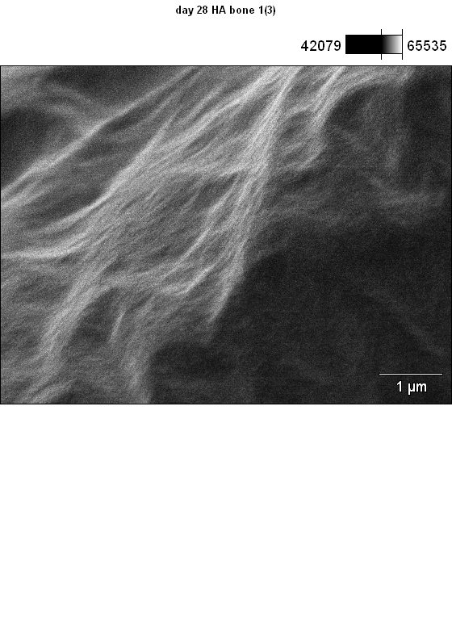

Accelerating Voltage: 10.0 kV Magnification: 17000

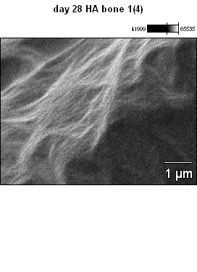 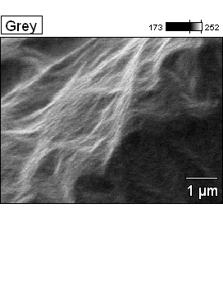

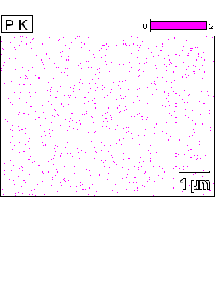 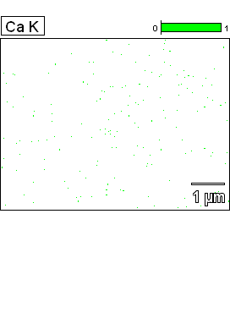

Data Type: Counts Mag: 17000 Acc. Voltage: 10.0 kV

 

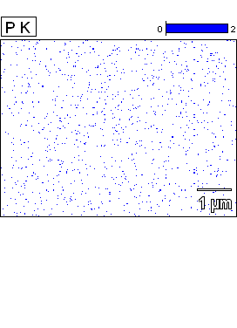 

Data Type: Counts Mag: 17000 Acc. Voltage: 10.0 kV

 

 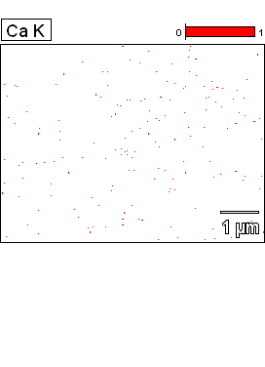

Data Type: Counts Mag: 17000 Acc. Voltage: 10.0 kV

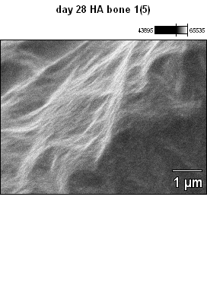 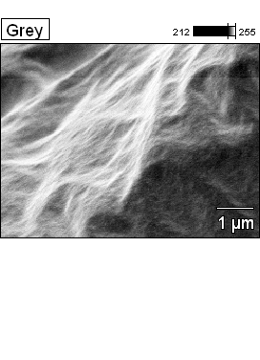

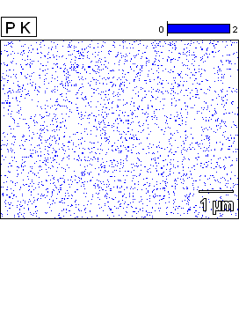 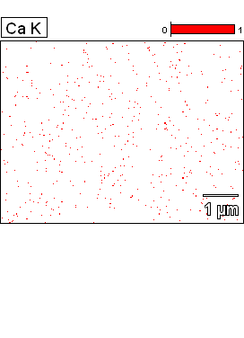

Data Type: Counts Mag: 17000 Acc. Voltage: 10.0 kV