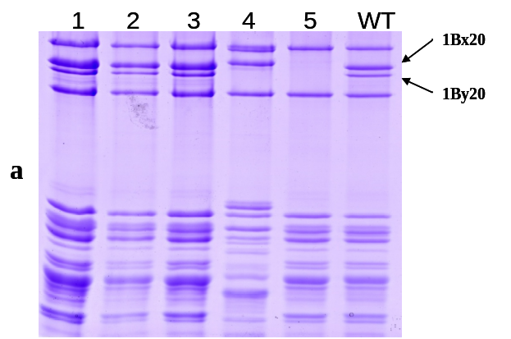

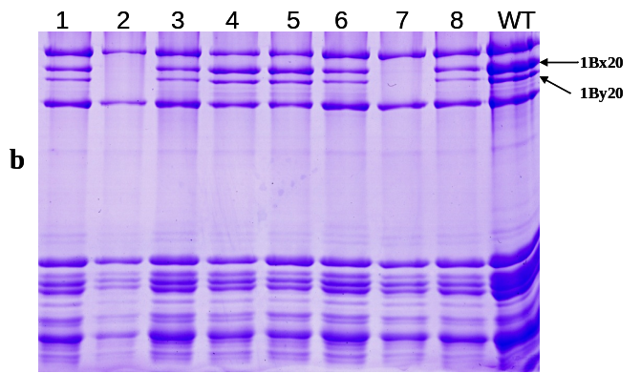

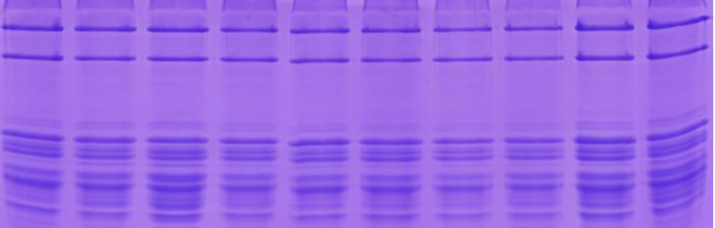

c

S1 Fig. Screening of wheat somatic variation mutants at the Glu-B1 locus in the tissue culture offspring of LX987 by SDS-PAGE. In the second generation derived from tissue culture (a), a plant was found to be missing 1Bx20 and 1By20 (sample 5). The plants from sample 5 appeared different bands for the composition of HMW-GS, some with and some without 1Bx20 and 1By20 in the third generation (b). Stable line AS208 was obtained from sample 5 in the fourth generation, in which the two bands of 1Bx20 and 1By20 were missed completely. WT stands for LX987.

