S1 Fig.
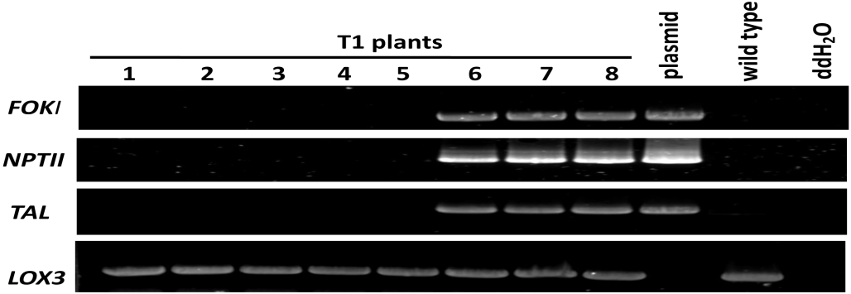
S1 Fig. The segregation of the TALEN transgene in T1 mutants.Gel images of PCR products obtained with the primer sets for FOKI, NPTII, TALE and LOX3.Lane 1~5 are representatives of T1 lines lack the T-DNA region; Lane6~8 are lines with T-DNA region.

