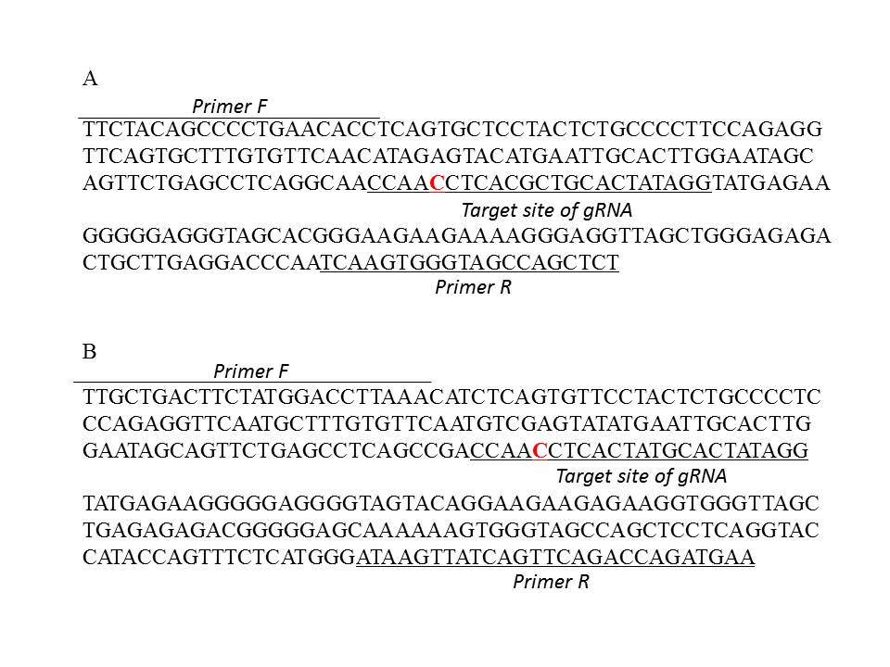
S1 Fig. Sequence of the mouse (A) and rat (B) Il2rg locus. Red capital letters indicate the position of the one base exchange.

