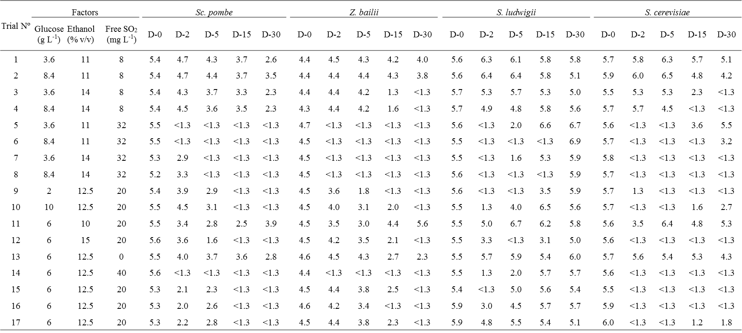
S1 Table. Growth of Sc. pombe, Z. bailii, S. lugwigii and S. cerevisiae in the test wine as a function of glucose, ethanol and sulphur dioxide concentrations.
D-0, D-2, D-5, D-15 and D-30 represent observations taken on 0, 2, 5, 15 and 30 days of incubation, respectively.

