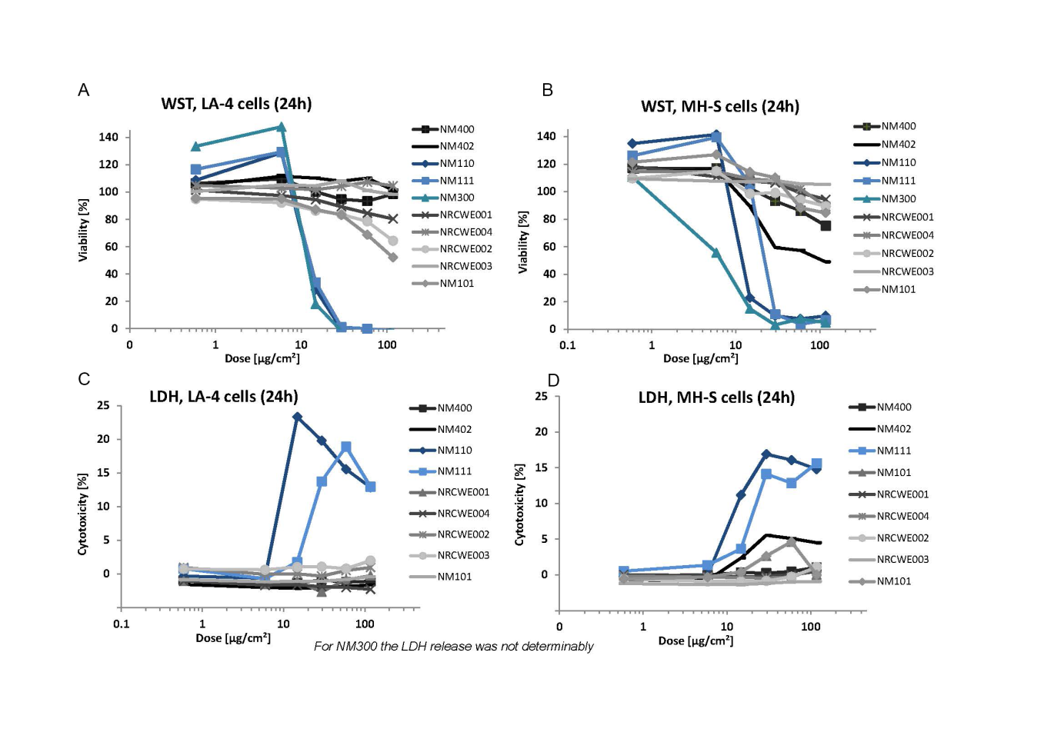
S1 Fig. Cell viability by WST-1 assay. A) LA-4 and B) MH-S cells 24 hours after incubation with ten different nanomaterials such as two types of MWCNTs (NM-400 and NM-402), two types of zinc oxide (non-functionalised NM-110 and functionalised NM-111), one type of silver (NM-300) and 5 types of TiO₂ (NRCWE001, NRCWE-002, NRCWE-003, NRCWE-004 and NM-101). Membrane damage was assessed by LDH release in C) LA-4 and D) MH-S cells 24 hours after incubation with the same nanomaterials except for NM-300.

