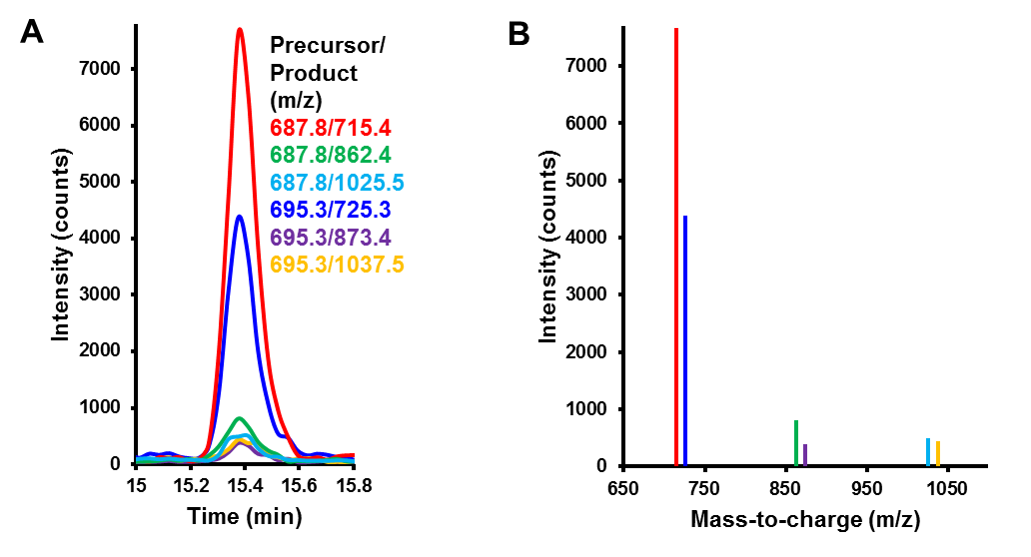

S3 Fig. Representative chromatogram and spectrum. Transitions for HDAC1,2 peptide YGEYFPGTGDLR in 5XFAD mouse brain hemisphere are shown as a (A) chromatogram and (B) spectrum. Chromatogram peaks of transitions are representative of data for other peptides in neural tissue. Peak areas were used for quantification.

