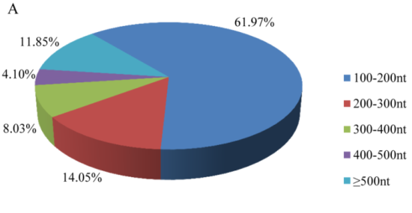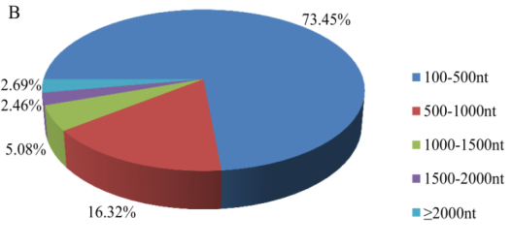
S1 Fig. Length distribution of P. pseudoannulata transcriptome sequences.

