Supporting information
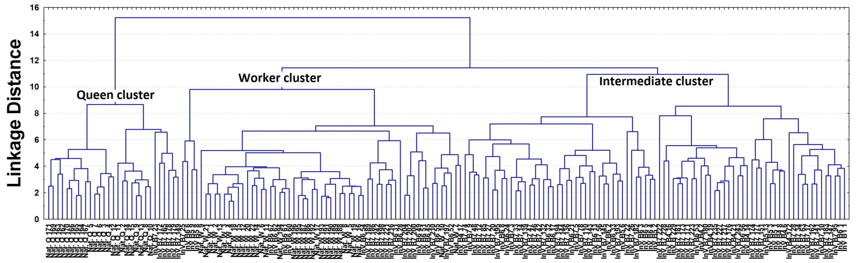
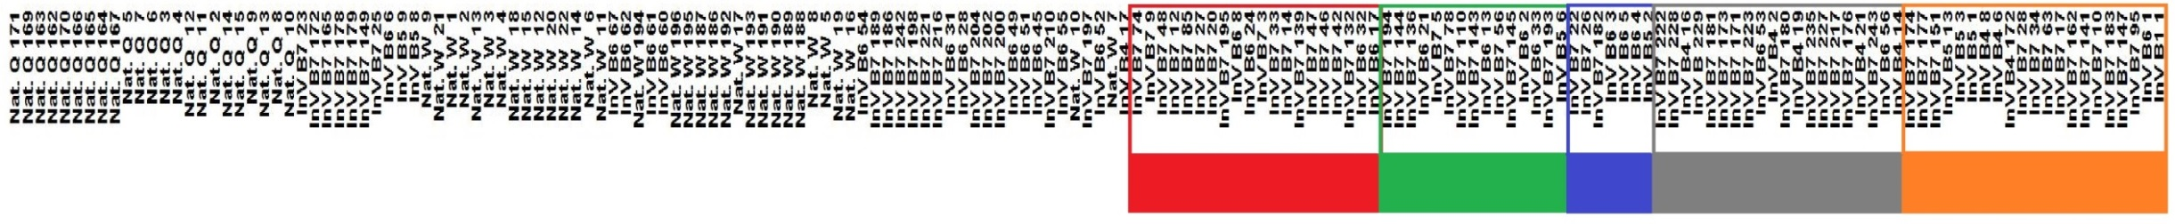

Figure S1: Dendrogram with the categorization of morphotypes based on morphological phenotypes in comparison to hive-reared bees. Sample identification is magnified (abbreviations, Nat. Q = Natural queen, Nat. W= Natural worker and InV = in vitro reared sample). In the branch indicated as "Intermediate Cluster", it is possible to define five sub-classifications (colored boxes) of these intermediate phenotypes, based on linkage distance as a function of different levels of morphological similarity.

