Figure S1. Regions recognized within GRIN gag overlaid onto IIIB



Figure S2. Regions recognized within GRIN Pol overlaid onto IIIB



Figure S3. Regions recognized within GRIN Nef overlaid onto IIIB



Figure S4. Regions recognized within GRIN ENV overlaid onto IIIB 

Figure S5. Upper panel representative flow plot of vaccine-induced Nef-specific CD8 response. Lower Panel SPICE plots of vaccine induced CD8 responses

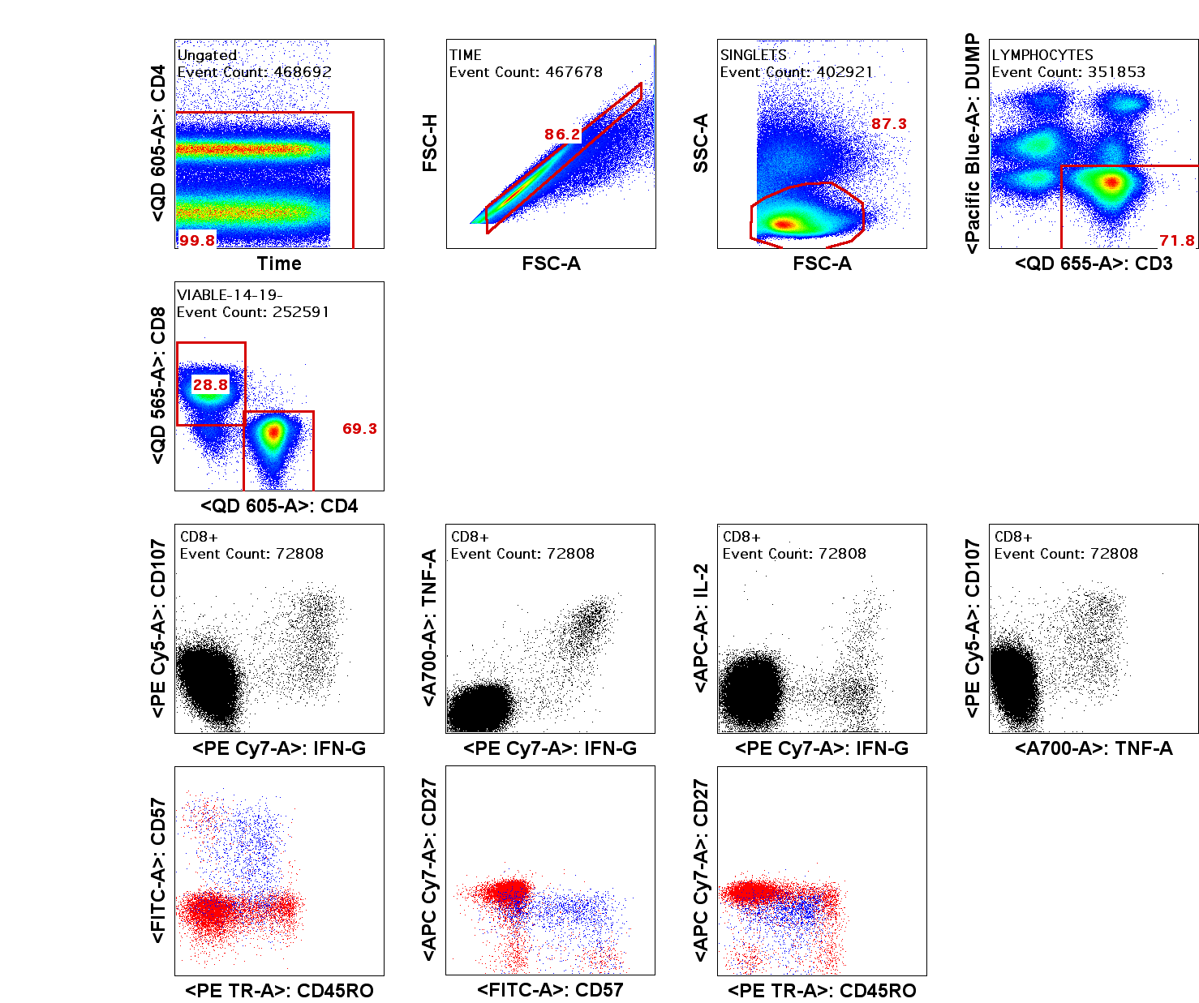

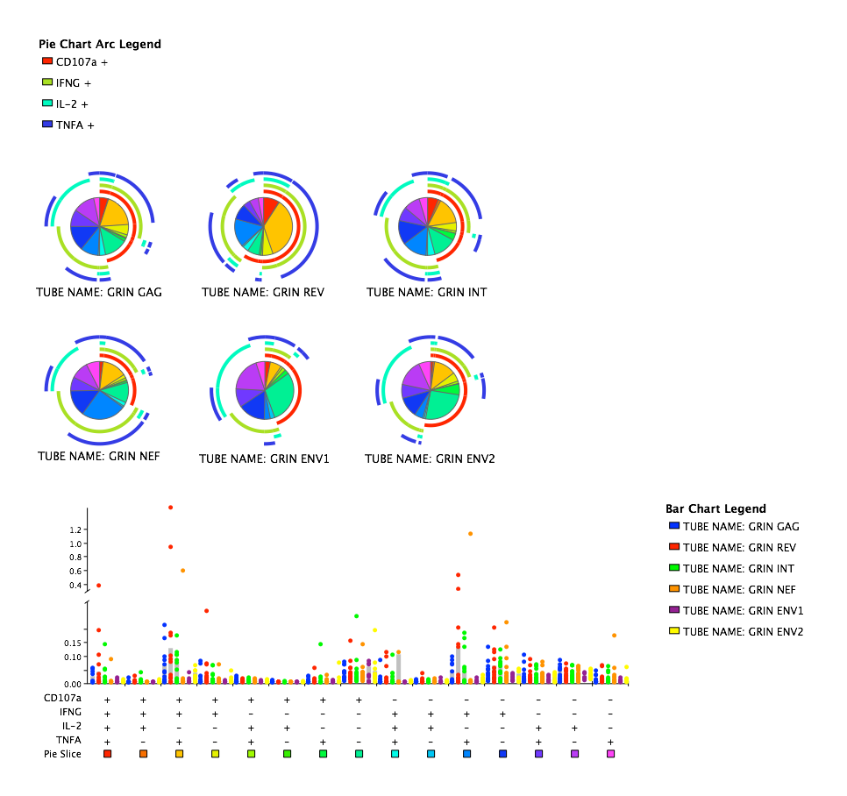

Table S1. Peptides mapped in vaccinees

|  |  |  |
| --- | --- | --- |
| PID | Antigen | Peptide |
| 005 | GAG | DAWEKIRLRPG |
| 005 | INT | MAVFIHNFKRKGGIG |
| 005 | INT | LQKQITKIQNFRVYYR |
| 005 | NEF | DSRLALKHRAQELHP |
| 005 | ENV | TRKSYRIGPGQTFYA |
| 005 | ENV | PCRIKQIIRMW |
| 010 | ENV | PCRIKQIIRMWQRVG |
| 017 | GAG | DRFALNPSLLETTEG |
| 017 | RT | KWTVQPIMLPDKESW |
| 017 | RT | KVAMESIVIWGKTPK |
| 017 | INT | SGIRKVLFLDG |
| 017 | INT | TSAAVKAACWWANIQ |
| 017 | ENV | PCRIKQIIRMW |
| 018 | INT | FNLPPIVAKEI |
| 025 | RT | STNNETPGVRY |
| 025 | RT | IYAGIKVKQLC |
| 028 | ENV | AVFLGFLGAAG |
| 030 | NEF | REVLIWKFDSRLALK |
| 036 | GAG | YKRWIILGLNK |
| 036 | RT | IYAGIKVKQLC |
| 040 | RT | KGSPAIFQSSM |
| 040 | RT | VQPIMLPDKESW |
| 040 | RT | ESIVIWGKTPK |
| 040 | ENV | EFNMWKNNMVD |
| 040 | ENV | ENIANNAKNIIVQFA |
| 040 | ENV | RAIEAQQQLLK |
| 040 | ENV | AMYAPPIEGVIRCES |
| 040 | ENV | KSYDDIWQNMTWLQW |
| 040 | INT | EFGIPYNPQSQGVVA |
| 048 | RT | EAELELAENRE |
| 048 | RT | QGQDQWTYQIYQ |
| 048 | RT | ESIVIWGKTPK |
| 048 | ENV | MHEDIISLWDQ |
| 048 | ENV | PCRIKQIIRMW |
| 053 | ENV | KQQVYSLFYRLDIEK |
| 053 | ENV | MHEDIISLWDQSLKP |
| 070 | GAG | GATPQDLNVML |
| 070 | ENV | VTVYYGVPVWRDAET |
| 070 | ENV | ENIANNAKNIIVQFA |
| 072 | RT | WASQIYAGIKVKQLC |
| 072 | ENV | KVTFEPIPIHYCAPA |
| 072 | ENV | INCIRPNNNTRKSYRI |
| 072 | ENV | PCRIKQIIRMW |
| 076 | GAG | DRFALNPSLLE |
| 076 | GAG | LFNTVATLYCV |
| 076 | RT | ETFYVDGAANR |
| 076 | INT | PAETGQETAYF |
| 076 | ENV | EFNMWKNNMVDQMHE |
| 076 | ENV | LRKYFSNKTIIFTNS |
| 076 | ENV | SNLLRAIEAQQQLLK |
| 078 | ENV | PGQTFYATDIVGDIR |
| 078 | ENV | PCRIKQIIRMWQRVG |
| 082 | INT | KLVSSGIRKVLFLDG |
| 082 | INT | FNLPPIVAKEI |
| 082 | INT | THLEGKVILVAVHVA |
| 082 | INT | YYRDSRDPIWK |
| 082 | RT | YARKRSAHTNDVRQL |
| 081 | GAG | DRFALNPSLLE |
| 081 | RT | WASQIYAGIKVKQLC |
| 081 | ENV | EFNMWKNNMVD |
| 081 | ENV | RYLRDQQLLGI |
| 085 | GAG | LFNTVATLYCV |
| 085 | GAG | KALRAEQATQDVKGW |
| 085 | GAG | DRFALNPSLLE |
| 085 | RT | IEELRAHLLSW |
| 085 | RT | TYQIYQEPFKNLKTG |
| 085 | RT | WETWWMDYWQATWIPE |
| 085 | INT | KLVSSGIRKVL |
| 085 | INT | EDHERYHSNWR |
| 085 | INT | FRVYYRDSRDPIWK |
| 116 | GAG | DAWEKIRLRPG |
| 116 | GAG | GATPQDLNVML |
| 116 | GAG | VGNIYKRWIILGLNK |
| 116 | NEF | EEEEVGFPVR |
| 116 | NEF | IWKFDSRLALKHRAQELHP |
| 120 | RT | YNVLPQGWKGSPAIF |
| 120 | RT | EVVQKVAMESI |
| 120 | INT | EFGIPYNPQSQGVVA |
| 120 | NEF | EEEEVGFPVR |
| 135 | INT | FNLPPIVAKEI |
| 136 | GAG | EQKDREQVPPLVSLK |
| 136 | RT | ISPIETVPVTL |
| 136 | RT | IEELRAHLLSW |
| 139 | GAG | YKRWIILGLNK |
| 145 | GAG | DAWEKIRLRPG |
| 145 | RT | VHGVYYDPSKDLVAE |
| 145 | NEF | IWKFDSRLALK |
| 145 | RT | WIPEWEFVNTP |
| 154 | GAG | DRFALNPSLLETTEG |
| 154 | RT | GKLNWASQIYAGIKV |
| 154 | INT | TKIQNFRVYYR |
| 154 | NEF | REVLIWKFDSRLALK |

Table S2. Conservation Scores of putative CD8 epitopes

|  |  |  |  |  |  |  |  |
| --- | --- | --- | --- | --- | --- | --- | --- |
| GRIN | U455 | IIIB | ELI | CH77 | CH106 | 247FV02 | 97ZA012 |
| EDHERYHSNW | EDHEKYHCNW | DEHEKYHSNW | EEHEKYHNNW | EEHEKYHNNW | DEHEKYHSNW | EEHEKYHNNW | EDHEKYHSNW |
| Conserved | 0.80 | 0.70 | 0.70 | 0.70 | 0.70 | 0.70 | 1.00 |
| EEVGFPVR | WLEGFPVR | EEVGFPVT | DEVGFPVR | EEVGFPVR | EEVGFPVR | GEVGFPVR | EEVGFPVR |
| Conserved | 0.63 | 0.88 | 0.88 | 1.00 | 1.00 | 0.88 | 1.00 |
| IPYNPQSQGV | IPYNPQSQGV | IPYNPQSQGV | IPYNPQSQGV | IPYNPQSQGV | IPYNPQSQGV | IPYNPQSQGV | IPYNPQSQGV |
| Conserved | 1.00 | 1.00 | 1.00 | 1.00 | 1.00 | 1.00 | 1.00 |
| ETFYVDGAANR | ETFYVDGAANR | ETFYVDGAANR | ETFYVDGAANR | ETFYVDGAASR | ETFYVDGAANR | ETFYVDGAANR | ETFYVDGAANR |
| Conserved | 1.00 | 1.00 | 1.00 | 0.91 | 1.00 | 1.00 | 1.00 |
| LPPIVAKEI | LPPVVAKEI | LPPVVAKEI | LPPVVAKEI | LPPVVAKEI | LPPIVAKEI | LPPIVAKEI | LPPIVAKEI |
| Conserved | 1.00 | 1.00 | 1.00 | 1.00 | 0.89 | 0.89 | 0.89 |
| KIEELRAHL | KIEELRAHL | KIEELRQHL | KIEKLREHL | KIEELRQHL | KIEELREHL | KVEELREHL | KIEDLRQHL |
| Conserved | 1.00 | 0.89 | 0.78 | 0.89 | 0.89 | 0.78 | 0.78 |
| WKFDSRLALK | WKFDSTLALK | ---------- | WRFNSRLAFE | WRFDSRLAFQ | WKFDSRLAFH | WKFDSHLARR | WEFDSSLARR |
| Conserved | 0.90 | 0.00 | 0.60 | 0.70 | 0.80 | 0.70 | 0.60 |
| AEQATQDVKGW | AEQATQDVKNW | AEQASQEVKNW | AEQASQDVKNW | AEQASQEVKNW | AEQASQDVKNW | AEQATQDVKNW | AEQATQEVKNW |
| Conserved | 0.91 | 0.73 | 0.82 | 0.73 | 0.82 | 0.91 | 0.82 |
| SPAIFQSSM | SPSIFQSSM | SPAIFQSSM | SPAIFQSSM | SPAIFQSSM | SPAIFQSSM | SPAIFQSSM | SPAIFQSSM |
| Conserved | 0.89 | 1.00 | 1.00 | 1.00 | 1.00 | 1.00 | 1.00 |
| KVAMESIVIW | KVSTESIVIW | KITTESIVIW | RISTESIVIW | KISTESIVIW | KIAKESIVIW | KIALEGIVIW | KIALESIVIW |
| Conserved | 0.80 | 0.70 | 0.60 | 0.70 | 0.80 | 0.70 | 0.80 |
| LFNTVATLY | LYNTVAVLY | LYNTVATLY | LYNTVATLY | LYNTVAVLY | LFNTVAVLY | LYNTVATLY | LYNTVATLY |
| Conserved | 0.78 | 0.89 | 0.89 | 0.78 | 0.89 | 0.89 | 0.89 |
| MHEDIISLW | MHEDIISLW | MHEDIISLW | MHEDIISLW | MHEDVISLW | MHEDIISLW | MHEDIISLW | MHEDIISLW |
| Conserved | 1.00 | 1.00 | 1.00 | 0.89 | 1.00 | 1.00 | 1.00 |
| GQDQWTYQI | GQDQWTYQI | GQGQWTYQI | GHGQWTYQI | GQDQWTYQI | EQGQWTYQI | GNDQWTYQI | GDDQWTYQI |
| Conserved | 1.00 | 0.89 | 0.78 | 1.00 | 0.78 | 0.89 | 0.89 |
| RYLRDQQL | RYLQDQQL | RYLKDQQL | RYLKDQQL | RYLQDQQL | RYLRDQQL | RYLRDQQL | RYLKDQQL |
| Conserved | 0.88 | 0.88 | 0.88 | 0.88 | 1.00 | 1.00 | 0.88 |
| RAIEAQQQLL | RAIEAQQHLL | RAIEAQQHLL | RAIEAQQHLL | RAIEAQQHLL | RAIEAQQHML | KAIEAQQHML | RAIEAQQHML |
| Conserved | 0.90 | 0.90 | 0.90 | 0.90 | 0.80 | 0.70 | 0.80 |
| NNETPGVRY | NNETPGVRY | NNETPGIRY | NNETPGIRY | NNETPGIRY | NNETPGIRY | NNETPGIRY | NNETPGIRY |
| Conserved | 1.00 | 0.89 | 0.89 | 0.89 | 0.89 | 0.89 | 0.89 |
| NIYKRWII | DIYRRWII | EIYKRWII | EIYKRWII | EIYKRWII | EIYKRWII | DIYKRWII | DIYKRWII |
| Conserved | 0.75 | 0.88 | 0.88 | 0.88 | 0.88 | 0.88 | 0.88 |
| IMLPDKESW | IQLPEKDSW | IVLPEKDSW | IKLPEKESW | IVLPEKDSW | IKLPEKDSW | IKLPEKDSW | IQLPEKDSW |
| Conserved | 0.89 | 0.89 | 0.78 | 0.89 | 0.89 | 0.89 | 0.89 |
| QIYAGIKVK | QIYAGIKVK | QIYPGIKVR | QIYPGIKVR | QIYPGIKIK | QIYAGIKVR | QIYPGIKVK | QIYPGIKVR |
| Conserved | 1.00 | 0.78 | 0.78 | 0.89 | 0.89 | 0.89 | 0.78 |
| KRWIILGLNK | RRWIILGLNK | KRWIILGLNK | KRWIIVGLNK | KRWIILGLNK | KRWIILGLNK | KRWIILGLNK | KRWIIMGLNK |
| Conserved | 0.90 | 1.00 | 0.90 | 1.00 | 1.00 | 1.00 | 0.90 |

Table S3. Inhibition levels and percentages of all viruses used in the VIA panel.

|  |  |  |  |  |  |  |  |
| --- | --- | --- | --- | --- | --- | --- | --- |
| Virus | Clade | Mean log VIA | Median log VIA | Low log VIA | High log VIA | # inhibited by vaccinees | % inhibited |
| U455 | A | 3.10 | 3.28 | 1.12 | 4.3 | 23 | 95.8 |
| IIIB | B | 2.36 | 1.94 | 0.65 | 4.96 | 17 | 70.8 |
| 247FV2 | C | 2.01 | 1.69 | 0.03 | 4.17 | 15 | 62.5 |
| CHO77 | B | 1.77 | 1.64 | 0.39 | 4.81 | 14 | 58.3 |
| CH106 | B | 1.37 | 1.31 | 0.26 | 3.26 | 10 | 41.7 |
| ZA97012 | C | 1.03 | 0.72 | 0 | 4.16 | 5 | 20.8 |
| ELI | D | 0.88 | 0.77 | 0.25 | 2.33 | 3 | 12.5 |