Bertheleme et al,

Supplementary Information

Table S1 Oligos used to generate the mutant receptor constructs

Primer | Sequence (5' to 3')
A79F_forward | gatgttgggtgtttacttgcgtattttcttggctgccaga
A79F_reverse | taccaaaacgaagcaagcaataaacaaacaaccatgacaagcagc
L184A_forward | catggtctacttcaatttcttcgcgtgtgttttggtccctttgttg
L184A_reverse | ggagaagatagaagattgagtcaaaaccaaaacgaagcaag
A199R_forward | ctaagtccttggctattatagttggtttgttcgctttgtgttg
A199R_reverse | gcaatgatgcccgcagccctcgtgccggtca
A208L_forward | ctattttcttggctgccagaagacaactaaagcaaatggaatctcaacc
A208L_reverse | ggttgagattccatttgctttagttgtcttctggcagccaagaaaatag
A272L_forward | tcatgctccattgtggttgatgtatctagctatagttttgtcccacac
A272L_reverse | gtgtgggacaaaactatagctagatacatcaaccacaatggagcatga

Table S2 Expression levels of the thirty mutants and the wild-type calculated using the eGFP fluorescence as described by Drew et al. (2008, Nature Protocols, 3: 784-798).

 | RFU | Level of Expression (mg/L)
Rag 23.1 | 16,843 | 0.6
Rag 23.2 | 20,715 | 1.1
Rag 23.3 | 22,439 | 1.2
Rag 23.4 | 19,046 | 0.9
Rag 23.5 | 16,389 | 0.6
Rag 23.6 | 20,479 | 1.0
Rag 23.7 | 23,799 | 1.4
Rag 23.8 | 14,547 | 0.4
Rag 23.9 | 19,162 | 0.9
Rag 23.10 | 17,677 | 0.7
Rag 23.11 | 18,500 | 0.8
Rag 23.12 | 19,021 | 0.9
Rag 23.13 | 20,392 | 1.0
Rag 23.14 | 18,314 | 0.8
Rag 23.15 | 18,906 | 0.9
Rag 23.16 | 21,423 | 1.2
Rag 23.17 | 20,992 | 1.1
Rag 23.18 | 21,782 | 1.2
Rag 23.19 | 23,018 | 1.3
Rag 23.20 | 22,388 | 1.2
Rag 23.21 | 16,312 | 0.6
Rag 23.22 | 14,803 | 0.4
Rag 23.23 | 15,874 | 0.5
Rag 23.24 | 19,569 | 0.9
Rag 23.25 | 14,356 | 0.4
Rag 23.26 | 15,904 | 0.6
Rag 23.27 | 16,984 | 0.7
Rag 23.28 | 19,843 | 1.0
Rag 23.29 | 20,120 | 1.0
Rag 23.30 | 18,013 | 0.8
WT | 19,954 | 1.0

Figure S1 NECA-induced activity of the WT A_{2A}R, Rag23 and the quadruple mutants intermediate between the WT and Rag23. See Table 1 for the precise details of each mutant. The receptor constructs were expressed in the MMY24 S. cerevisiae strain using the p306GPD vector. The activity of cells containing empty vector is shown as a control.

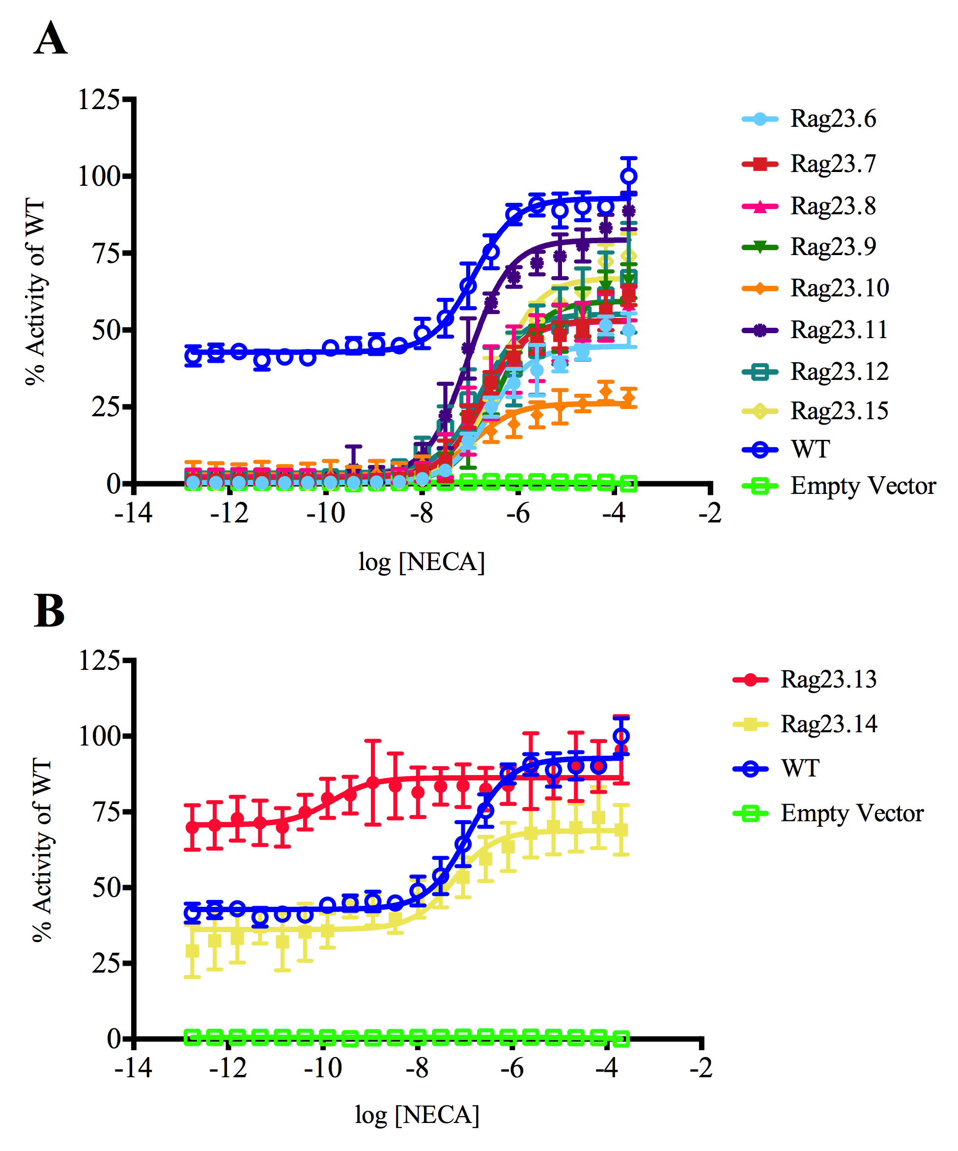
Figure S2A and B NECA-induced activity of the WT A_{2A}R and the triple mutants intermediate between the WT and Rag23. See Table 1 for the precise details of each mutant. The receptor constructs were expressed in the MMY24 S. cerevisiae strain using the p306GPD vector. The activity of cells containing empty vector is shown as a control.

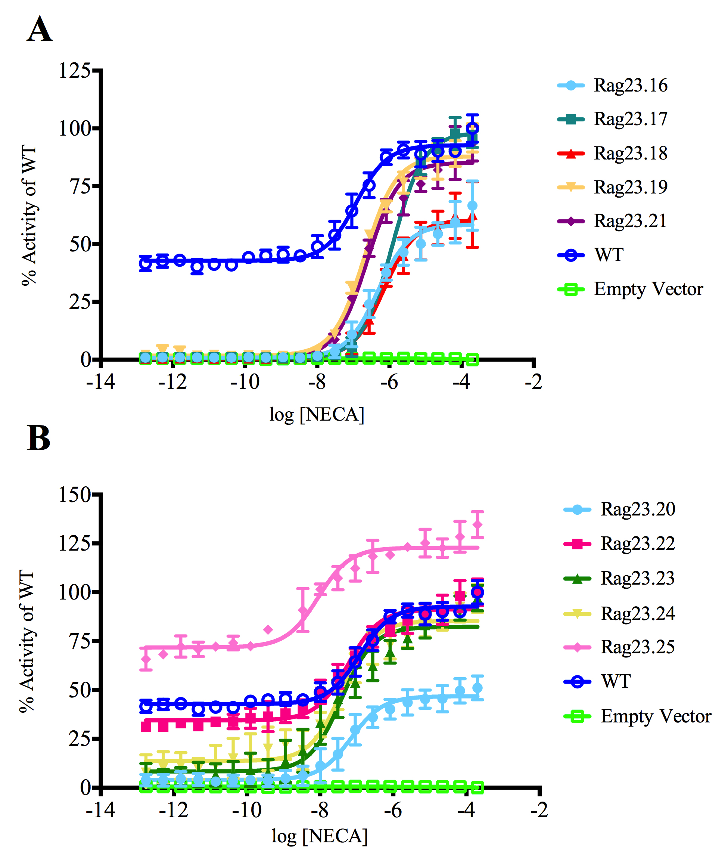
Figure S3A and B NECA-induced activity of the WT A_{2A}R and the double mutants intermediate between the WT and Rag23. See Table 1 for the precise details of each mutant. The receptor constructs were expressed in the MMY24 S. cerevisiae strain using the p306GPD vector. The activity of cells containing empty vector is shown as a control.

Figure S4 NECA-induced activity of the WT A_{2A}R and the single mutants intermediate between the WT and Rag23. See Table 1 for the precise details of each mutant. The receptor constructs were expressed in the MMY24 S. cerevisiae strain using the p306GPD vector. The activity of cells containing empty vector is shown as a control.

