Table S1. OCT4 and its pseudogenes

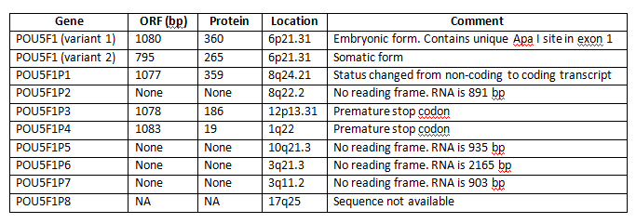
Source: http://www.ncbi.nlm.nih.gov/sites/entrez

