Figure S5: p63 as a positive control phenotype for gene signature generation. A). Identifications of genes differentially expressed (Rank product) between p63 positive and negative cervix cell lines (pfp<0.01) B). Identifications of genes differentially expressed between p63 positive and negative head and neck cell lines (pfp<0.01) C). Table of 62 common and congruent differentially expressed (DE) Genes determined by Rank Product Analysis

P63 negative (western)
P63 positive (western)
A) 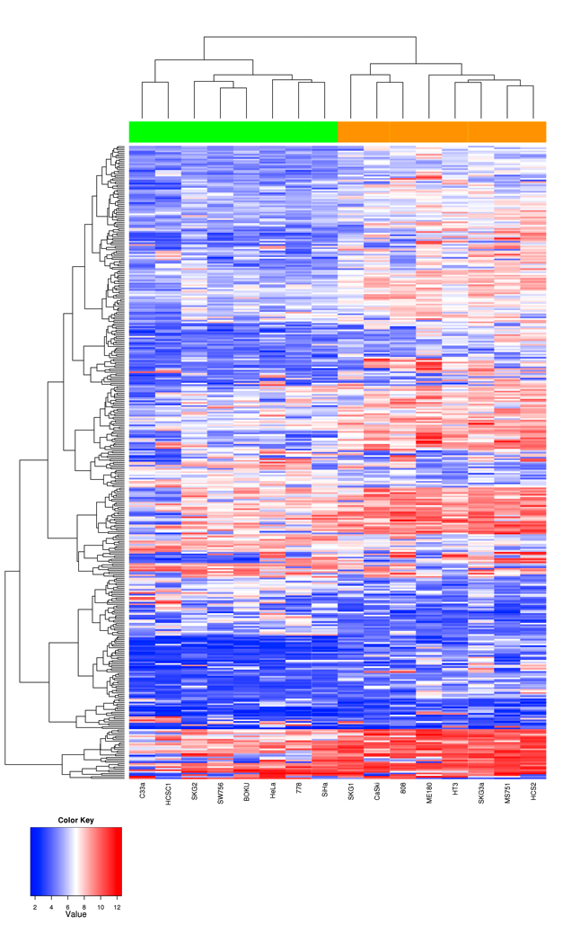B) 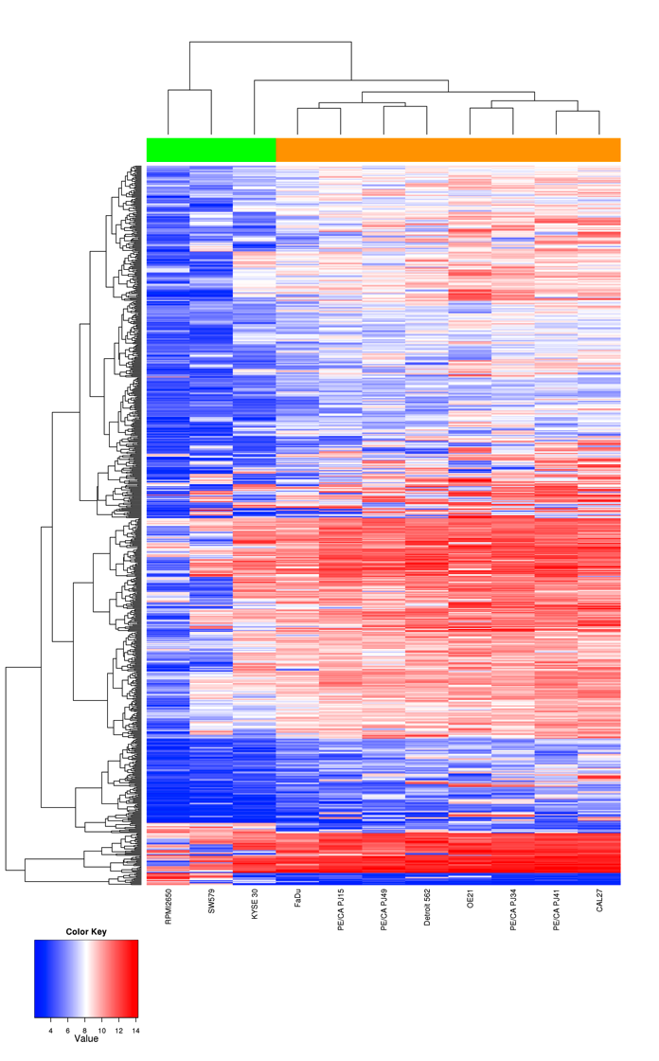

C)
CTA-55I10.1  CSTA  TP63  SERPINB13  DSC3  DSG3  ESRP1  KRT5  DSC2  CDH1  CLCA2  KRT13  IL1A  ITGB6  OLR1 | SFN  DSP  KYNU  IRF6  GPX2  GRHL2  TMEM30B  LPAR3  MAL2  PRRG4  TRIM29  ZNF750  PTHLH  F11R  CD44  GALNT3 | RASEF  LAMC2  GJB5  S100A14  MAST4  ITGA6  IL8  THBD  CXCL16  LPAR6  SAMD9  TACSTD2  IFI16  IGFBP3  IFI44  GM2A | FGFBP1  DAPP1  FYB  IL20RB  IRX2  CASP1  IL1RAP  SOX15  CA2  KCNJ15  SERPINB4  C10orf116  PDPN  ZNF165  BNC1

