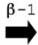
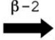
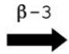

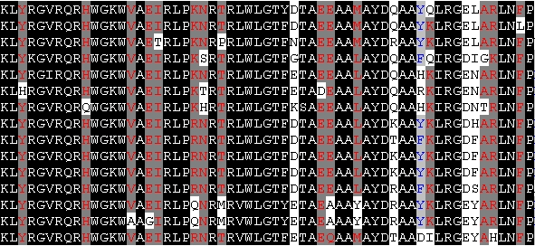
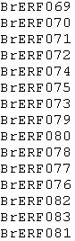
Ⅰ
AP2 domain
★
★
★
★
★
★
★
LxxxvVxxKLxxI
LxKxPSxxIDxxWxxI
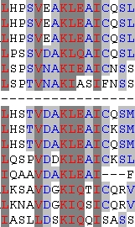
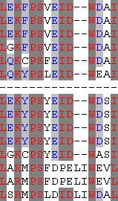

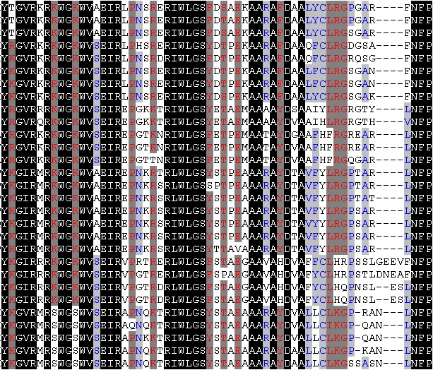
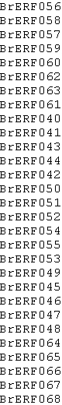
Ⅱ
AP2 domain

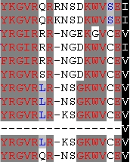
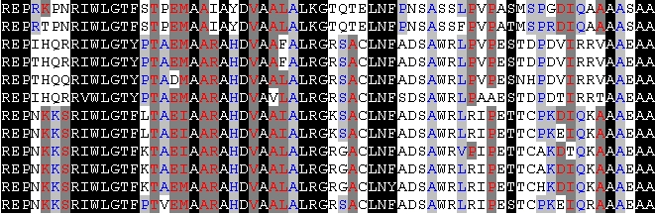
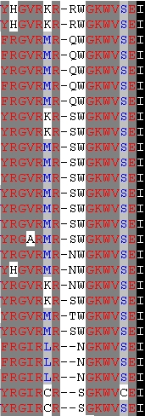
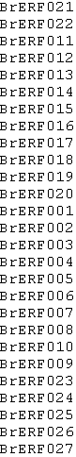
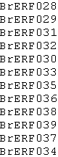
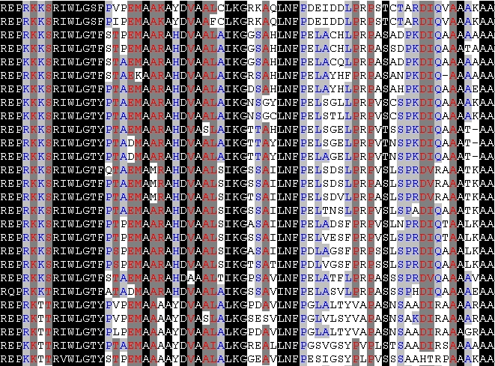
Ⅲ
AP2 domain

A rich
LPxL

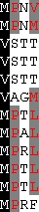

KKGCMKGKGGPEN
AP2 domain
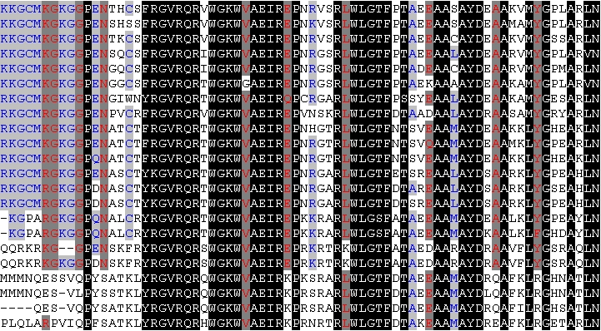
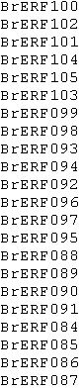

Ⅳ

Figure S1A
Alignment of the AP2/ERF domains and additional domains of each DREB subfamily group (GroupⅠ~Ⅳ) from B. rapa. All groups had representative AP2 domains. Additionally, Group Ⅰhad another two conserved consensus sequences, Group Ⅲ had an A-rich region and consensus sequences [LPxL], Group Ⅳ also had one conserved consensus sequences. The black background represented the most conserved amino acid residues in each group. The black bar and arrows represented predicted α-helix and β-sheet regions, respectively, within the AP2/ERF domain. Asterisks represented amino acid residues that directly make contact with DNA (Allen et al., 1998).

AP2 domain
★
★
★
★
★
★
★
QMIEELL
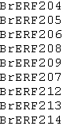
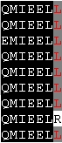
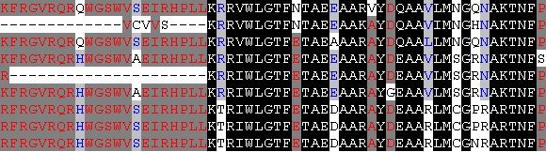
Ⅴ

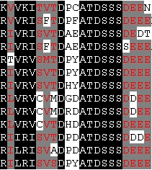
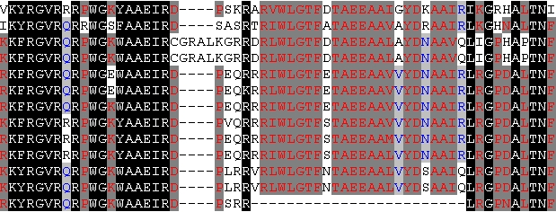
CRF domain
AP2 domain
MAPK
TEH
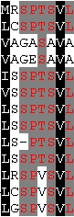
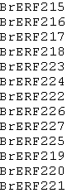
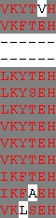

Ⅵ

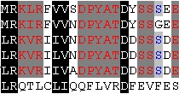
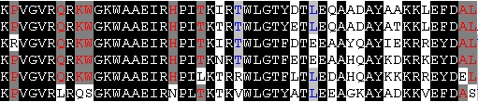
CRF domain
AP2 domain
LPDxDFxD
FNxxxLxIP

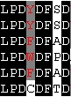
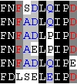
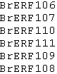
Ⅵ-L

AP2 domain
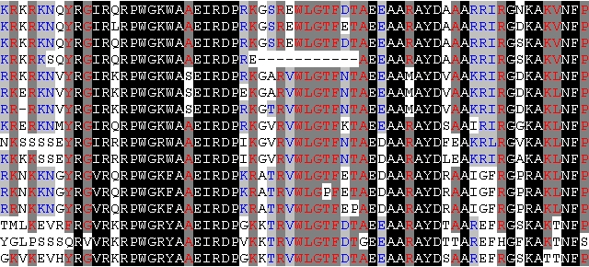
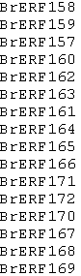

Ⅶ

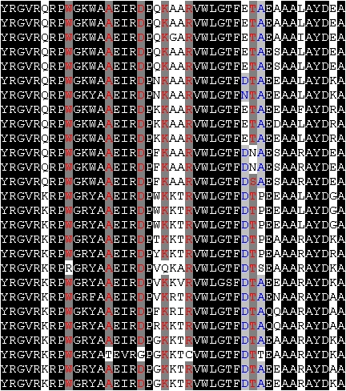
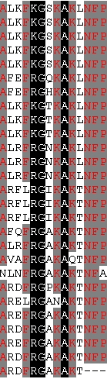
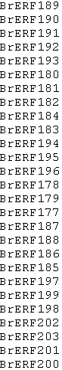
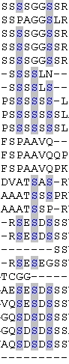
Ⅷ
AP2 domain
Ser rich region

AP2 domain
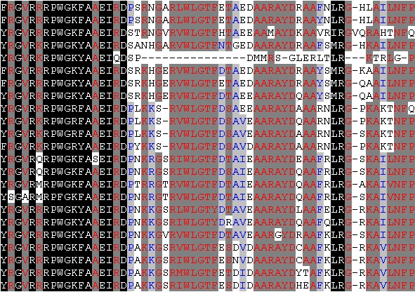
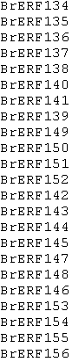
Ⅸ

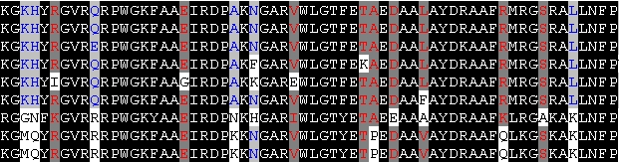
AP2 domain
Ser rich region
Ser rich region
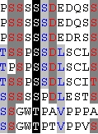
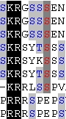
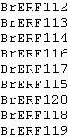
Ⅹ

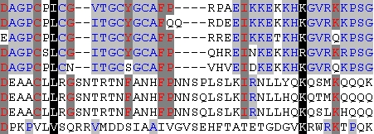
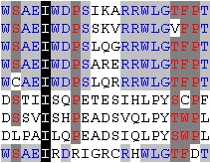
AP2 domain
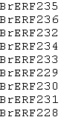
Ⅹb-L

AP2 domain

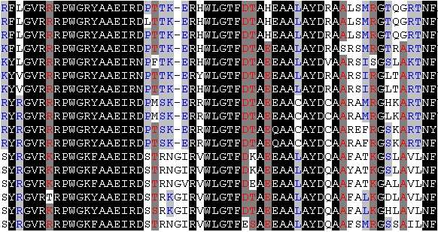
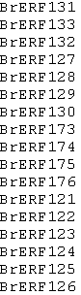
ⅩI

Figure S1B
Alignment of the AP2/ERF and additional domains of each ERF subfamily group (GroupⅤ~Ⅺ) from B. rapa. All groups had representative AP2 domains. Additionally, Group Ⅴhad consensus sequences [QMIEELL], Group Ⅵ had a conserved CRF domain, a TEH region and a putative MAP kinase phosphorylation site. Group Ⅵ-L had a conserved CRF domain and consensus sequences [FNxxxLxIP], [LPDxDFxD]. Group Ⅷ and Group Ⅹ had Ser rich region in N or C terminal ends. The black background represented the most conserved amino acid residues in each group. The black bar and arrows represented predicted α-helix and β-sheet regions, respectively, within the AP2/ERF domain. Asterisks represented amino acid residues that directly make contact with DNA (Allen et al., 1998).

AP2 domain I
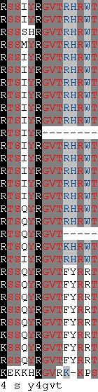
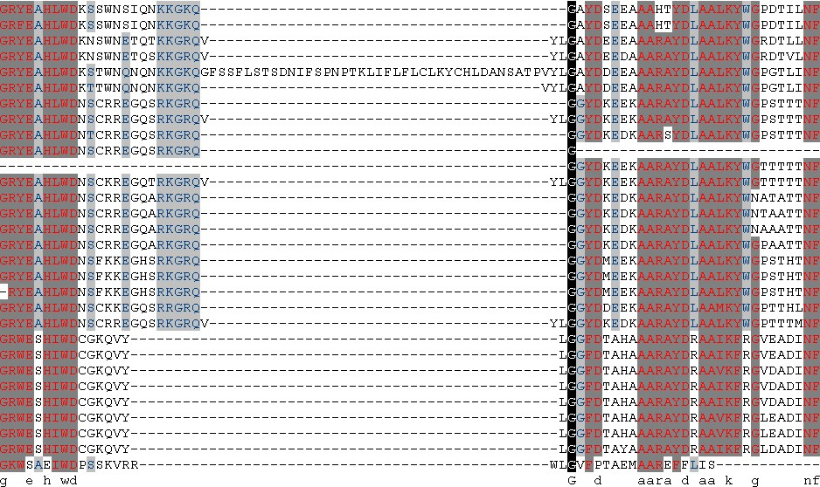
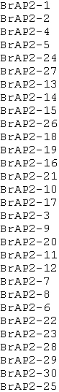
AP2
Subfamily

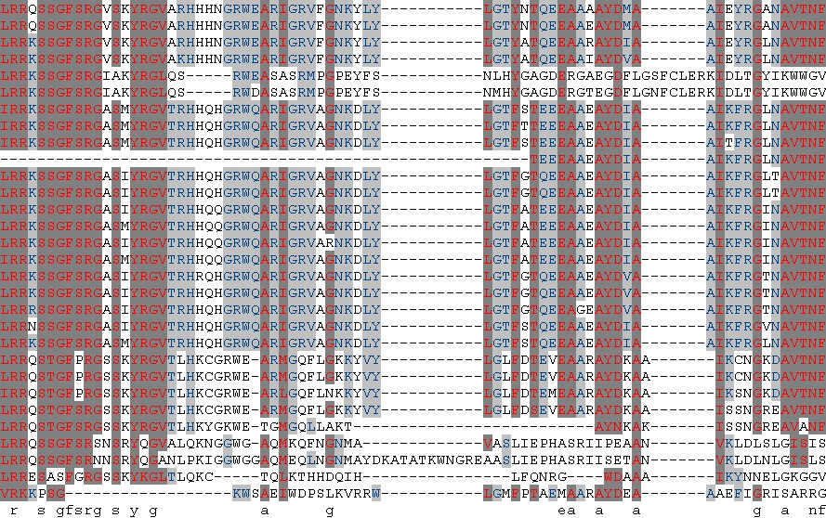
AP2 domainⅡ

Figure S1C
Alignment of the AP2/ERF domains of AP2 subfamily from B. rapa. The black background represented the most conserved amino acid residues in each group. Each AP2 subfamily member had two AP2/ERF domains, AP2 domain Ⅰand AP2 domain Ⅱ.

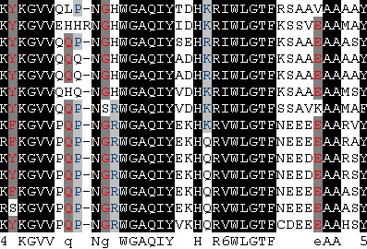
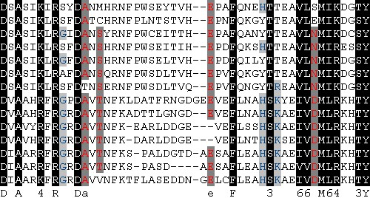
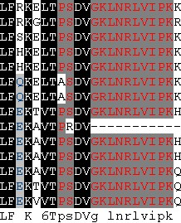
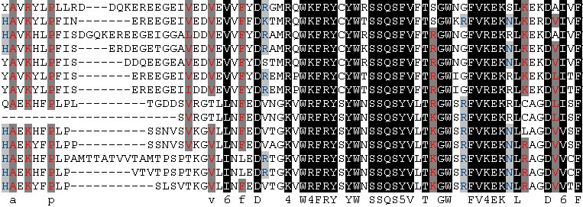
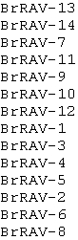
AP2 domain
B3 domain
Figure S1D
Alignment of the AP2/ERF and B3 domains of RAV subfamily from B. rapa. The black background represented the most conserved amino acid residues in each group. Each RAV subfamily member had an AP2/ERF domain and a B3 domain.
RAV
Subfamily

