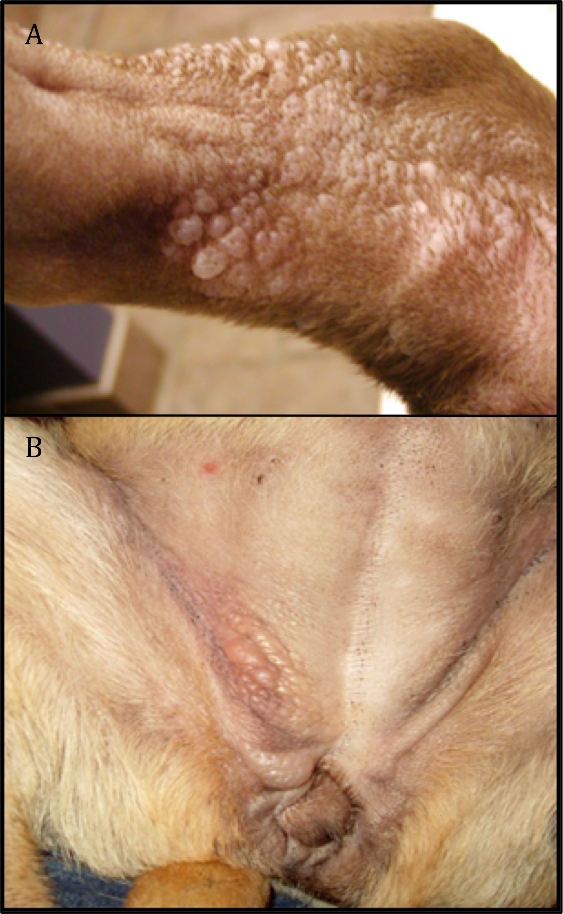

Figure S1. Examples of vesicular hyaluronosis. The Shar-Pei breed specific dermatological changes display as vesicles on the surface of the skin. Manifestations are typically seen on the (A) upper legs, (B) belly, chest, ventral neck and flanks. The vesicles are filled with hyaluronan and easily rupture which can lead to secondary infections.

