SUPPORTING FIGURE S3 for

A template-free, ultra-adsorbing, high surface area carbonate nanostructure

Johan Forsgren, Sara Frykstrand, Kathryn Grandfield, Albert Mihranyan, and Maria Strømme

S3. FTIR spectrum for the intermediate product formed during the first reaction step
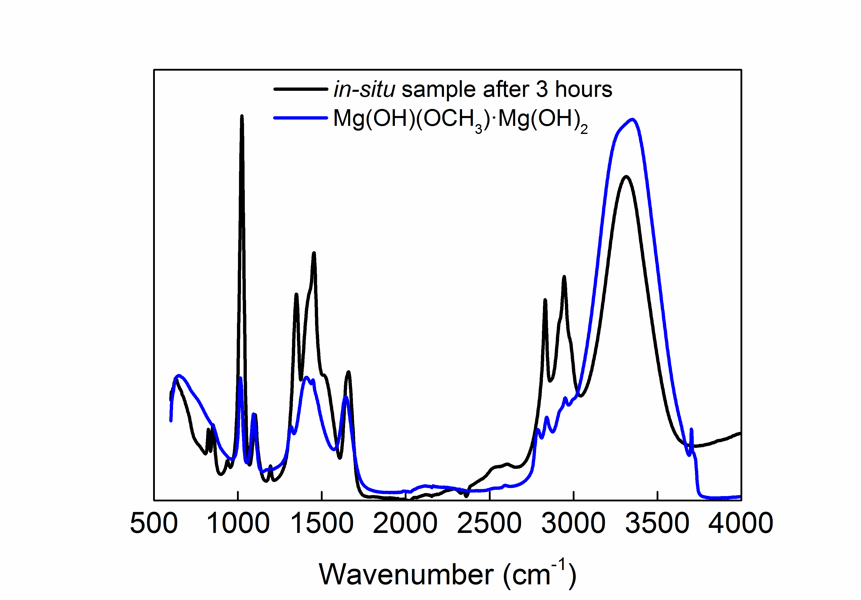
Figure S3. FTIR spectrum for the in-situ sample collected from the reaction vessel after 3 hours of reaction, together with a reference sample.

A small sample was withdrawn from the liquid in the reaction vessel after 3 h of reaction. The obtained sample was analysed with FTIR in order to establish its constituents, see Fig. S3. A reference sample consisting of Mg(OH)(OCH₃)·Mg(OH)₂ was prepared by hydrolysis of Mg(OCH₃)₂ as described by Ranjit and Klabunde.¹ The sharp band at 3740 cm⁻¹ for the reference sample is indicative of isolated –OH groups. Since the spectrum for the in situ-sample lacks this sharp band, it can be argued that this sample does not contain Mg(OH)₂. The broad band around 3400 cm⁻¹ for both samples are indicative of hydrogen bonded –OH groups, and the sharp bands between 2920 cm⁻¹ and 2790 cm⁻¹, as well as the band at 1100 cm⁻¹, are all indicative of the presence of –OCH₃ groups. The presence of carbonate groups is clear from the bands between 1650 cm⁻¹ and 1440 cm⁻¹, while the band around 1030 cm⁻¹ is assigned to the v_{C-O} stretch in the methanol in the sample. The band around 540 cm⁻¹ is indicative of the Mg-O bond. Since the spectrum for the in-situ sample shares the characteristics of Mg(OH)(OCH₃) that has been described and well characterised earlier by Ranjit and Klabunde, we believe that one intermediate product in the synthesis of Upsalite is indeed the OHMgOCH₃ as described in step 1a of the reaction scheme.

SUPPORTING REFERENCE
1 Ranjit, K. T.; Klabunde, K. J. Solvent Effects in the Hydrolysis of Magnesium Methoxide, and the Production of Nanocrystalline Magnesium Hydroxide. An Aid in Understanding the Formation of Porous Inorganic Materials. Chem. Mater. 2005, 17, 65-73.

