A: Protein sequences

ThiS
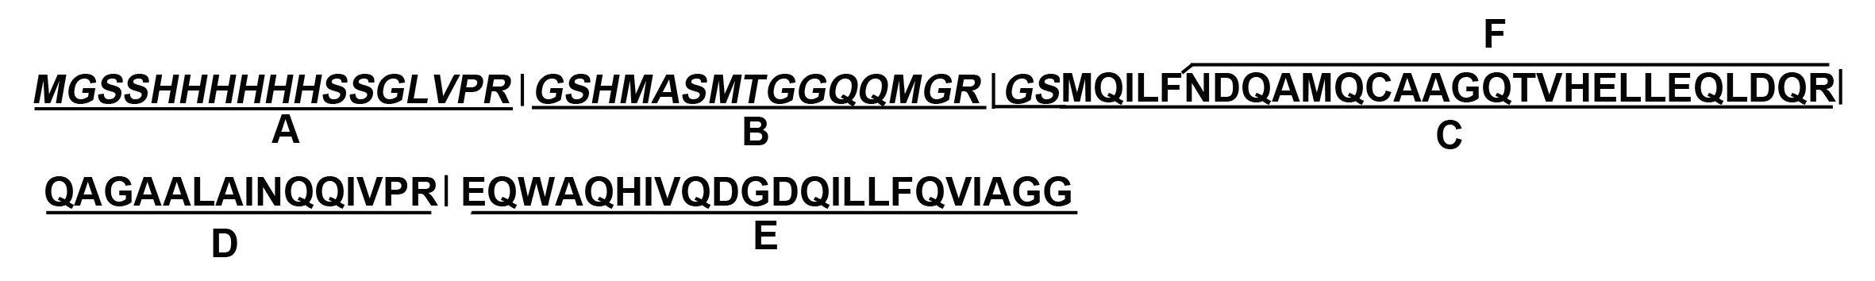

ThiS-mRI＇
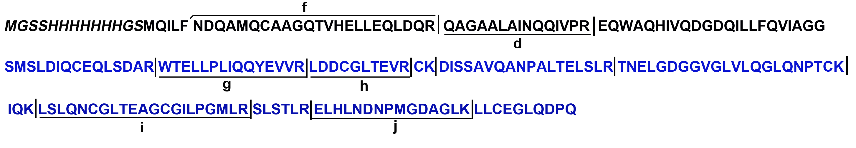

B: MALDI-TOF MS
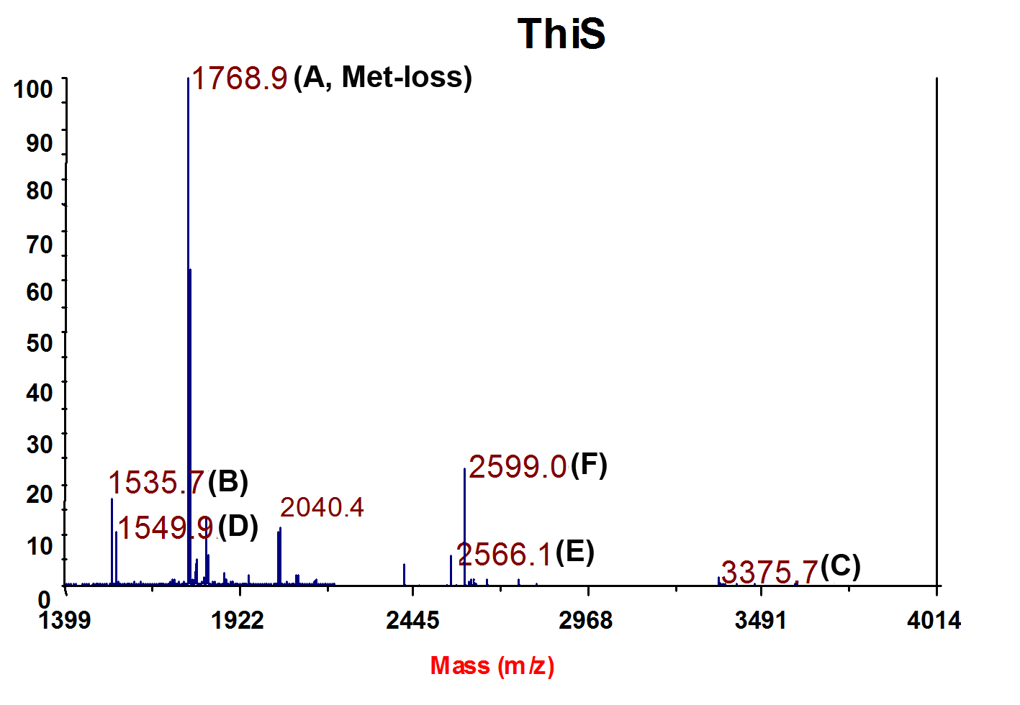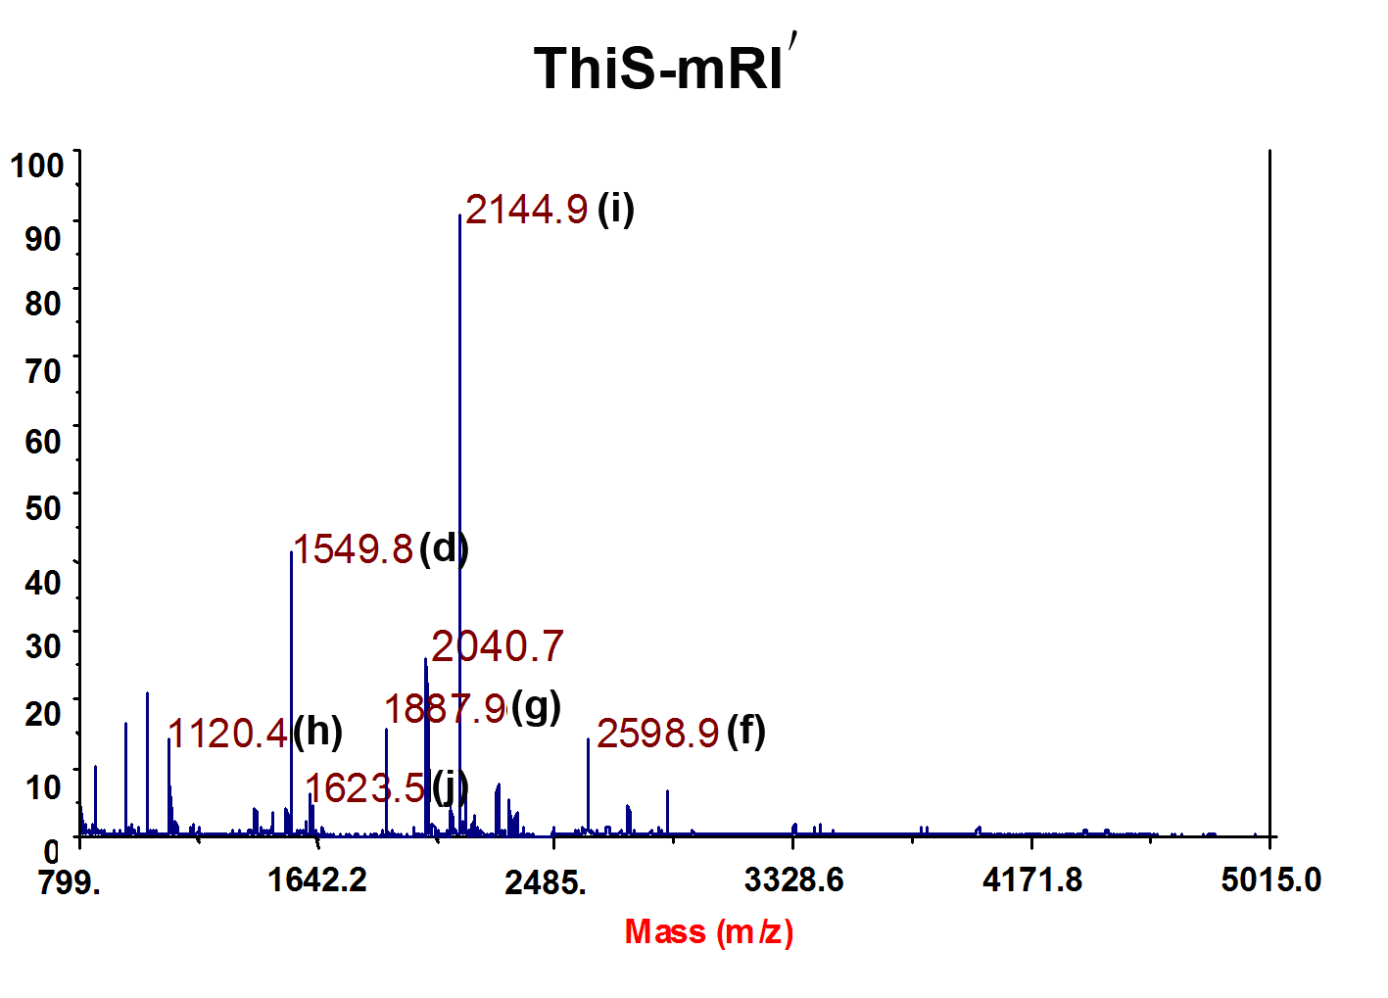

C: MALDI-TOF MS/MS

ThiS 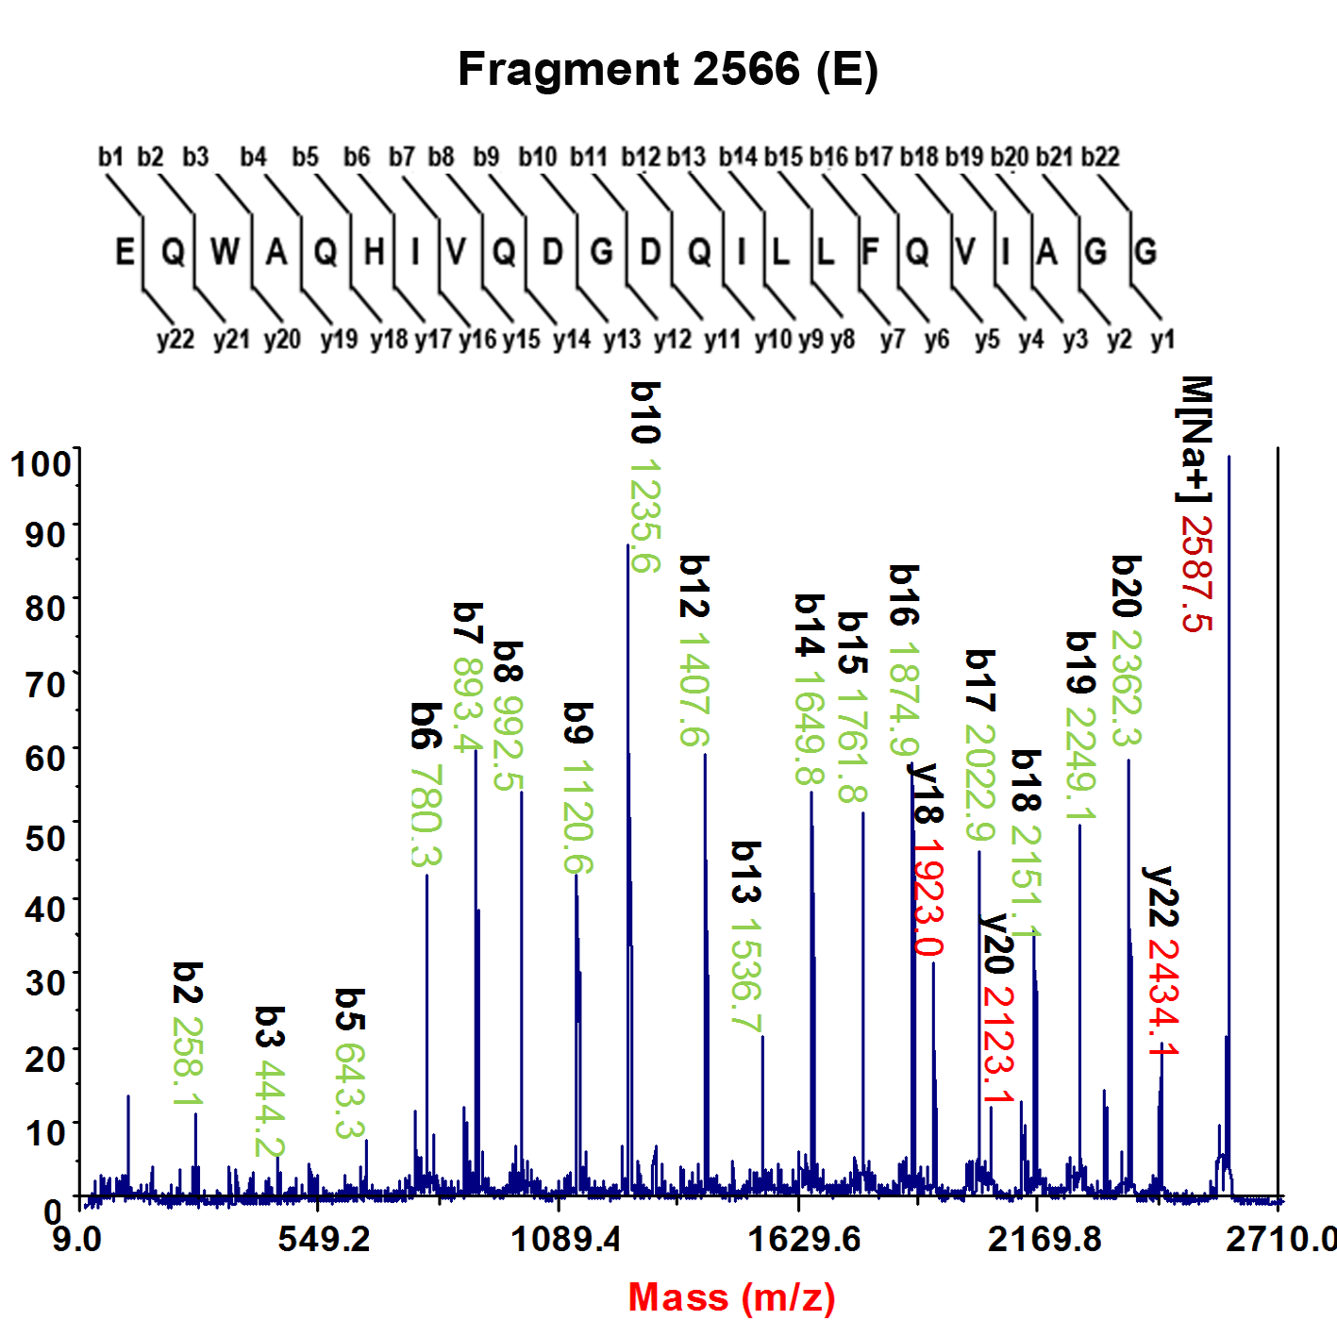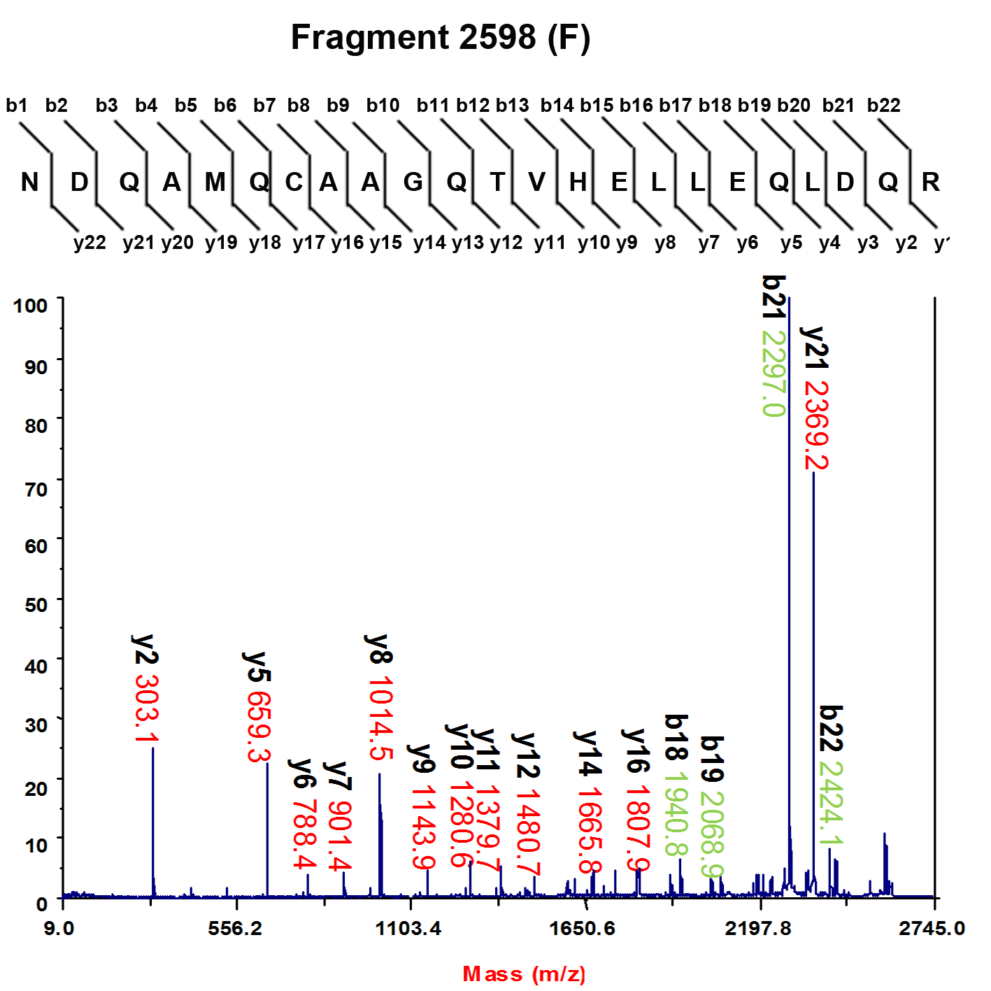
ThiS-mRI＇
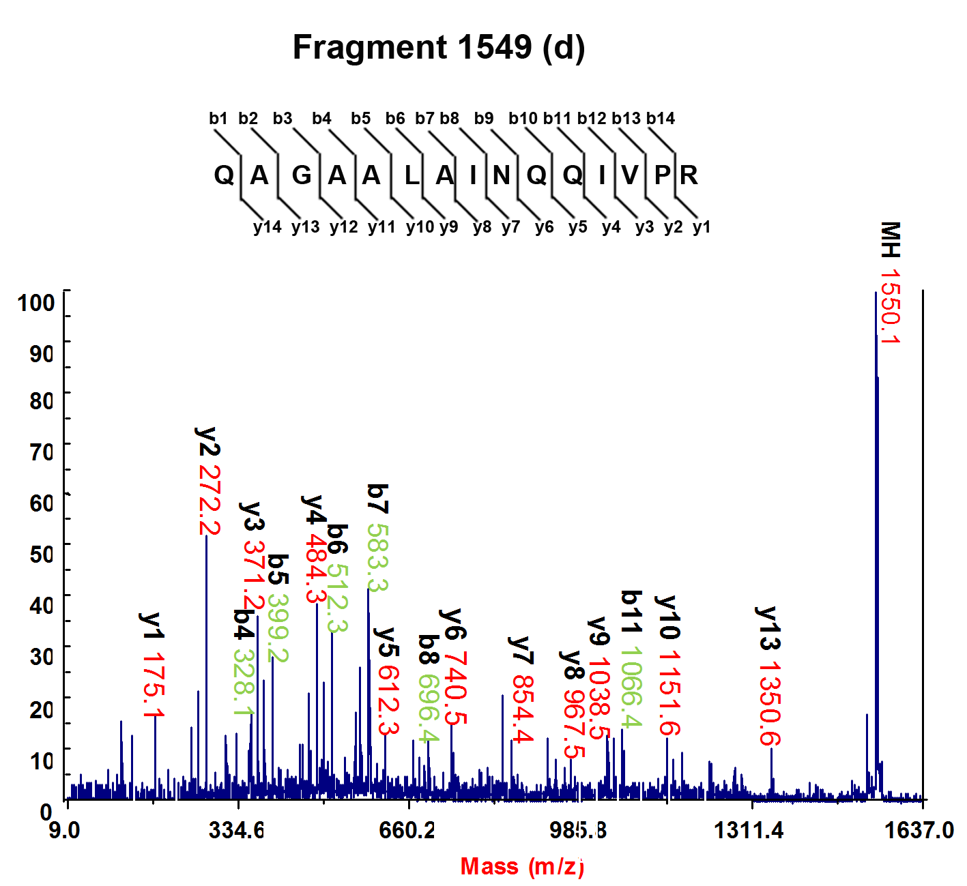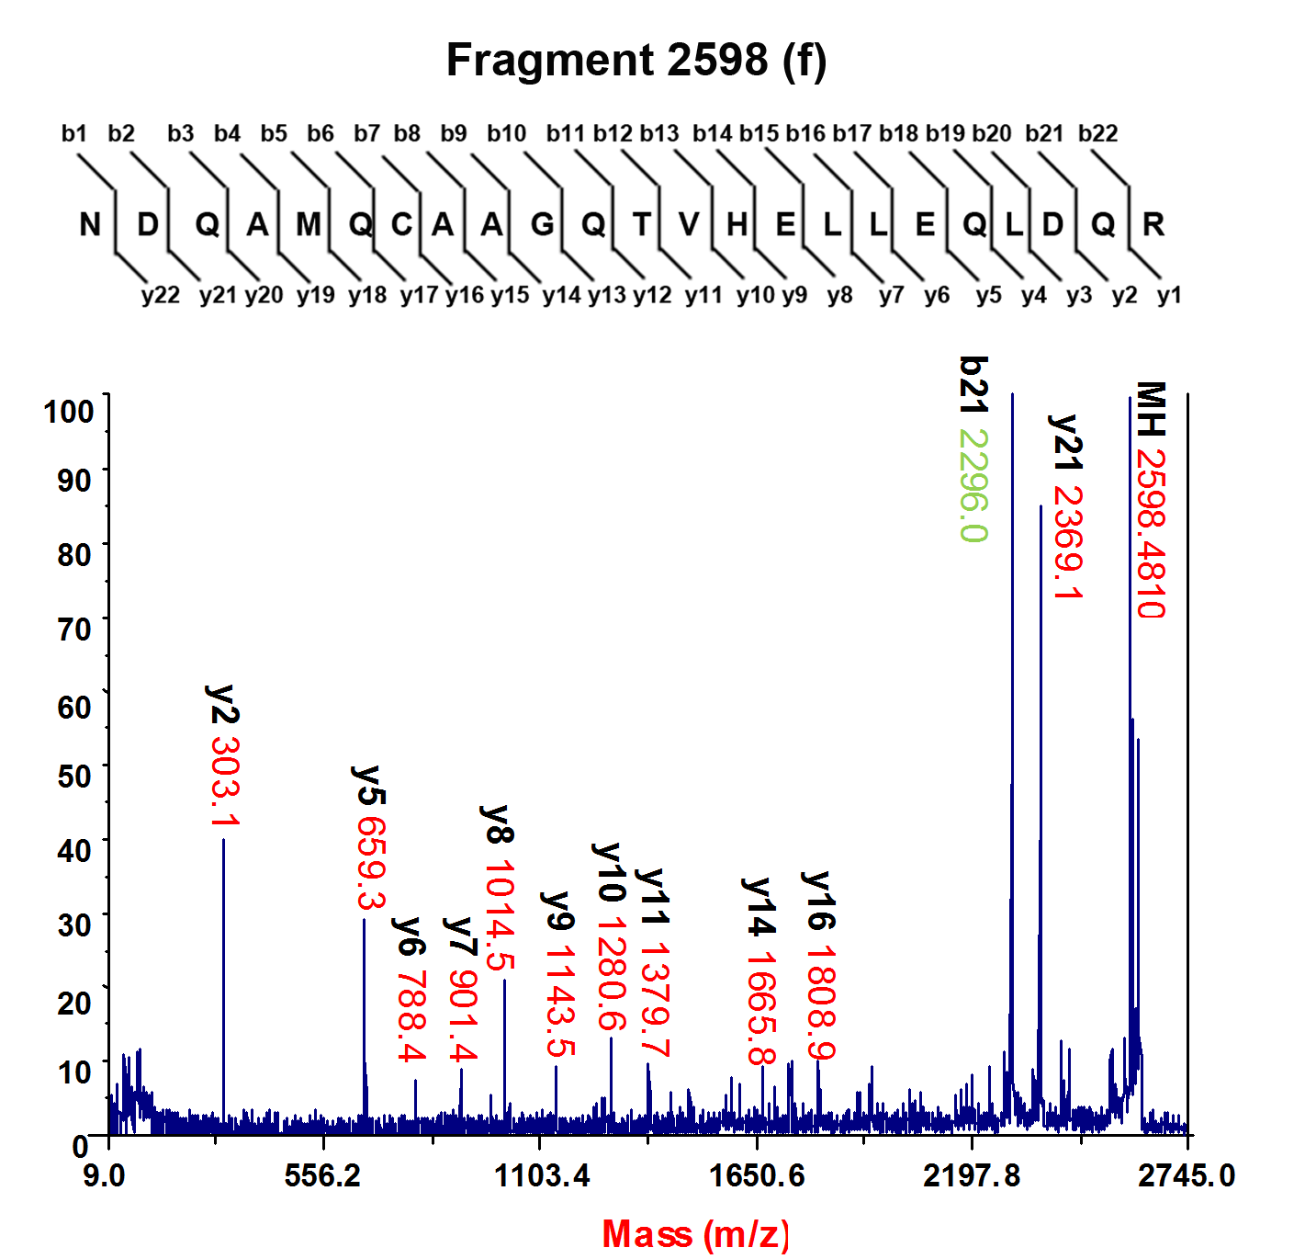
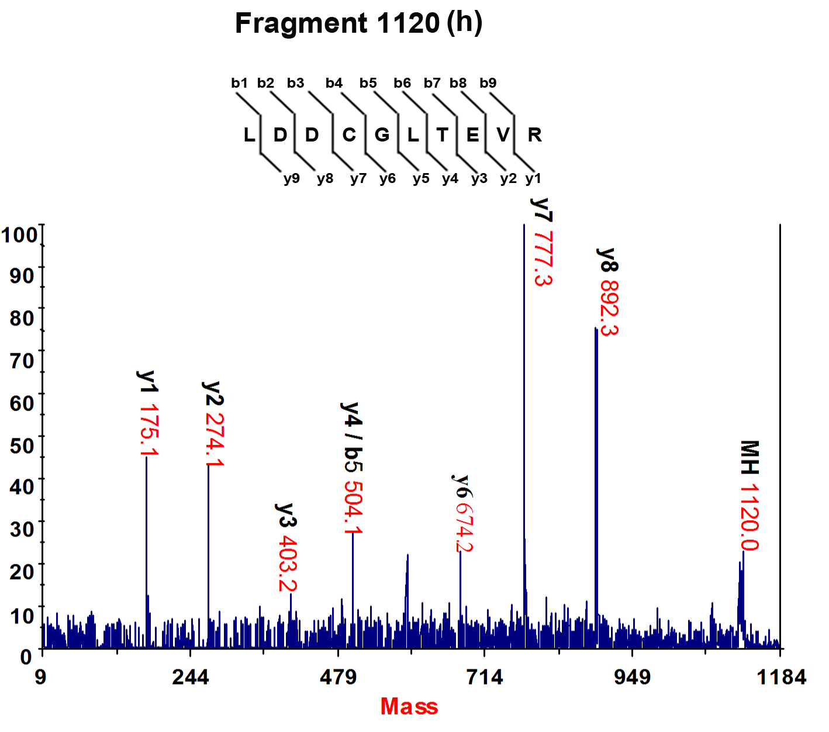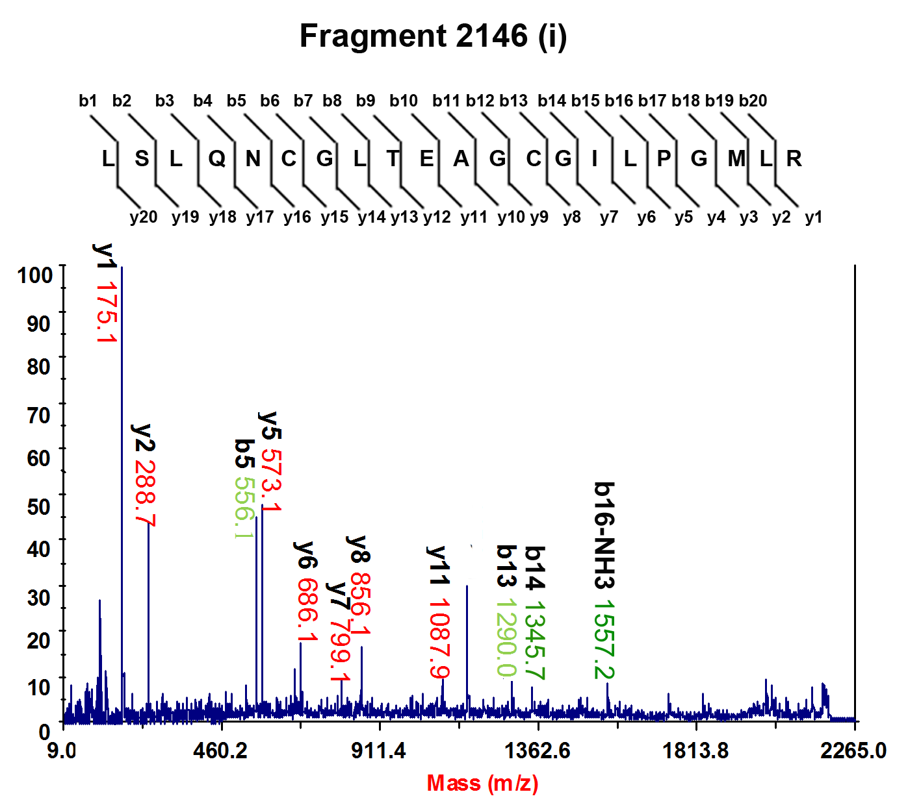

Figure S2 – Identification of a degradated fragment of ThiS-mRI by Mass Spectrometry.
A: protein sequences of recombinant ThiS and a suspected degradated fragment of ThiS-mRI (termed ThiS-mRI’) were shown, with the vector coded sequences in italics, ThiS sequence in black and the mRI sequence in blue. All the trypsin cleavage sites were indicated by vertical lines in the sequences. The fragments detected by MS or tandem-MS were labeled with underlines or overlines. B: The suspected 25 kD ThiS-mRI’ was subjected to in-gel trypsinization and analysized by MALDI-TOF MS. A vector coded ThiS (sequence shown in A) was overexpressed and purified, and used as control. All the trypsinized fragments of ThiS were detected and labeled corresponding to that expected in A. The trypsinized fragments of the suspected ThiS-mRI’ were partially detected and labeled correspondingly. Peaks of predicted fragment 1549 (D/d) and unidentified fragments of 2040 and 2598 (F/f) were present in both spectra. C: The peaks in B were analyzed by tandem MS, with the ions of predicted b- and y-ion fragmentations indicated. In the upper panel for ThiS, the peak 2566 (E) corresponding to the C-terminal fragment of ThiS was verified, and the unidentified peak 2598 (F) was verified as a non-specifically digested fragment from middle of the sequence of ThiS. In the lower panels for ThiS-mRI’, the peak 1549 (d), as well as the previously unidentified peak 2598 (f) was verified as sequences of ThiS. Peaks of 1120 (h) and 2146 (i) were verified as sequences of mRI, although the later was not completely resolved.
Above results indicated that the suspected 25 kD ThiS-mRI’ was a bona fide degradated fragment of ThiS-mRI.

