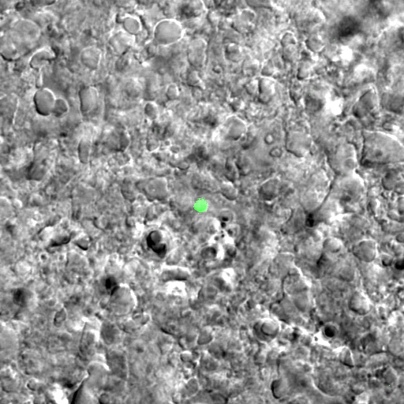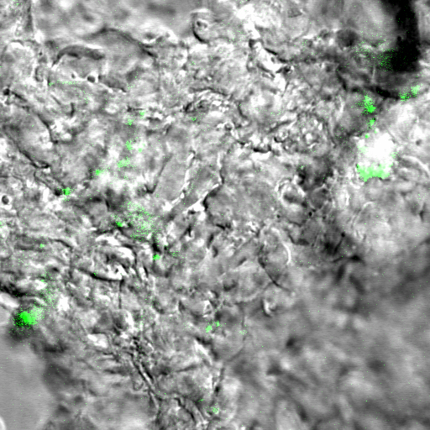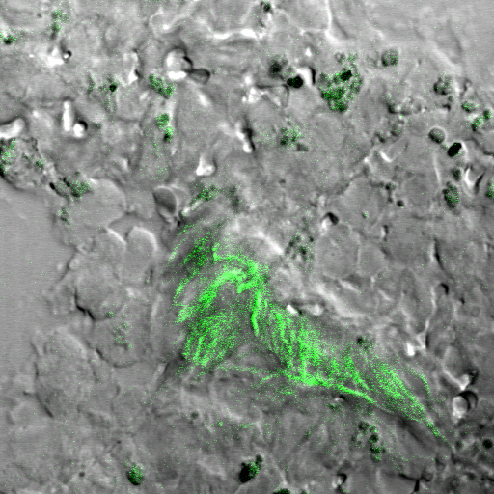

Brain

Liver

Spleen

Lymph node

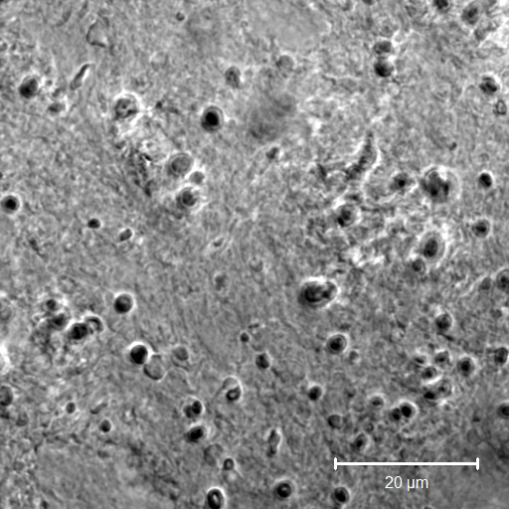

A

D

C

B

A

B

**Figure S2. Tracking of GFP-transfected Macrophages in healthy mice**