Figure S4 (A). PFGE analyses of plasmids from healthy C. perfringens poultry strains. Agarose plugs containing DNA from each specified isolate were digested with NotI and subjected to PFGE and staining with ethidium bromide. See Table1 and 2 for isolate features. Line numbers indicate isolate numbers M: Mid-Range II PFG molecular DNA ladder (Kb).
netB+ netB-

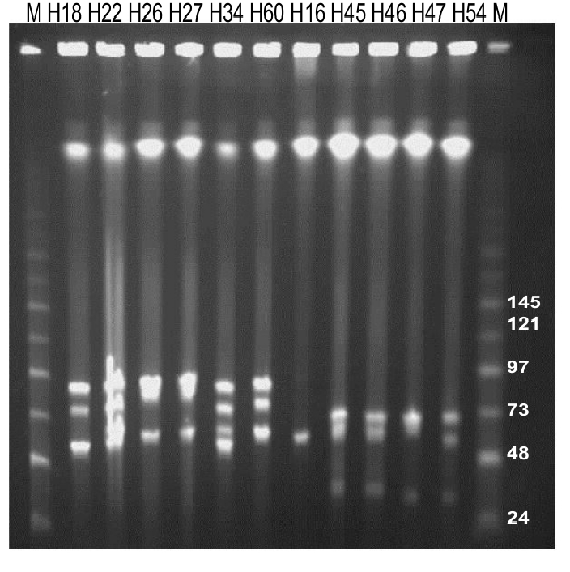

Figure S4 (B). PFGE Southern blot of plasmids from healthy C. perfringens poultry strains. Southern blotting of PFGE (Figure 4A) was performed with only DIG-labelled probe for cpb2 gene. M: Mid-Range II PFG molecular DNA ladder (Kb).

Figure S4 (C). PFGE Southern blot of plasmids from healthy C. perfringens poultry strains. Southern blotting of PFGE (Figure 4A) was performed with only DIG-labelled probe for netB gene. M: Mid-Range II PFG molecular DNA ladder (Kb).

