Figure S2: Visual representations of the location of primers of the two genes (CSK, C2orf68 ).
CSK:

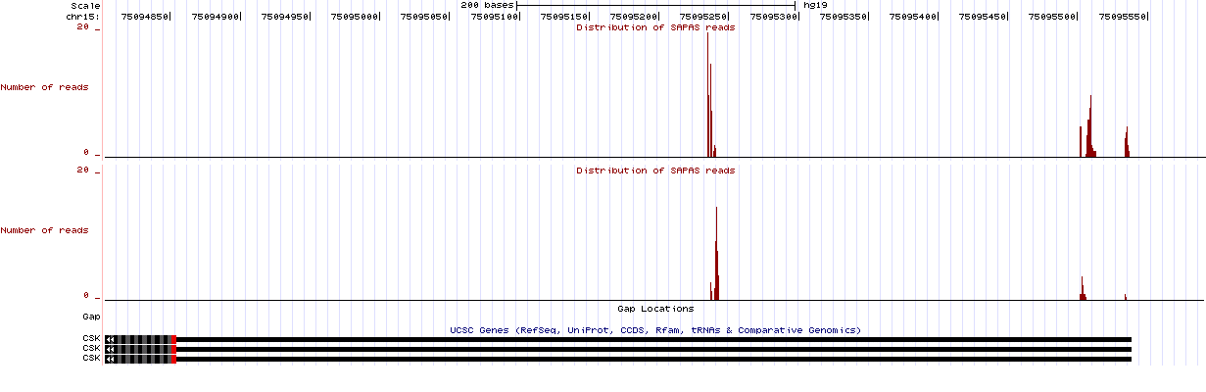
C2orf68

