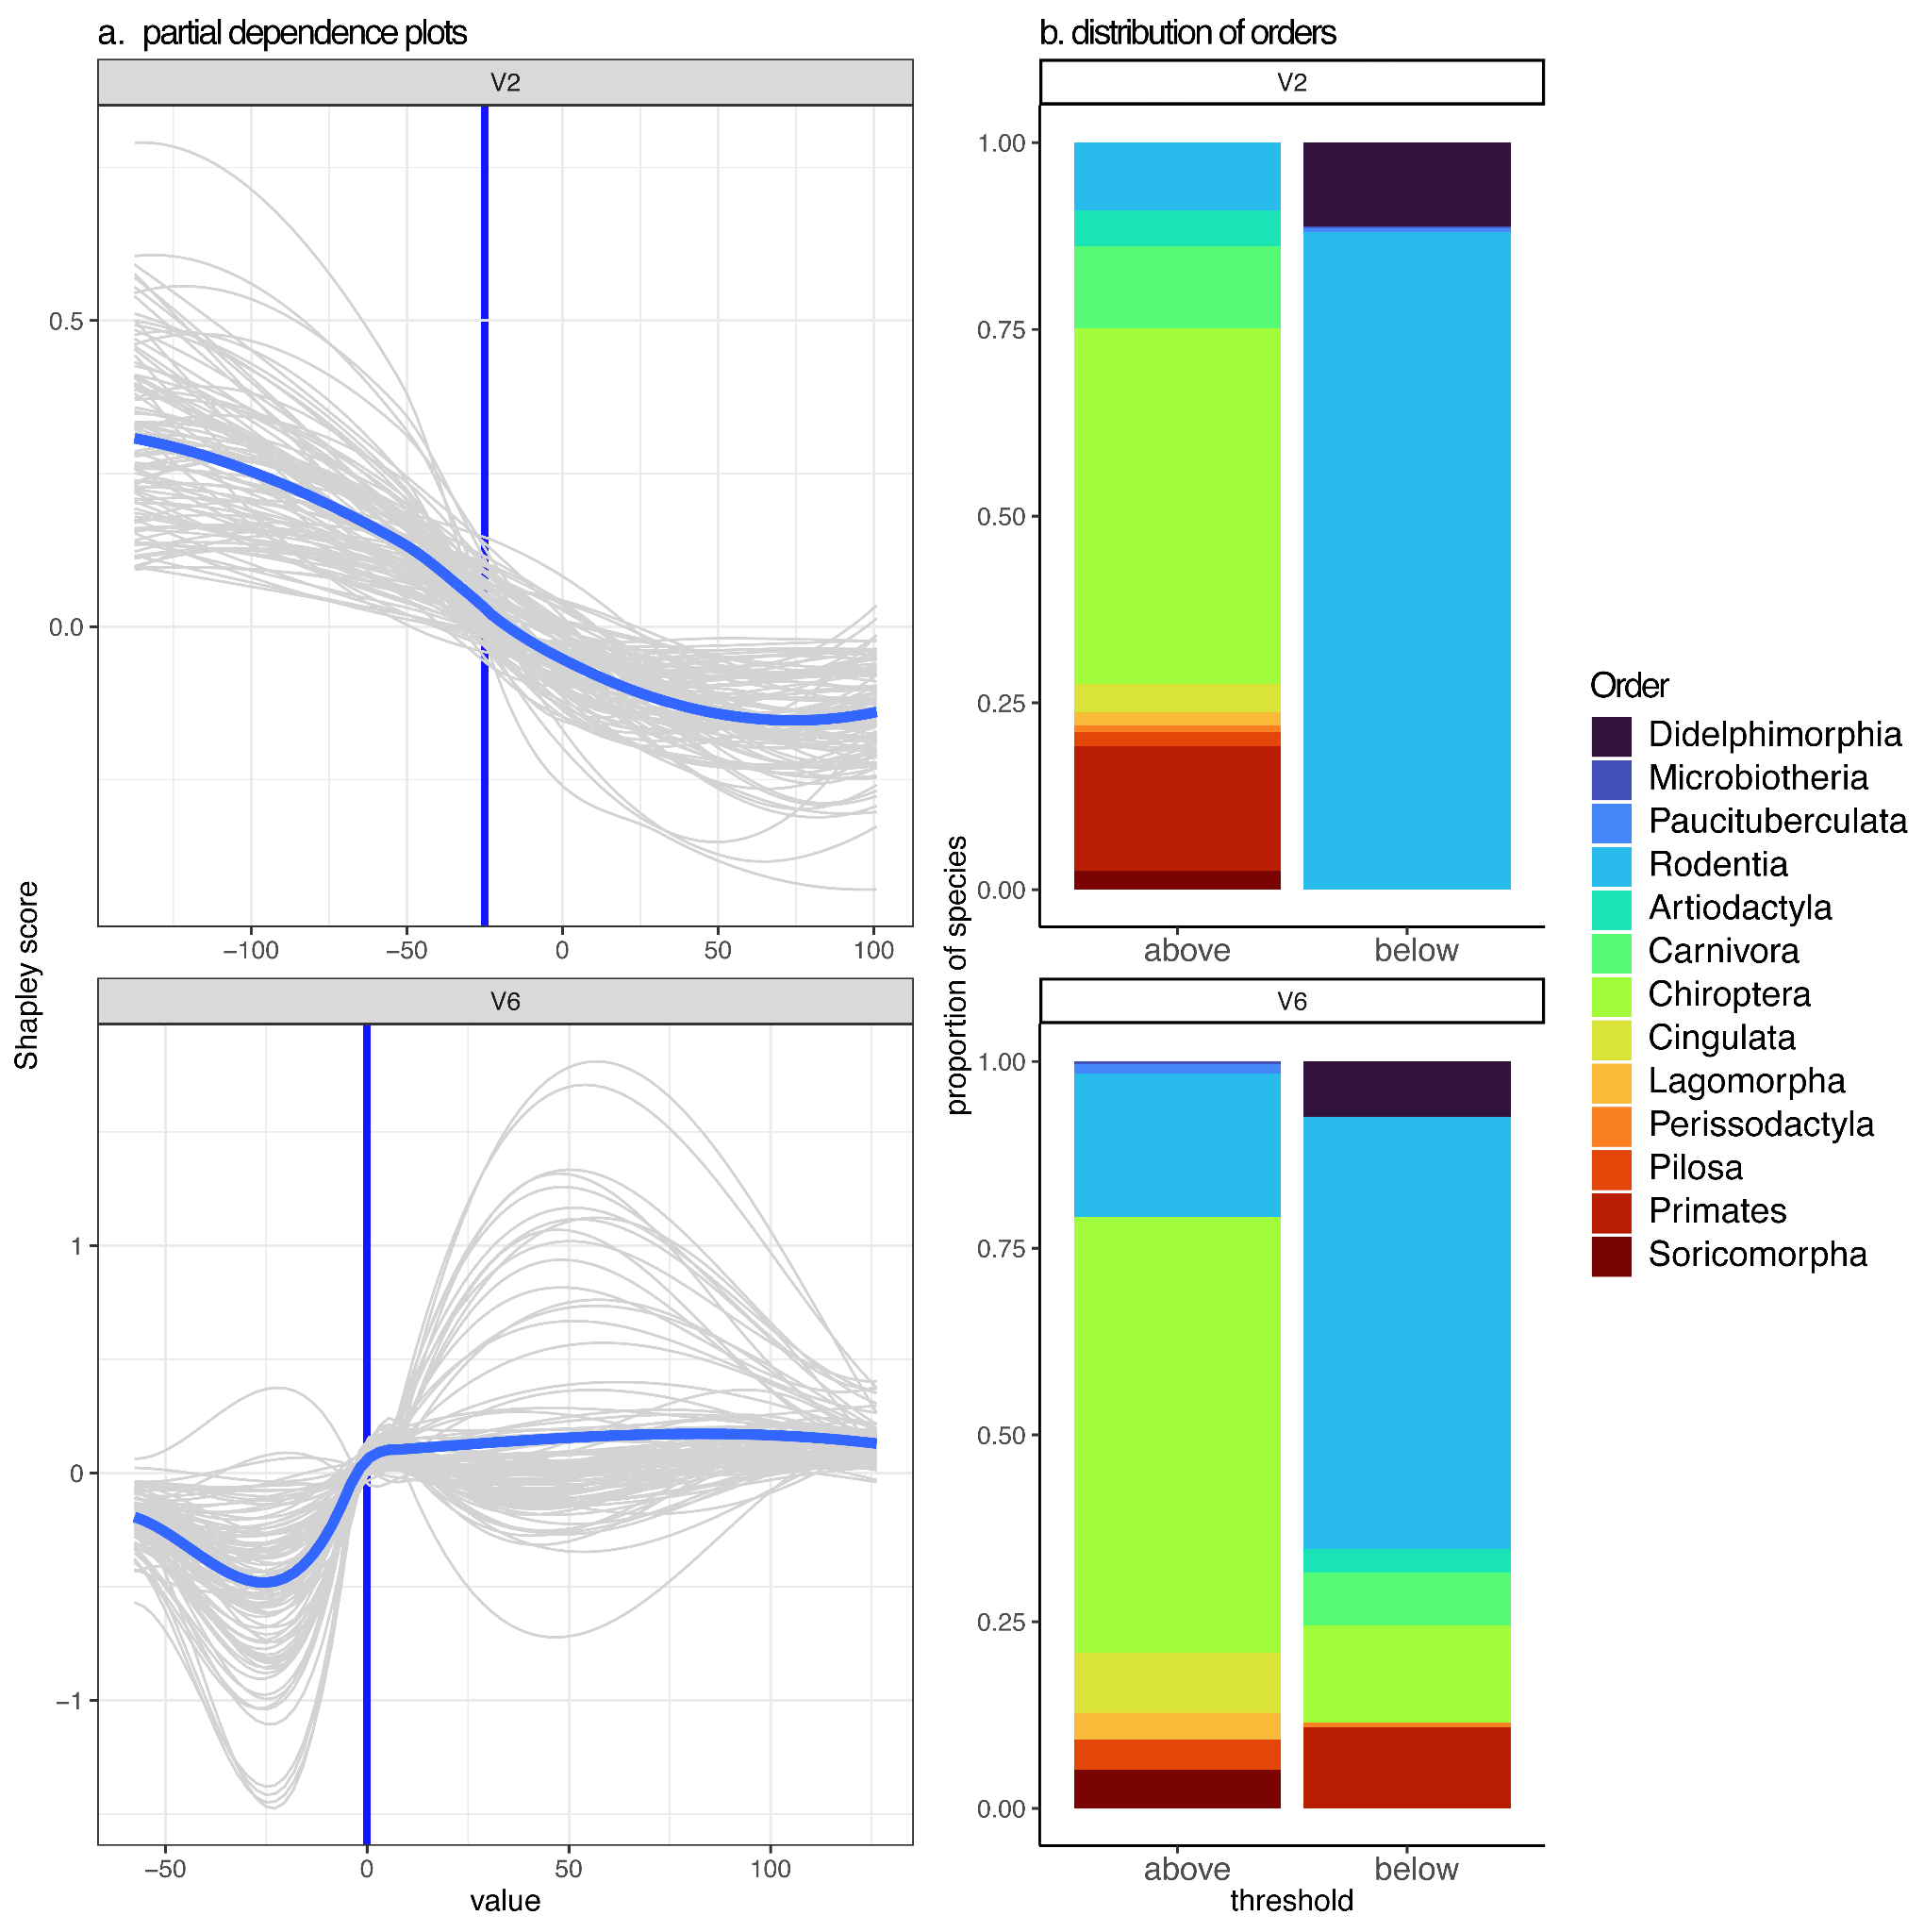
S2 Fig. (a) Shapley partial dependence plots showing the effect of PCoA dimensions on L. (Viannia) host status. Blue non-linear lines represent the average effect across model iterations , while grey lines show each individual model iteration (model fit with 70% of data). Dark blue vertical line represents a threshold value, where the dimension switches from having a negative effect on host status to a positive effect on host status. Only dimensions with importance scores > 0 for > 95% of model iterations are shown. (b) distribution of hosts within each order with PCoA dimension values above or below the threshold.

