S7 Fig. Association between worsened health and experiences of/exposure
to COVID-19
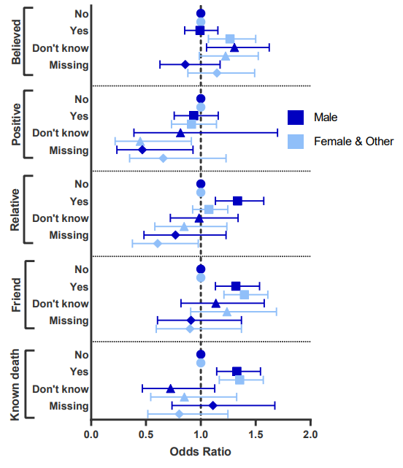
Note: adjusted for age and country.

