S1 Fig. Causal diagram showing selection of covariates for confounding control. ª
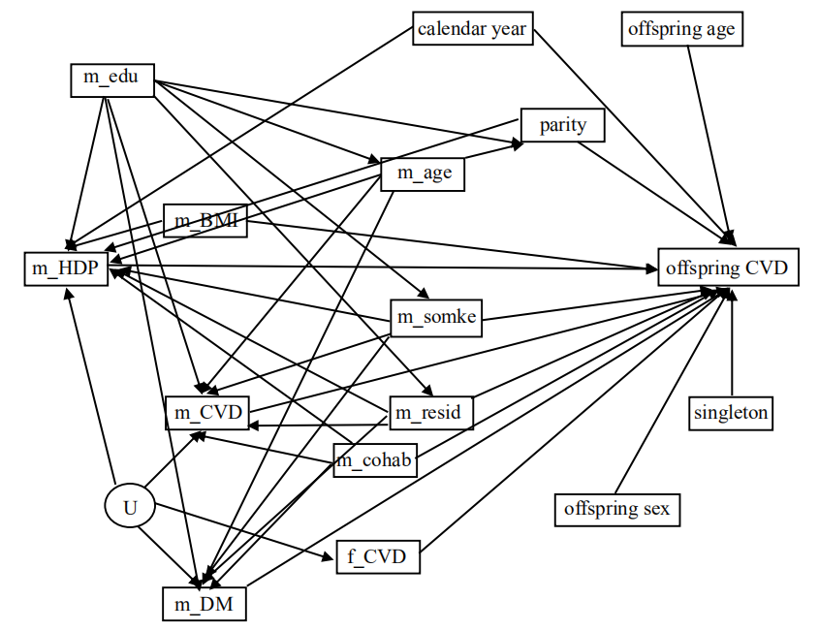
ª m_HPD: maternal hypertension disorders, m_age: maternal age, m_smoke: maternal smoking, m_edu: maternal education, m_cohab: maternal cohabitation, m_resid: maternal residence at birth, m_BMI: maternal BMI, m_CVD: maternal history of CVD before childbirth, m_DM: maternal history of diabetes before childbirth, f_CVD: paternal history of CVD before birth of the child, U: unmeasured variable

