S5 Appendix. Empowerment score diagnostics

Figure A Distributions of the individual dimension factor scores and the total empowerment score overlayed with the standard normal distribution
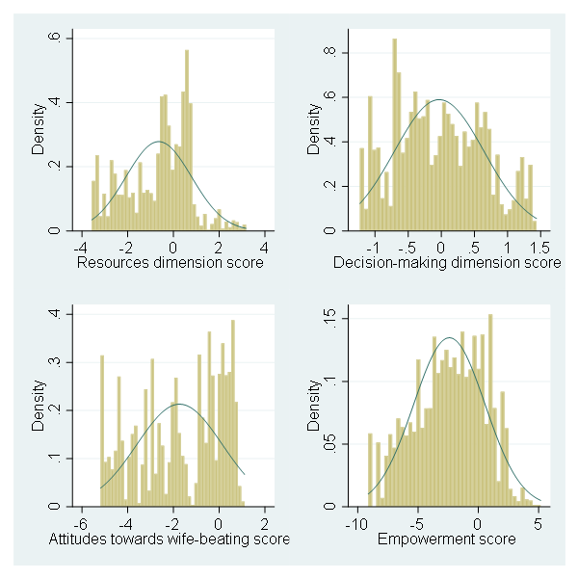

Figure B Correlation between individual dimension and total empowerment scores and the Gender Inequality Index

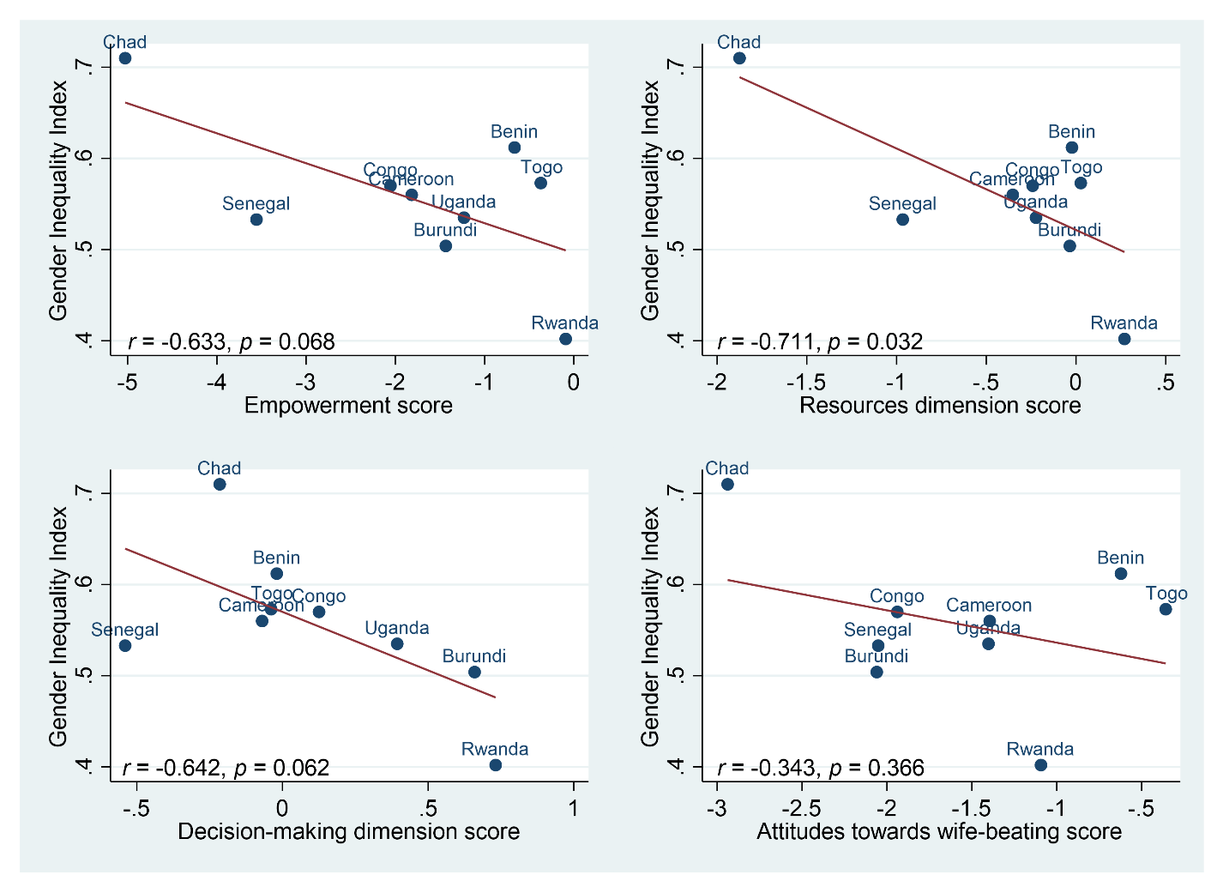
Table A Biserial correlations between the continuous total empowerment and individual dimensions scores and all considered outcomesª

 | Empowerment score | Resources score | Decision-making score | Attitudes towards wife-beating score
Cognitive development off track | -0.10** | -0.11** | -0.04** | -0.06**
Socio-emotional development off track | -0.03** | 0.01 | 0.01 | -0.05**
Literacy-numeracy development off track | -0.13** | -0.10** | -0.12** | -0.09**
Physical development off track | -0.07** | -0.09** | -0.07** | -0.02**
Overall development off track | -0.10** | -0.10** | -0.05** | -0.06**
HAZ | 0.06** | 0.06** | -0.05** | 0.06**
Stunted (HAZ <-2) | -0.05** | -0.06** | 0.06** | -0.05**
Number of learning resources | 0.15** | 0.10** | 0.11** | 0.13**
Number of maternal stimulation activities | 0.10** | 0.06** | 0.16** | 0.06**
≥4 maternal stimulation activities | 0.08** | 0.06** | 0.10** | 0.04**
Number of paternal stimulation activities | 0.15** | 0.11** | 0.13** | 0.10**
≥4 paternal stimulation activities | 0.08** | 0.07** | 0.06** | 0.06**
Dietary diversity score | 0.17** | 0.16** | 0.12** | 0.10**
Minimum dietary diversity (DDS≥4) | 0.11** | 0.09** | 0.05** | 0.09**

ª Abbreviations used: HAZ, height-for-age Z-score; DDS, dietary diversity score. Statistical significance: * p < 0.05. ** p < 0.01.

Table B Biserial correlations between the total empowerment and individual dimensions quintile categories and all considered outcomesª

 | Empowerment quintile categories | Resources quintile categories | Decision-making quintile categories | Attitudes towards wife-beating quintile categories
Cognitive development off track | -0.04** | -0.06** | -0.06** | -0.03**
Socio-emotional development off track | -0.02* | 0.00 | -0.02* | -0.03**
Literacy-numeracy development off track | -0.09** | -0.07** | -0.08** | -0.07**
Physical development off track | -0.04** | -0.06** | -0.05** | -0.01
Overall development off track | 0.07** | 0.06** | 0.05** | 0.04**
HAZ | -0.06** | -0.05** | -0.04** | -0.03**
Stunted (HAZ <-2) | -0.04** | -0.06** | -0.05** | -0.02**
Number of learning resources | 0.09** | 0.09** | 0.08** | 0.06**
Number of maternal stimulation activities | 0.07** | 0.05** | 0.07** | 0.06**
≥4 maternal stimulation activities | 0.04** | 0.04** | 0.05** | 0.03**
Number of paternal stimulation activities | 0.08** | 0.06** | 0.07** | 0.07**
≥4 paternal stimulation activities | 0.04** | 0.04** | 0.04** | 0.03**
Dietary diversity score | 0.05** | 0.05** | 0.05** | 0.04**
Minimum dietary diversity (DDS≥4) | 0.03** | 0.02** | 0.03** | 0.04**

ª Abbreviations used: HAZ, height-for-age Z-score; DDS, dietary diversity score. Statistical significance: * p < 0.05. ** p < 0.01.

