Derivation and external validation of a clinical prognostic model identifying children at risk of death following presentation for diarrheal care

Authors:
Sharia M. Ahmed (Division of Infectious Diseases, University of Utah School of Medicine, Sharia.M.Ahmed@utah.edu)
Ben J. Brintz (Division of Epidemiology, University of Utah School of Medicine, ben.brintz@hsc.utah.edu); PhD
Alison Talbert (KEMRI/Wellcome Trust Research Programme, Centre for Geographic Medicine Research, Kilifi, Kenya, atalbert@kemri-wellcome.org); MBBS
Moses Ngari (KEMRI/Wellcome Trust Research Programme, Centre for Geographic Medicine Research, Kilifi, Kenya, MNgari@kemri-wellcome.org); DrPhilos
Patricia B. Pavlinac (Department of Global Health, Global Center for Integrated Health of Women, Adolescents and Children (Global WACh), University of Washington, Seattle, WA, USA, ppav@uw.edu); PhD
James A. Platts-Mills (Division of Infectious Diseases and International Health, University of Virginia, Charlottesville, VA, USA, JP5T@hscmail.mcc.virginia.edu); MD
Adam C. Levine (Department of Emergency Medicine, Warren Alpert Medical School of Brown University, Providence, RI, USA, adam_levine@brown.edu); MD
Eric J. Nelson (Department of Pediatrics and Environmental and Global Health, Emerging Pathogens Institute, University of Florida, Gainesville, FL, USA, eric.nelson@ufl.edu); MD PhD
Judd L. Walson (Department of Global Health, University of Washington, Seattle, WA, USA, walson@uw.edu); MD
Karen L. Kotloff (Department of Pediatrics, Center for Vaccine Development, University of Maryland School of Medicine, Baltimore, MD, USA, Kkotloff@som.umaryland.edu); MD
James A Berkley (KEMRI/Wellcome Trust Research Programme, Centre for Geographic Medicine Research, Kilifi, Kenya, JBerkley@kemri-wellcome.org); MD
Daniel T. Leung (Division of Infectious Diseases, University of Utah School of Medicine, Daniel.leung@utah.edu); MD

SUPPLEMENT S1
Table A in S1: Full list of considered predictor variables
Study site (site)
Child sex (f3_gender)
Loss of skin turgor (f3_drh_turgor)
Intravenous rehydration (f3_drh_iv)
Hospitalized (f3_drh_hosp)
Your relationship to the child (f4a_relationship)
Where child’s father lives (f4a_dad_live)
Primary caregiver’s max school (f4a_prim_schl)
People living in house 6 months (f4a_ppl_house)
Children under 60 months in the house (f4a_yng_children)
How many rooms used for sleeping (f4a_slp_rooms)
Predominant floor (f4a_floor)
Electricity (f4a_house_elec)
Bicycle/rickshaw (f4a_house_bike)
Telephone (f4a_house_phone)
Television (f4a_house_tele)
Car/truck (f4a_house_car)
Animal-drawn cart (f4a_house_cart)
Motorcycle/scooter (f4a_house_scoot)
Refrigerator (f4a_house_fridge)
Agricultural land (f4a_house_agland)
Radio (f4a_house_radio)
Boat with motor (f4a_house_boat)
None of the above assets (f4a_house_none)
Electricity (f4a_fuel_elec)
Biogas (f4a_fuel_biogas)
Straw/shrubs/grass (f4a_fuel_grass)
Liquid propane gas (f4a_fuel_propane)
Coal/lignite (f4a_fuel_coal)
Animal dung (f4a_fuel_dung)
Natural gas (f4a_fuel_natgas)
Charcoal (f4a_fuel_charcoal)
Agricultural crop residue (f4a_fuel_crop)
Kerosene (f4a_fuel_kero)
Wood (f4a_fuel_wood)
Other fuel (f4a_fuel_other)
Goat (f4a_ani_goat)
Sheep (f4a_ani_sheep)
Dog (f4a_ani_dog)
Cat (f4a_ani_cat)
Cow (f4a_ani_cow)
Rodents (f4a_ani_rodents)
Fowl (f4a_ani_fowl)
Other animal (f4a_ani_other)
No animals (f4a_ani_no)
Water piped to house (f4a_water_house)
Covered well in house/yard (f4a_water_covwell)
Water piped into yard (f4a_water_yard)
Covered public well (f4a_water_covpwell)
Public tap (f4a_water_pubtap)
Protected spring (f4a_water_prospring)
Open well in house/yard (f4a_water_well)
Unprotected spring (f4a_water_unspring)
Open public well (f4a_water_pubwell)
River/stream (f4a_water_river)
Pond/lake (f4a_water_pond)
Deep tube well (f4a_water_deepwell)
Rainwater (f4a_water_rain)
Shallow tube well (f4a_water_shallwell)
Bought water (f4a_water_bought)
Other water source (f4a_water_othr)
Bore hole (f4a_water_bore)
Main source of drinking water (f4a_ms_water*)
How often is water available (f4a_water_avail)
Did you give the child stored water (f4a_store_water)
Do you usually treat drinking water? (f4a_trt_water)
Usual treatment method (f4a_trt_method)
How are child’s feces disposed (f4a_disp_feces)
Facility used to dispose of feces (f4a_fac_waste)
How many households share facility? (f4a_share_fac)
Wash hands before eating? (f4a_wash_eat)
Wash hands before cooking (f4a_wash_cook)
Wash hands before you nurse? (f4a_wash_nurse)
Wash hands after you defecate (f4a_wash_def)
Wash hands after handling animals (f4a_wash_animal)
Wash hands after cleaning a child (f4a_wash_child)
Wash hands other times (f4a_wash_othr)
What do you use to wash your hands? (f4a_wash_use)
Is the child currently breastfed? (f4a_breastfed)
How long as this diarrhea episode lasted (days)? (f4a_drh_days)
Maximum number of loose stools (f4a_max_stools)
Blood in stools (f4a_drh_blood)
Vomiting 3 or more times per day (f4a_drh_vomit)
Very thirsty (f4a_drh_thirst)
Drank much less than usual (f4a_drh_lessdrink)
Belly pain (f4a_drh_bellypain)
Irritable or restless (f4a_drh_restless)
Decreased activity or lethargy (f4a_drh_lethrgy)
Loss of consciousness (f4a_drh_consc)
Rectal straining (f4a_drh_strain)
Rectal prolapse (f4a_drh_prolapse)
Cough (f4a_drh_cough)
Convulsions (f4a_drh_conv)
Very thirsty (f4a_cur_thirsty)
Wrinkled skin (f4a_cur_skin)
Irritable or restless (f4a_cur_restless)
Dry mouth (f4a_cur_drymouth)
Fast breathing (f4a_cur_fastbreath)
ORALITE or ORS (f4a_hometrt_ors)
Homemade fluid (f4a_hometrt_maize)
Special mile or infant formula (f4a_hometrt_milk)
Home remedy/herbal medication (f4a_hometrt_herb)
Zinc (f4a_hometrt_zinc)
No special remedies given (f4a_hometrt_none)
Any other liquids (f4a_hometrt_othrliq)
Antibiotics (f4a_hometrt_ab)
Other treatment (f4a_hometrt_othr1)
Other treatment (f4a_hometrt_othr2)
How much offered to drink (f4a_offr_drink)
Seek outside care (f4a_seek_outside)
Pharmacy (f4a_seek_pharm)
Friend/relative (f4a_seek_friend)
Traditional healer (f4a_seek_healer)
Unlicensed practitioner (f4a_seek_doc)
Licensed practitioner (f4a_seek_privdoc)
Bought a remedy (f4a_seek_remdy)
Other hospital/center (f4a_seek_other)
Mid-upper arm circumference (f4b_muac)
Axillary temperature (f4b_temp)
Respiratory rate per minute (f4b_resp)
Chest indrawing (f4b_chest_indrw)
Eyes (f4b_eyes)
Mouth (f4b_mouth)
Skin pinch (f4b_skin)
Mental status (f4b_mental)
Rectal prolapse (f4b_rectal)
Bipedal edema (f4b_bipedal)
Abnormal hair (f4b_abn_hair)
Undernutrition (f4b_under_nutr)
Skin as ‘flaky paint’ appearance (f4b_skin_flaky)
Receive rehydration here (f4b_recommend)
Child was admitted to hospital (f4b_admit)
Child age (months) (base_age)
*f4a_ms_water was recategorized into the following: surface, other unimproved, other improved, piped, other[18, 19]

Fig A in S1: Flow diagram of study inclusion
GEMS
9439 children enrolled with acute diarrhea (≤7 days duration)
840 missing follow-up data
79 had follow-up data outside of follow-up study period
8520 eligible

460 missing predictor data

8060 included in analysis
- 43 died during treatment
- 122 died after discharge

Fig B in S1: Number of variables and area under the receiver operator curve (AUC) for random forest regression and logistic regression models predicting death after presentation to care for diarrhea for children 0-59 months of age in GEMS
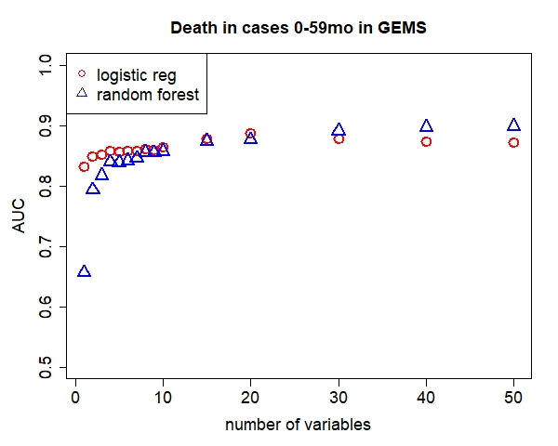

Table B in S1: Variable importance ordering, cross-validated average AUC, odds ratios, and 95% confidence intervals for logistic regression models predicting death in children 0-59mo in LMICs in GEMS ranked from most to less predictive (highest to lower variance reduction)
GEMS
AUC (95% CI): 0.86 (0.84, 0.88)
Variables | OR (95% CI)
MUAC | 0.48 (0.43, 0.54)
Respiratory rate | 1.03 (1.01 1,04)
Temperature | 1.51 (1.28, 1.78)
Age (months) | 1.02 (1.00, 1.03)
Num. ppl living in household | 1.00 (0.97, 1.02)
Num. days of diarrhea at presentation | 1.07 (0.95, 1.21)
Since diarrhea starts, how much offering child to drink | 1.35 (1.16, 1.57)
Num. children <60months live in household | 0.98 (0.88, 1.09)
Abnormal hair (sparse, loose, straight) | 4.03 (2.61, 6.14)
Num. rooms in house used for sleeping | 1.02 (0.96, 1.09)

Fig C in S1: Model derived using only data from GEMS Kenya, performance assessed in Kilifi data
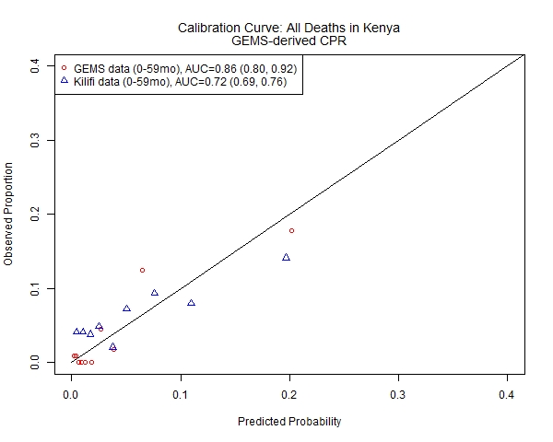
Table C in S1: Calibration assessment for model derived using only data from GEMS Kenya and applied to Kilifi data
Kenya only GEMS-derived model applied to KILIFI data  Intercept (95% CI) | Slope (95% CI)
-0.25 (-0.40, -0.10) | 0.50 (0.42, 0.58)

Table D in S1: DEATH AT ANY TIME Variable importance ordering and cross-validated average overall AUC and AUC by patient subset and 95% confidence intervals for a 2 (plain text), 5 (bold), and 10 (italicized) variable logistic regression model for predicting any death in children in GEMS
Patient Subset | 0-59mo (main text model) | 0-11mo | 12-23mo | 24-59mo
 | 0.84 (0.82, 0.86) | 0.80 (0.77, 0.83) | 0.80 (0.76, 0.85) | 0.91 (0.87, 0.95)
AUCs | 0.86 (0.84, 0.88) | 0.82 (0.79, 0.85) | 0.81 (0.77, 0.85) | 0.93 (0.89, 0.96)
 | 0.86 (0.84, 0.88) | 0.82 (0.79, 0.85) | 0.85 (0.81, 0.88) | 0.90 (0.86, 0.95)
1 | MUAC | MUAC | MUAC | MUAC
2 | Respiratory rate | Temperature | Temperature | Abnormal hair (e.g. sparse, loose, straight)
3 | Temperature | Respiratory rate | Num. people living in household | Skin has “flaky paint” appearance
4 | Age (months) | Age (months) | Respiratory rate | Respiratory rate
5 | Num. people living in household | Num. people living in household | Num. children <60months live in household | Temperature
6 | Num. days of diarrhea at presentation | Num. days of diarrhea at presentation | Num. days of diarrhea at presentation | Age (months)
7 | Since diarrhea starts, how much offering child to drink | Chest indrawing | Age (months) | Num. days of diarrhea at presentation
8 | Num. children <60months live in household | Where child’s father lives | Abnormal hair (e.g. sparse, loose, straight) | Undernutrition
9 | Abnormal hair (e.g. sparse, loose, straight) | Since diarrhea starts, how much offering child to drink | Num. rooms used for sleeping | Since diarrhea starts, how much offering child to drink
10 | Num. rooms used for sleeping | Num. children <60months live in household | Homemade remedy / herbal medication | Skin pinch

 | The Gambia | Mali | Mozambique | Kenya | India | Bangladesh | Pakistan | Fit in data from Africa | Fit in data from Asia
AUCs |  |  |  |  | too few outcomes, | too few outcomes, | too few outcomes, | 0.83 (0.82, 0.84) | too few outcomes,
 | 0.78 (0.77, 0.80) | 0.88 (0.87, 0.89) | 0.79 (0.77, 0.80) | 0.88 (0.85, 0.91) | model does not converge | model does not converge | model does not converge | 0.84 (0.83, 0.85) | model does not converge
 | 0.78 (0.76, 0.80) | 0.87 (0.85, 0.88) | 0.77 (0.75, 0.79) | 0.84 (0.81, 0.87) |  |  |  | 0.83 (0.82, 0.84)
1 | MUAC | MUAC | MUAC | MUAC |  |  |  | MUAC
2 | Respiratory rate | Temperature | Temperature | Age (months) |  |  |  | Age (months)
3 | Age (months) | Num. people living in household | Age (months) | Respiratory rate |  |  |  | Respiratory rate
4 | Num. days of diarrhea at presentation | Respiratory rate | Respiratory rate | Temperature |  |  |  | Temperature
5 | Num. people living in household | Age (months) | Undernutrition | Undernutrition |  |  |  | Num. people living in household
6 | Temperature | Chest indrawing | Abnormal hair (e.g. sparse, loose, straight) | Since diarrhea starts, how much offering child to drink |  |  |  | Num. days of diarrhea at presentation
7 | Num. rooms used for sleeping | Num. rooms used for sleeping | Since diarrhea starts, how much offering child to drink | Bipedal edema |  |  |  | Num. children <60months live in household
8 | Num. children <60months live in household | How are child’s feces disposed? | Num. people living in household | Num. days of diarrhea at presentation |  |  |  | Since diarrhea starts, how much offering child to drink
9 | Mental status | Num. children <60months live in household | Where child’s father lives | Num. people living in household |  |  |  | Undernutrition
10 | Chest indrawing | Special milk or infant formula | Num. children <60months live in household | Main source of drinking water |  |  |  | Num. rooms used for sleeping
 |  |  |  |  |  |  |  | 2-variable CPM performance in data from Asia
 |  |  |  |  |  |  |  | 0.93 (0.90, 0.96)

Table E in S1: DEATHS BY AGE in GEMS and Kilifi data
GEMS
 | 0-11mo | 12-23mo | 24-59mo
N | 3383 | 2779 | 1898
Any died | 100 (3.0%) | 46 (1.7%) | 19 (1.0%)
In treatment | 23 (0.7%) | 12 (0.4%) | 8 (0.4%)
After treatment* | 77 (2.3%) | 34 (1.2%) | 11 (0.6%)
Kilifi
N | 1385 | 989 | 527
Any died | 130 (9.2%) | 76 (8.7%) | 53 (10.1%)
In treatment | 70 (5.0%) | 36 (3.6%) | 21 (4.0%)
After treatment* | 60 (4.6%) | 40 (4.2%) | 32 (6.3%)
* Percentages reflect the number of kids who died at home out of all the children discharged alive (did not die during treatment)

Table F in S1: DEATHS BY SITE in GEMS and Kilifi data
GEMS
 | Overall | The Gambia | Mali | Mozamb. | Kenya | India | Bdesh | Pakistan
N | 8060 | 859 | 1783 | 518 | 1122 | 1473 | 1348 | 957
Any died | 165 (2.5%) | 37 (4.3%) | 23 (1.3%) | 39 (7.5%) | 43 (3.8%) | 2 (0.1%) | 6 (0.4%) | 15 (1.6%)
In treatment | 43 (0.5%) | 17 (2.0%) | 3 (0.2%) | 16 (3.1%) | 2 (0.2%) | 0 (0%) | 5 (0.4%) | 0 (0%)
After treatment* | 122 (1.5%) | 20 (2.4%) | 20 (1.1%) | 23 (4.6%) | 41 (3.7%) | 2 (0.1%) | 1 (0.1%) | 15 (1.6%)
Kilifi
N | 2901
Any died | 259 (8.9%)
In treatment | 127 (4.4%)
After treatment* | 132 (4.8%)
* Percentages reflect the number of kids who died at home out of all the children discharged alive (did not die during treatment)

Table G in S1: Test performance of different screening criteria for identifying children likely to die at any point after presenting to care for acute diarrhea in GEMS data.
 | Proportion of patients who screen positive | Sensitivity  T+|D+ | Specificity  T-|D- | PPV  D+|T+ | NPV  D-|T-
Ages 0-6mo | 17.7% | 0.30 | 0.83 | 0.03 | 0.98
Ages >6mo to 59mo | 82.3% | 0.70 | 0.17 | 0.02 | 0.97
Ages 0-6mo and MUAC <12.5 | 6.4% | 0.20 | 0.94 | 0.06 | 0.98
Ages >6mo to 59mo and MUAC<12.5 | 11.2% | 0.46 | 0.90 | 0.08 | 0.99
Ages 0-59mo and MUAC <12.5 | 17.5% | 0.66 | 0.83 | 0.08 | 0.99
CPM* predicted probability ≥0.05 | 8.3% | 0.28 | 0.97 | 0.12 | 0.99
CPM* predicted probability ≥0.10 | 3.1% | 0.28 | 0.97 | 0.19 | 0.98
CPM* predicted probability ≥0.15 | 1.6% | 0.17 | 0.99 | 0.22 | 0.98
CPM* predicted probability ≥0.20 | 1.2% | 0.13 | 0.99 | 0.23 | 0.98
*clinical prognostic model (CPM) including MUAC and respiratory rate, fit a single time to all ages 0-59mo
PPV=positive predictive value; NPV=negative predictive value

Table H in S1: Patient characteristics of observations included in analysis and dropped due to missing predictor data
 | Dropped due to missing predictor data | Included in analysis | Eligible
 | (N=460) | (N=8060) | (N=8520)
number who died | 14 (3.0%) | 165 (2.0%) | 179 (2.1%)
age (months)
Mean (SD) | 16.9 (13.2) | 16.9 (12.2) | 16.9 (12.3)
Median [Min, Max] | 12.0 [0, 59.0] | 14.0 [0, 59.0] | 13.0 [0, 59.0]
site
The Gambia | 22 (4.8%) | 859 (10.7%) | 881 (10.3%)
Mali | 3 (0.7%) | 1783 (22.1%) | 1786 (21.0%)
Mozambique | 52 (11.3%) | 518 (6.4%) | 570 (6.7%)
Kenya | 290 (63.0%) | 1122 (13.9%) | 1412 (16.6%)
India | 31 (6.7%) | 1473 (18.3%) | 1504 (17.7%)
Bangladesh | 27 (5.9%) | 1348 (16.7%) | 1375 (16.1%)
Pakistan | 35 (7.6%) | 957 (11.9%) | 992 (11.6%)
MUAC
Mean (SD) | 13.5 (1.67) | 13.7 (1.51) | 13.7 (1.52)
Median [Min, Max] | 13.6 [6.83, 20.0] | 13.7 [6.93, 36.8] | 13.7 [6.83, 36.8]
respiratory rate
Mean (SD) | 39.3 (11.4) | 37.6 (8.93) | 37.7 (9.08)
Median [Min, Max] | 37.0 [19.5, 80.0] | 36.5 [13.5, 122] | 37.0 [13.5, 122]
Missing | 4 (0.9%) | 0 (0%) | 4 (0.0%)
Temperature (C)
Mean (SD) | 37.4 (1.10) | 37.2 (0.981) | 37.2 (0.988)
Median [Min, Max] | 37.1 [35.0, 40.7] | 37.0 [33.0, 41.1] | 37.0 [33.0, 41.1]
Missing | 1 (0.2%) | 0 (0%) | 1 (0.0%)
Num. ppl living in household
Mean (SD) | 6.87 (6.21) | 11.3 (11.9) | 11.1 (11.7)
Median [Min, Max] | 5.00 [2.00, 100] | 7.00 [2.00, 229] | 7.00 [2.00, 229]
Missing | 2 (0.4%) | 0 (0%) | 2 (0.0%)

Fig D in S1: Patient characteristics of top predictive variables in GEMS derivation dataset and Kilifi external validation dataset
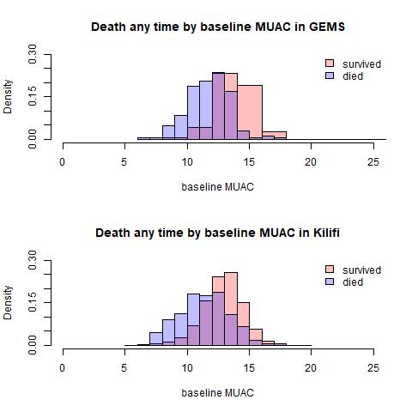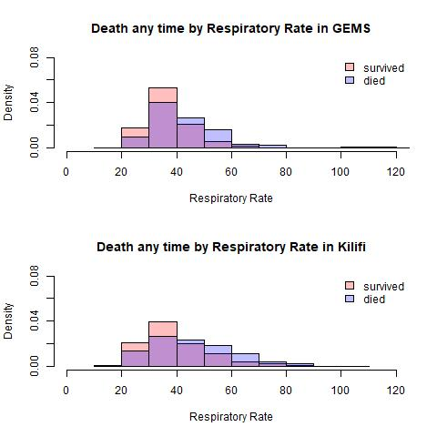

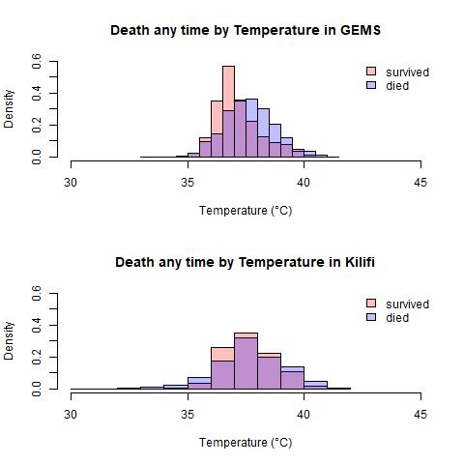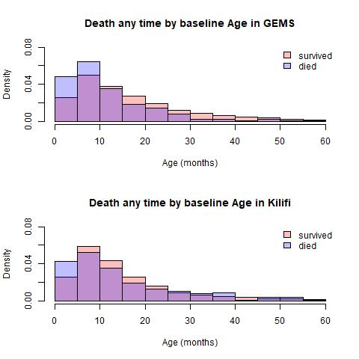

TRIPOD Checklist: Prediction Model Development and Validation

Section/Topic |  | Item |  |  | Checklist Item | Page
 | Title and abstract
Title |  | 1 |  | D;V | Identify the study as developing and/or validating a multivariable prediction model, the target population, and the outcome to be predicted. | 1
Abstract |  | 2 |  | D;V | Provide a summary of objectives, study design, setting, participants, sample size, predictors, outcome, statistical analysis, results, and conclusions. | 2
 | Introduction
Background and objectives |  | 3a |  | D;V | Explain the medical context (including whether diagnostic or prognostic) and rationale for developing or validating the multivariable prediction model, including references to existing models. | 3
 |  | 3b |  | D;V | Specify the objectives, including whether the study describes the development or validation of the model or both. | 3
 | Methods
Source of data |  | 4a |  | D;V | Describe the study design or source of data (e.g., randomized trial, cohort, or registry data), separately for the development and validation data sets, if applicable. | 3-5
 |  | 4b |  | D;V | Specify the key study dates, including start of accrual; end of accrual; and, if applicable, end of follow-up. | 3-5
Participants |  | 5a |  | D;V | Specify key elements of the study setting (e.g., primary care, secondary care, general population) including number and location of centres. | 3-5
 |  | 5b |  | D;V | Describe eligibility criteria for participants. | 3-5
 |  | 5c |  | D;V | Give details of treatments received, if relevant. | 3-5
Outcome |  | 6a |  | D;V | Clearly define the outcome that is predicted by the prediction model, including how and when assessed. | 5
 |  | 6b |  | D;V | Report any actions to blind assessment of the outcome to be predicted. | 3-5
Predictors |  | 7a |  | D;V | Clearly define all predictors used in developing or validating the multivariable prediction model, including how and when they were measured. | 5, suppl
 |  | 7b |  | D;V | Report any actions to blind assessment of predictors for the outcome and other predictors. | 3-5
Sample size |  | 8 |  | D;V | Explain how the study size was arrived at. | 8
Missing data |  | 9 |  | D;V | Describe how missing data were handled (e.g., complete-case analysis, single imputation, multiple imputation) with details of any imputation method. | 8
Statistical analysis methods |  | 10a |  | D | Describe how predictors were handled in the analyses. | 5-7
 |  | 10b |  | D | Specify type of model, all model-building procedures (including any predictor selection), and method for internal validation. | 5-7
 |  | 10c |  | V | For validation, describe how the predictions were calculated. | 5, suppl
 |  | 10d |  | D;V | Specify all measures used to assess model performance and, if relevant, to compare multiple models. | 5-7
 |  | 10e |  | V | Describe any model updating (e.g., recalibration) arising from the validation, if done. | n/a
Risk groups |  | 11 |  | D;V | Provide details on how risk groups were created, if done. | 7
Development vs. validation |  | 12 |  | V | For validation, identify any differences from the development data in setting, eligibility criteria, outcome, and predictors. | 4,5,  13,14
 | Results
Participants |  | 13a |  | D;V | Describe the flow of participants through the study, including the number of participants with and without the outcome and, if applicable, a summary of the follow-up time. A diagram may be helpful. | 8, suppl
 |  | 13b |  | D;V | Describe the characteristics of the participants (basic demographics, clinical features, available predictors), including the number of participants with missing data for predictors and outcome. | 8, Table S8
 |  | 13c |  | V | For validation, show a comparison with the development data of the distribution of important variables (demographics, predictors and outcome). | Fig S4
Model development |  | 14a |  | D | Specify the number of participants and outcome events in each analysis. | 8, Table S6
 |  | 14b |  | D | If done, report the unadjusted association between each candidate predictor and outcome. | n/a
Model specification |  | 15a |  | D | Present the full prediction model to allow predictions for individuals (i.e., all regression coefficients, and model intercept or baseline survival at a given time point). | Table S2
 |  | 15b |  | D | Explain how to the use the prediction model. | 10, Table S7
Model performance |  | 16 |  | D;V | Report performance measures (with CIs) for the prediction model. | Tables 1, S4
Model-updating |  | 17 |  | V | If done, report the results from any model updating (i.e., model specification, model performance). | n/a
 | Discussion
Limitations |  | 18 |  | D;V | Discuss any limitations of the study (such as nonrepresentative sample, few events per predictor, missing data). | 13-14
Interpretation |  | 19a |  | V | For validation, discuss the results with reference to performance in the development data, and any other validation data. | 12,13
 |  | 19b |  | D;V | Give an overall interpretation of the results, considering objectives, limitations, results from similar studies, and other relevant evidence. | 11-14
Implications |  | 20 |  | D;V | Discuss the potential clinical use of the model and implications for future research. | 12
 | Other information
Supplementary information |  | 21 |  | D;V | Provide information about the availability of supplementary resources, such as study protocol, Web calculator, and data sets. | 7
Funding |  | 22 |  | D;V | Give the source of funding and the role of the funders for the present study. | 1

*Items relevant only to the development of a prediction model are denoted by D, items relating solely to a validation of a prediction model are denoted by V, and items relating to both are denoted D;V. We recommend using the TRIPOD Checklist in conjunction with the TRIPOD Explanation and Elaboration document.

