S1 Fig.: Sodium Voltage-Gated Channel Alpha Subunit gene family expression data
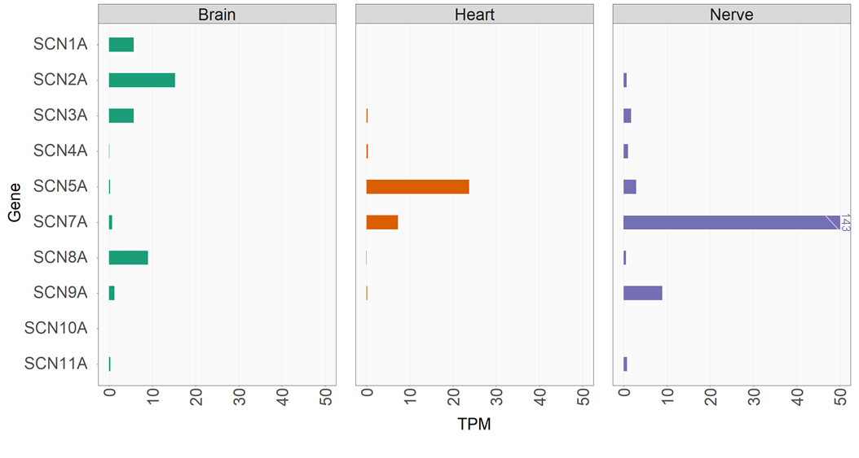
Expression data reproduced from the Genotype-Tissue Expression (GTEx) portal (www.gtexportal.org) for nine of the ten VGSC-α genes. Unlike the epilepsy-related VGSC-α genes (SCN1A, SCN2A, SCN3A and SCN8A), SCN9A is expressed primarily in peripheral nerves.

