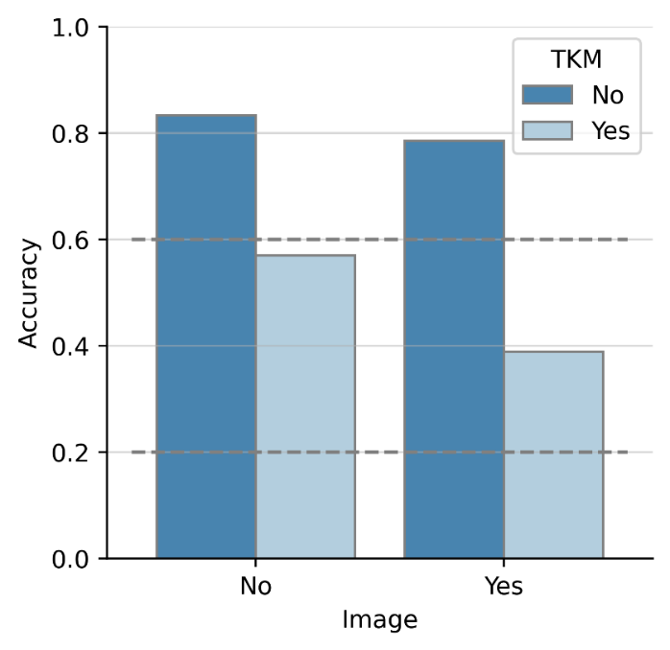
Supplementary Figure 5. The difference in accuracy between questions that require TKM knowledge and questions that do not, compared by whether the question includes images or not. Details are the same as in the Supplementary Figure 2.

