S5 Text – Variable ranking for the European and non-European cohort for each of the three outcomes of interest
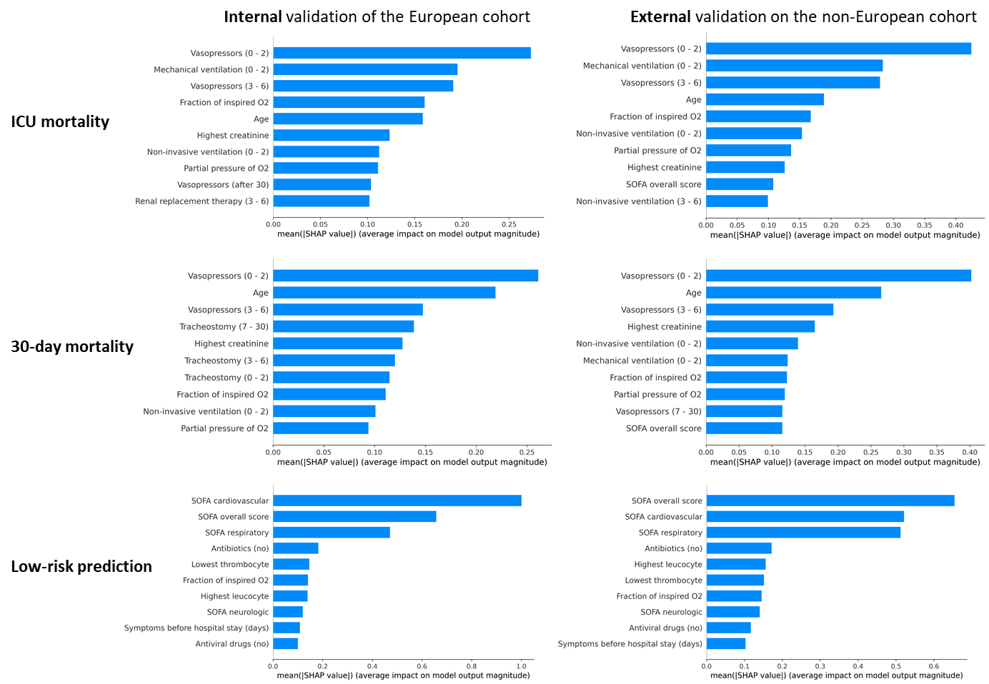
Fig A Variable ranking based on average SHAP values for each of the three outcomes for the model derived in the overall European cohort and validated in the external, non-European cohort.

