Table S9. PDB ligands supporting the benzamide prediction for DAPK1
Ligand ID | Chemical Structure | # PDB  Occurrence | Ligand ID | Chemical Structure | # PDB  Occurrence
0CE | 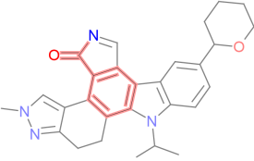 | 1 | SKE | 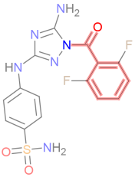 | 1
609 | 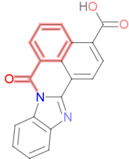 | 1 | STU | 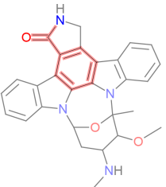 | 46
KSA | 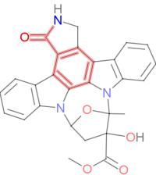 | 3

Benzamide substructure is shown in pink.

