Supporting Information
Synthesis and Redetermination of the Crystal Structure of NbF₅

Martin Möbs and Florian Kraus*
M. Sc. M. Möbs, Prof. Dr. F. Kraus, Anorganische Chemie, Fluorchemie, Philipps-Universität Marburg, Hans Meerwein-Str. 4, 35032 Marburg, Germany, E-mail: f.kraus@uni-marburg.de, https://www.uni-marburg.de/de/fb15/arbeitsgruppen/anorganische_chemie/ag-kraus

Table of contents
Table of contents 1
Vibrational Spectroscopy 2
References 4

Vibrational Spectroscopy
The Raman spectra were measured with a Monovista CRS+ confocal Raman microscope (Spectroscopy & Imaging GmbH) using a 532 nm solid-state laser and either a 300 grooves/mm (low-resolution mode, FWHM: <4.62 cm⁻¹) or an 1800 grooves/mm (high-resolution mode, FWHM: <0.368 cm⁻¹) grating. The sample was filled and sealed in a quartz capillary inside the glovebox and was then placed under the Raman microscope for data acquisition.
IR spectra were recorded on a Bruker alpha FT-IR spectrometer using the ATR Diamond module with a resolution of 4 cm⁻¹. The spectrometer was located inside a glovebox (MBraun) under argon atmosphere. The spectra were processed with the OPUS software package.(OPUS V7.2, 2012)
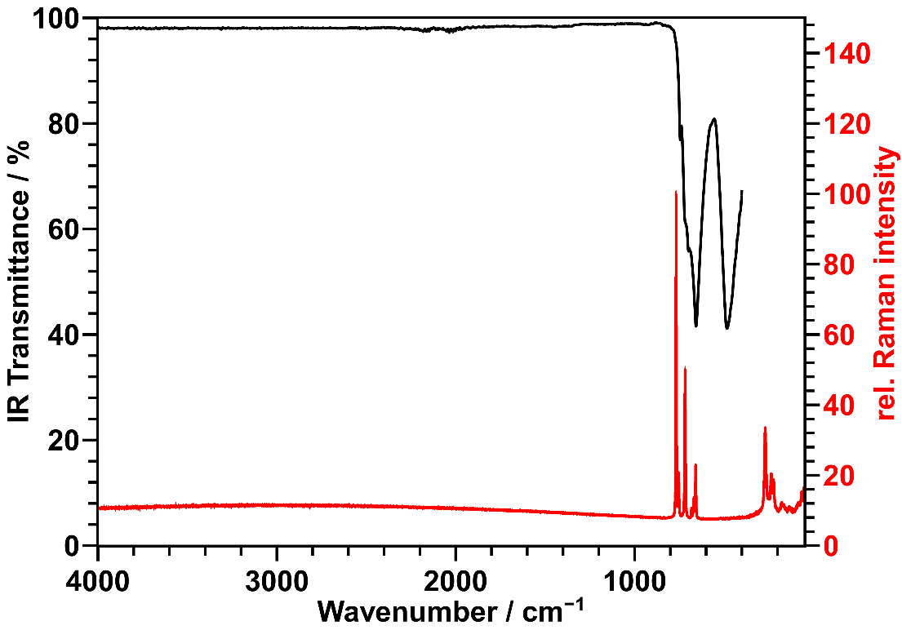
Figure S 1: Infrared (black) and Raman spectrum (red) of NbF₅ powder.

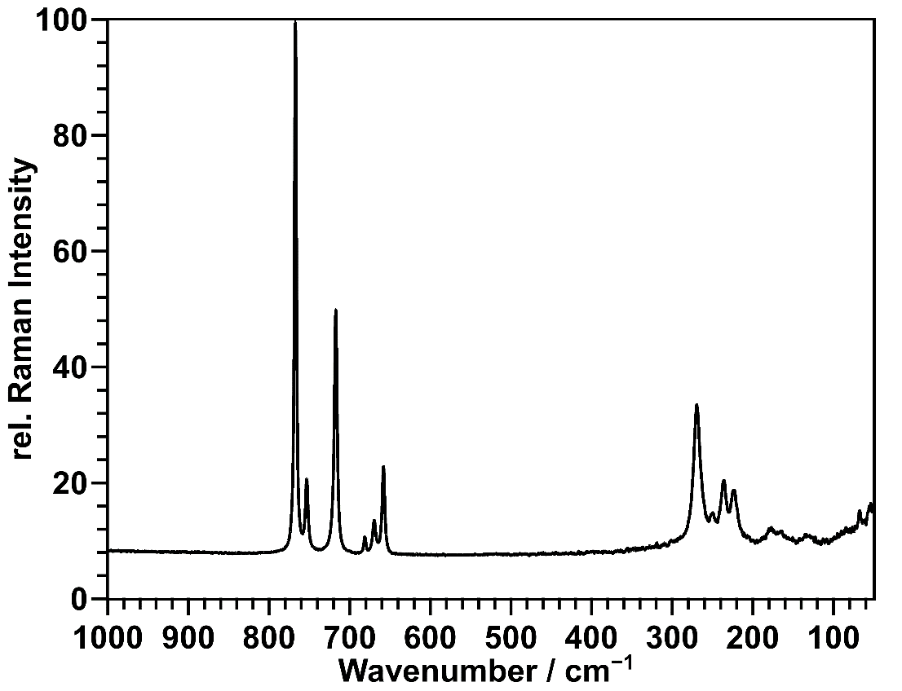
Figure S 2: Enlarged section of the Raman spectrum of NbF₅. No further bands have been observed in the region of 1000 – 4000 cm^{–1}.

Table S8. Observed vibrational frequencies for the Raman spectrum (>50 cm^{–1}) and the IR spectrum (> 400 cm^{–1}) of NbF₅. Approximate band and assignment is given according to literature (Beattie et al., 1969; Preiss & Reich, 1968).
ν(observed) / cm^{–1} |  | Assignment
IR | Raman
 | 68 | lattice vibration
 | 133 | Nb–F deformation
 | 165
 | 179
 | 224 | Ring-deformation
 | 236
 | 250
 | 270
483 |  | Nb–F stretching
656 | 658
 | 669
 | 681
698 | 718
718 | 753
745 | 767

References
Beattie, I. R., Livingston, K. M. S., Ozin, G. A. & Reynolds, D. J. (1969). J. Chem. Soc., A 958–965.
OPUS V7.2 (2012). Ettlingen, Germany: Bruker Optik GmbH.
Preiss, H. & Reich, P. (1968). Z. Anorg. Allg. Chem. 362, 19–23.

